Obtayn

by

Akhil Suresh
Divya Kulkarni

Presented to the Faculty of
Fergusson College
In Partial Fulfillment
Of the Requirements
For the Degree

msc computer science

JUNE 2021

< Leave this page blank >

OBTAYN

by

<Student’s full official name>

APPROVED BY

__________________________________________
<Chair’s Name, Degree>, Chair

__________________________________________
<Member’s Name, Degree >, Committee Member

__________________________________________
<Member’s Name, Degree >, Committee Member

__________________________________________
<Member’s Name, Degree >, Committee Member

RECEIVED/APPROVED BY THE COLLEGE OF <COLLEGE NAME>:

<Associate Dean’s Name, Degree>, Associate Dean

__________________________________________
<Dean’s Name, Degree>, Dean
< Leave this page blank >

Acknowledgments
<Optional. If you do not include a dedication, delete this entire page. Do not delete the section break on the Dedication page above. Press Ctrl+Shift+8 to see the section break.>

< Leave this page blank >

ABSTRACT
OBTAYN

Akhil Suresh
Divya Kulkarni
Fergusson College, 2021

< Project> Chair: <Chair’s Name>
Co-Chair: <If applicable. Co-Chair’s Name>

A lot of times, there are region-specific authentic goods that we cannot always buy from e-commerce websites. The best way to procure these goods is to ask an acquaintance to bring them for you when they return. However, it is not necessary that every time we need something, we have someone to bring it for us. To facilitate this exchange, we thought of a common platform where users post requests and the ones travelling can accept them. These requests can be viewed in the feed, along with photos of required items. Travellers can directly accept requests from here. Once a request gets accepted, the requestor & traveller can chat with each other.

TABLE OF CONTENTS

Introduction 1
Need For System 1
Existing System 1
About the System 1
Salient Features 1
Assumption : Once users establish direct contact, delivery & payment can be mutually organized by them. 1
Detailed description of hardware and software requirements 3
Hardware Requirements 3
Software Requirements 3
Requirements from User 3
Feasibility study 4
Technical feasibility 4
Operational Feasibility 4
Time Feasibility 4
Market research and analysis 4
Unique preposition & value creation 4
Stakeholder Analysis 5
Identification of stakeholders 5
Persona identification 5
Stakeholder engagement 5
Stakeholder communication 5
Project Plan 6
Project Management Plan 6
Project Scope 6
Risk Management plan 6
Identification, analysis and mitigation plan 6
Risk response Strategies 6
Project Team structure, roles and responsibilities 6
Project Tracking, Scheduling 6
Product Backlog, Scrum cycle, methodology 7
Requirement Analysis 7
Requirement collection methods used 7
Requirements finalization process 7
Requirements documentation 7
User Stories 8
Detailed User stories description 9
Landing Page 9
Sign Up 10
Login 11
Homepage 13
Search 15
Location 17
Profile 18
Logout 20
Feed 21
Filter 23
Accept Request from Feed 25
Create Post 27
Create Request 29
Delete a request 31
Delete a post 33
Notifications 34
View all Requests 36
View Chat List 38
View Chat thread 40
Requirements Estimation 41
Other Tasks 1 unit = 30min 41
Total Estimation 45
Effort Estimation Report 46
Development only: 46
Other tasks: 46
Design 47
Software Development Methodology 47
Peer review process 47
Collaboration Methodology 47
Coding Guidelines 47
Source Code Repository 47
Technical stack details 48
Technologies used, their versions 48
Database Design 50
USER 50
REQUEST 50
POST 51
CHAT 51
ER Diagram 52
Component Diagram 54
Sequence diagrams 55
Wireframes 55
1. Landing Page- Login 55
2. Landing Page – Sign up 56
3. Continue with Google 57
4. Home Page 58
5. View & Edit Profile Details 59
6. Update Profile Picture 60
7. Create Post 62
8. Requests 67
9. Chat 69
Development 70
Application flow 70
Application features 72
Landing Page 72
Sign Up, Login & Validations 72
Homepage (Feed) 77
Notifications 78
Add Request/Post 79
Accept Request 85
Delete Request 88
Edit Profile 89
My Requests 96
Chat 97
Mark Request as Fulfilled 100
Delete Request 103
Chat Notifications 104
Error Page 105
Testing 106
Quality process 106
Test Cases identification 106
Test Cases execution 106
Defect Tracking and analysis 106
Limitations & Future Enhancements 107
Limitations 107
Future Enhancements 107
Conclusion 108
References 109
Glossary: 110
Appendix A: 111

List of Tables
Table 2.1[press Shift + Enter] Sample Table Caption [Use “Table Caption” Style”] 3

List of Figures
Figure 2.1[press Shift + Enter] Sample Figure Caption [Use “Figure Caption” Style”] 3
Introduction

Need For System
A lot of times, there are region-specific authentic goods that we cannot always buy from e-commerce websites. The best way to procure these goods is to ask an acquaintance to bring them for you when they return. However, it is not necessary that every time we need something, we have someone to bring it for us.

Existing System
As far as we know, there is no system that facilitates exchange between travelers and people who want certain items from certain places.

About the System
To facilitate this exchange, we thought of a common platform where users post requests and the ones traveling can accept them. These requests can be viewed in the feed, along with photos of required items. Travelers can directly accept requests from here. Once a request gets accepted, the requester & traveler can chat with each other.

Salient Features

- Post requests – Users can request for a specific item by posting it on the ‘Feed’ and tag the location of procurement. (S)he can also include a picture of the item, if required.
- Appreciation posts – Users can post pictures of received items as a token of appreciation.
- Feed – Scroll-able list containing pending requests. A traveler can accept requests directly from here. Also can be filtered by categories.
- Requests Tab – Users can view 2 categories of requests (incoming, outgoing).
- Connecting People- Users who accept requests from the feed can chat with the requester for further communication.
Assumption : Once users establish direct contact, delivery & payment can be mutually organised by them.
Detailed description of hardware and software requirements

Hardware Requirements

Software Requirments
- Node js
- React js
- Firebase cli
- Web browser
- Text editor
- Firebase project ??

Requirements from User
- Any modern browser

Feasibility study
Technical feasibility
The development of this system was done using Visual Studio Code, which is a free software. The framework used is React and Firebase, which again are free.
To make collaboration and version control easier, we used Git and GitHub repositories.
Required software and hardware specifications are achievable. Hence, this system is technically feasible.
Operational Feasibility
The graphical user interface of the application is user friendly and easy to interpret. The system won’t be requiring any additional coding knowledge from the user’s end, which makes it operationally feasible.

Time Feasibility
The project was developed as per the initial planning and strategizing and met every deadline that needed to be fulfilled in a realistic and achievable manner.
Hence, it is time feasible.

Market research and analysis
Unique preposition & value creation

Stakeholder Analysis

Identification of stakeholders
Persona identification
Stakeholder engagement
Stakeholder communication

Project Plan
{Project planning methodology used}

Project Management Plan
Project Scope
Risk Management plan
Identification, analysis and mitigation plan
Risk response Strategies
Project Team structure, roles and responsibilities
Project Tracking, Scheduling
For scheduling tasks and tracking progress, we prepared a Gantt chart containing all user stories.
Each story had following data – Name of member who the story is assigned to
- Exhaustive task list to complete that story
- Start & end dates
- Percentage completed for each task

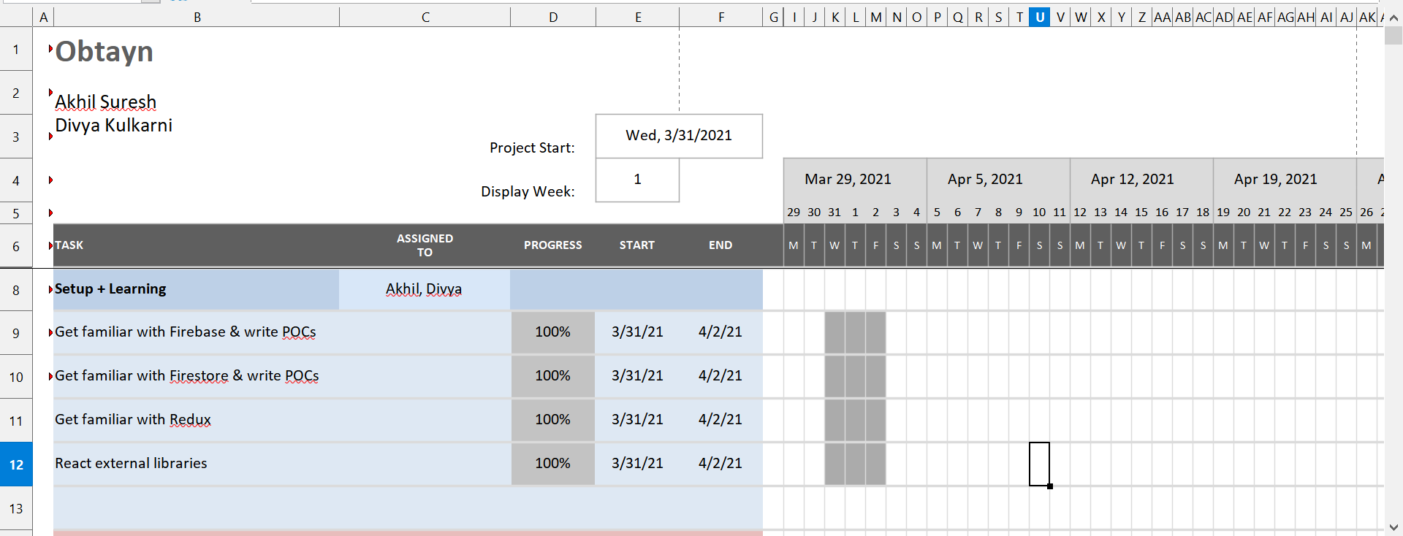Figure 1: Gantt Chart
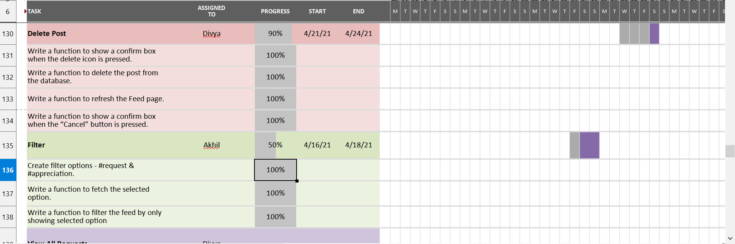
Product Backlog, Scrum cycle, methodology

Requirement Analysis
Requirement collection methods used
Requirements finalization process

Requirements documentation
Must have requirements
- Users Profile (name, email, phone no, profile pic)
- Feed containing requests, appreciation posts
- Filters to categorize posts on the feed - Apparel, Lifestyle, Electronics etc
- Section to view requests (Incoming, Outgoing - both containing Pending & Accepted requests)
- Functionality to accept requests
- Notification when someone accepts a User’s request
- Functionality to chat with users on request acceptance
- Feed can be sorted by current location
- Users can allow location access or manually set current location
- Users can mark an accepted request as “Fulfilled”, which suggests that the User has received their item. This will permanently delete that request from the system.

Nice to have requirements
- Traveler posting available items
- Requester can send targeted request
User Stories
Following User stories define Users’ interactions with the system, when s(he) opens our web application. They are written from the point of view of a person using our application, and written in a simple language.

- I, as a User, want to see the landing page when I visit the website q
- I, as a User, want to see the Sign Up form on the screen.
- I, as a User, want to see the Login form on the screen.
- I, as a User, want to see the Homepage after login.
- I, as a Traveler, want to search for a Request on the Feed.
- I, as a User, want to be able to type a location and get a suggestion list.
- I, as a User, want to click on my username to view & edit my Profile details.
- I, as a User, want to logout.
- I, as a User, want to view all posts on the Feed.
- I, as a User, want to filter the Feed to view only Requests or Appreciation Posts.
- I, as a Traveler, want to accept a Request from the Feed.
- I, as a User, want to write a new Post.
- I, as a Requester, want to request a new item.
- I, as a Requester, want to delete my request.
- I, as a User, want to delete my post.
- I, as a User, want to view Recent Activity (Notifications).
- I, as a User, want to view all Requests.
- I, as a User, want to view Chats.
- I, as a User, want to send a message.

Detailed User stories description

Following are User Stories mentioned above, with detailed description, task list, time estimate & test cases for each story.
For task estimations, we have considered 1 unit = 30min.

Landing Page

1
User Story | I, as a User, want to see the landing page when I visit the website
Description | Landing page has the brand name and a brief about what this website is, and the login form by default.  I can switch between login and sign up form .  I’ll be redirected to homepage if I’m a logged in user.

Task | Estimated Units | Actual Units
Create background carousal | 4 | 6
Create Sign Up form containing Name, email, password, confirm password & contact number fields. | 1 | 3
Create “Continue with Google” button | 4 | 6
Validate user inputs ,show error if invalid entries | 1 | 2
Write a function to add user and validate email | 4 | 5
Write a function to redirect to Login if Sign Up is successful. | 2 | 1
Make the landing page style dynamically according to screen size | 4 | 7
Total | 16 | 30

Sign Up

2
User Story | I, as a User, want to see the Sign Up form on the screen.
Description | Sign Up form contains Full Name, Email & Password fields (which are required), and Contact Number field as an optional field.  I can also choose to “Continue with Google”, where I can use my Google account to sign up.  After registration, the system shows a “Successful Registration” message, and I am redirected to the Login page.

Task | Estimated Units | Actual Units
Create a Signup component. | 4 | 6
Create Sign Up form containing Name, email, password, confirm password & contact number fields. | 1 | 4
Create “Continue with Google” button | 4 | 2
Validate user inputs ,show error if invalid entries | 1 | 1
Write a function to add user and validate email | 4 | 5
Write a function to redirect to Login if Sign Up is successful. | 2 | 1
Total | 16 | 19

Test Case | Expected Result | Actual Result
To verify that Users do not mistype their email address while signing up. | System sends a confirmation link to the entered email address , which the user cannot confirm hence cannot login with this id. | System sends a confirmation link to the entered email address , which the user cannot confirm hence cannot login with this id.
To verify that Users do not Sign Up with pre-existing email id | System alerts Users that id is already in use. | System alerts Users that id is already in use.
To verify that Users do not sign up without entering all required fields | System notifies Users to fill the required fields . | System notifies Users to fill the required fields .

Login

3
User Story | I, as a User, want to see the Login form on the screen.
Description | If I am an existing User, I can log in using valid credentials (email & password), or I can choose “Continue with Google”.  After logging in I’m redirected to the Homepage

Task | Estimated Units | Actual Units
Create a Login component. | 1 | 1
Create Login form containing email & password fields, and a Login button. | 1 | 4
Create “Continue with Google” button | 2 | 1
Validate user inputs | 1 | 1
Write a function to authenticate user | 4 | 6
Write a function to authenticate Google user | 4 | 3
Write a function to alert unregistered Users and block them from accessing the application. | 3 | 3
Write a function to redirect to Homepage if Login is successful. | 2 | 2
Total | 18 | 21

Test Case | Expected Result | Actual Result
To verify that Users log in with valid credentials | System redirects users to the homepage. | System redirects users to the homepage.
To verify that Users do not log in with wrong password | System alerts the user that the password is incorrect | System alerts the user that the password is incorrect
To verify that Users do not log in with unregistered email | System informs the user that the email is not registered. | System informs the user that the email is not registered.
To verify that Users log in with their Google account. | System redirects Users to Homepage if Google authenticates them. | System redirects Users to Homepage if Google authenticates them.

Homepage

4
User Story | I, as a User, want to see the Homepage after login.
Description | Given that I have logged in successfully, the system redirects me to Homepage containing the Feed(contains posts), header with options like Search Bar, Create Post, Open Chats, View Profile and link to navigate to Feed, Requests tab. This page also contains Recent Activity, which shows notifications.

Task | Estimated Units | Actual Units
Create Navbar component with  - Link to Feed page  - Link to Requests page  - Notifications button  - Create post button  - Open chats button  - Users’ name as a button | 4 | 6
Create Search component with Category, Keywords, Location fields and Search, Reset buttons. | 5 | 6
Create Filter component with Request & Post filters. | 1 | 2
Create a Feed component with  - Scrollable list of posts  - “Scroll to Top” button | 1 | 6
Write a function to fetch all required data into components. | 7 | 6
Write a function to redirect to Requests from header. | 2 | 1
Write a function to redirect to Create Post from header. | 1 | 1
Write a function to redirect to Homepage when User clicks on the system logo in the header. | 1 | 1
Total | 20 | 29

Test Case | Expected Result | Actual Result
To verify that Users do not access homepage without logging in | The system blocks them from going forward, and redirects Users to the login page. | The system blocks them from going forward, and redirects Users to the login page.
User is on Homepage | The system shows the user's name and loads all the components. | The system shows the user's name and loads all the components.
User is on the Homepage, and clicks on “Feed” in the header. | System refreshes Homepage. | System refreshes Homepage.
User clicks on the system logo in the header. | System redirects User to Homepage. | System redirects User to Homepage.

Search

5
User Story | I, as a Traveller, want to search for a Request on the Feed.
Description | On the Homepage, the system shows a “Search” section in the Header.  This section contains a drop-down list of Categories (Clothing, Home & Living, Hobbies, Electronics, Food), a search box for keywords, and a location-picker which autocompletes. After entering the required inputs and clicking on the Search button, the system displays posts corresponding to the search, which helps to filter the posts.

Task | Estimated Units | Actual Units
Create a search component, containing a dropdown list of categories, textbox for keyword, and a location picker. | 6 | 6
Load all the categories to show in dropdown. | 1 | 1
Write a function to show relevant requests as search results. | 4 | 6
Handle following cases -  - All fields are empty  - Any one field has value, rest are empty  - Any two fields have values, one is empty  - All fields have values | 2 | 4
Write a function to handle “No match found” exception. | 2 | 3
Write a function to clear the search fields
Style search bar to stay on top of the feed
Total | 15 | 20

Test Case | Expected Result | Actual Result
To verify that Users do not click the Search button without any data input i.e. no Category selected, no Keyword, no Location picked. | System should alert Users to enter data into at least one field. | System should alert Users to enter data into at least one field.
System does not find any posts that match Users’ search. | System should display a message - “Sorry, we could not find any matches for your search”. | System should display a message - “Sorry, we could not find any matches for your search”.
Network error occurs while Users are searching for a Request. | System alerts Users of the issue, and display results when connection is established. | System alerts Users of the issue, and display results when connection is established.
A particular Request appears in Users’ search result and the User tries to accept it, while it is simultaneously getting accepted by someone else. | System alerts the User - “Thank you for your interest, but this request is already accepted by someone.” | System alerts the User - “Thank you for your interest, but this request is already accepted by someone.”
To verify that Users do not enter invalid location | System prompts User to enter a valid location. | System prompts User to enter a valid location.
To verify that system does not crash on any combination of input fields being empty. | System shows relevant results. | System shows relevant results.

Location

6
User Story | I, as a User, want to be able to type a location and get a suggestion list.
Description | The create request page contains a field for location where once i start typing the location it gives me suggestions which matches the input from which i can select and the location is set. Same location picker is used in the search bar.

Task | Estimated Units | Actual Units
Create an input box for typing location | 4 | 5
Write a function to fetch locations related to value of input box | 1 | 8
Write a function to load the suggestions as drop-down | 4 | 7
Write a function to select the suggestion when user clicks on it | 1 | 5
Write a function to clear the suggestion and value. | 4 | 3
Total | 14 | 28

Test Case | Expected Result | Actual Result

Profile

7
User Story | I, as a User, want to click on my username to see my Profile details.
Description | When I click on my Username on the top-right corner of any page, the system shows a small window with my name, email and profile photo.  At the bottom of this window, I have the option to Log out.  When I hover my mouse over the my photo, I see an option to edit profile.  When I click on Edit Profile, I see a pop-up window where I can edit my name, contact number & also select a new profile photo. I cannot edit my email.

Task | Estimated Units | Actual Units
Create a Profile component containing -  - Current profile photo  - Edit profile picture option  - User name  - Email  - Logout button | 4 | 6
Write a function to display the Profile component when the User’s name is clicked. | 2 | 3
Write a function to load Profile details into the dropdown window. | 3 | 4
Write a function to show “Edit Profile” modal when profile photo is clicked. | 3 | 8
Write a function to check if a newly selected image for profile fits within constraints (extension, size). | 2 | 3
Write a function to  - Upload selected image to Storage.  - Show a progress bar while photo is uploading | 4 | 8
Write a function to update profile picture. And delete previous picture | 2 | 4
Write a function to display the selected picture
Total | 21 | 36

Test Case | Expected Result | Actual Result
To verify that Users do not select an invalid file type for profile photo. | System should alert Users of valid file formats and prompt Users to choose another image. | System should alert Users of valid file formats and prompt Users to choose another image.
To verify that Users do not select an image that is too big in size, as a profile photo. | System should inform Users of the maximum image size that is accepted, and prompt Users to choose another image. | System should inform Users of the maximum image size that is accepted, and prompt Users to choose another image.
Users click on their name in the top left corner of the header. | System shows a pop-up window with profile details. | System shows a pop-up window with profile details.
Users click outside the Profile pop-up window. | System closes the pop-up. | System closes the pop-up.
Users update their profile photo. | System refreshes the pop-up window, and displays the updated profile photo. | System refreshes the pop-up window, and displays the updated profile photo.
To verify that Users do not edit their emails. | System displays email with editing disabled. | System displays email with editing disabled.
To verify that profile gets updated even if a single field is changed. | System detects change and updates data accordingly. | System detects change and updates data accordingly.

Logout

8
User Story | I, as a User, want to log out of the application.
Description | When I click on my Username on the top-right corner of any page, the system shows a small window with my name, email and profile picture.  At the bottom of this window, I have the option to Log out.

Task | Estimated Units | Actual Units
Write a function to redirect User to the Login page when Logout is clicked. | 2 | 4
Total | 2 | 4

Test Case | Expected Result | Actual Result
Users click on Logout. | System redirects Users to Login page. | System redirects Users to Login page.
Network error occurs while Users are logging out. | System alerts Users of the issue, and logs Users out when connection is established. | System alerts Users of the issue, and logs Users out when connection is established.

Feed

9
User Story | I, as a User, want to view all posts on the Feed.
Description | On the Homepage of the system, I can view all posts in the Feed.  The Feed contains 2 types of posts - Requests and Appreciation Posts. I can scroll through these posts. To go back to the top of the Homepage, I can click the “Back to Top” button which appears on the bottom-right corner of the screen.

Task | Estimated Units | Actual Units
Create a Post component which contains  - User name  - User profile pic  - Title  - Timestamp  - Message  - Images(if any) 3 max  - Delete button for User who has posted | 4 | 6
Create a Request component which contains  - User name  - User profile pic  - Title  - Message  - Timestamp  - Location  - Category  - Accept button for everyone except User who has posted  - Delete button for User who has posted | 4 | 4
Create a Filter component with 2 options - Requests and Posts | 1 | 2
Create a Feed component which contains Filter & multiple Post and Request components | 5 | 7
Create a “Back to Top” button. | 1 | 4
Write a function to make the “Back to Top” button visible after User scrolls a particular number of posts. | 1 | 3
Write a function to go back to top of the page when “Back to Top” button is clicked | 1 | 2
Write a function to fetch all Posts and use the data for the Post component. | 2 | 4
Write a function to fetch all pending requests and use it for Request component | 2 | 4
Write a function to fetch Requests and Posts dynamically i.e. fetch data in small chunks, depending on how much User scrolls. | 4 | 6
Write a function to load all the Feed components. | 2 | 3
Total | 27 | 41

Test Case | Expected Result | Actual Result
Users open Homepage and Feed is empty | System displays a message - “We’re all caught up! No recent posts.” | System displays a message - “We’re all caught up! No recent posts.”
Users click on an image in the Feed. | System maximizes the image in a pop-up modal. | System maximizes the image in a pop-up modal.
A User posts on the Feed. | System refreshes Feed for all Users. | System refreshes Feed for all Users.

Filter

10
User Story | I, as a User, want to filter the Feed to view only Requests or Appreciation Posts.
Description | At the top of the Feed, I can select to view only Requests or only Appreciation Posts. On selecting any one filter, the Feed shows only those posts.  When viewing only requests the system asks for my location by asking for location permission and sorts Request posts according to the ones nearest to me.

Task | Estimated Units | Actual Units
Create filter options - Request & Post. | 1 | 2
Write a function to fetch the selected option. | 2 | 3
Write a function to filter the feed by only showing selected option | 4 | 3
Write a function to be called when #request is selected  - Asks user for location permission  - Asks user to manually enter location if permission is denied  - Store user location | 6 | 8
Write a function that takes requests location and user location and sorts the array by nearest to farthest | 5 | 4
Total | 18 | 20

Test Case | Expected Result | Actual Result
User clicks on the filter dropdown menu. | The dropdown menu shows the filters available | The dropdown menu shows the filters available
User selects a filter | The Feed is refreshed with only the filtered posts | The Feed is refreshed with only the filtered posts
User selects Request filter | The system asks the User for location access or the User enters the location manually | The system asks the User for location access or the User enters the location manually
User selects Request filter | The Feed is sorted by location nearest to farthest from the User’s location. | The Feed is sorted by location nearest to farthest from the User’s location.

Accept Request from Feed

11
User Story | I, as a Traveller, want to accept a Request from the Feed.
Description | When I scroll through Request posts, I see an option to accept the Request. On clicking this option, System prompts me to confirm my action. When I click “Continue”, System shows “Request Accepted” message and redirects me to the Requests page. Under “Incoming Requests” the current request is highlighted. The User is added to my Chat list, and we can start a new conversation.

Task | Estimated Units | Actual Units
Make a function to change the status of the Request on click of Accept button. | 2 | 2
Make a function to handle cases of already accepted requests. | 1 | 2
Make a function which adds a notification. | 2 | 5
Make a function to add Users to the Chat list. | 3 | 4
Make a function to redirect to the Requests page. | 2 | 2
Write a function to highlight current Request. | 2 | 4
Total | 12 | 19

Test Case | Expected Result | Actual Result
User accepts a Request from the feed. | The request is removed from the Feed, and added to his/her incoming requests. | The request is removed from the Feed, and added to his/her incoming requests.
User accepts a Request from the feed. | The requestor is added to the User's chat list. | The requestor is added to the User's chat list.
User accepts a Request from the feed. | The system sends a notification to the requestor. | The system sends a notification to the requestor.
Network error occurs while the User is accepting a Request from the Feed. | System notifies the User about the issue, and changes Request status as soon as connection is established. | System notifies the User about the issue, and changes Request status as soon as connection is established.
To verify that two Users do not accept a Request simultaneously. | System will compare timestamps and allocate the request to the User who accepted it first. | System will compare timestamps and allocate the request to the User who accepted it first.
 | System refreshes Feed for all other Users, and the corresponding Request is removed from the Feed. | System refreshes Feed for all other Users, and the corresponding Request is removed from the Feed.
To verify that Users do not accept their own Requests. | System blocks the User from accepting their own Request. | System blocks the User from accepting their own Request.

Create Post

12
User Story | I, as a User, want to create a new Post.
Description | When I click on the “Create Post” button in the header, I am redirected to a page containing form for adding new Request. I can switch to New Post.  This window contains a form with various fields like Title, Message and Images. Image sis an optional field.  On clicking the “Add Post” button, I am redirected to Feed, where my Post appears at the top. System shows my Username and Profile picture on the left of the post title.

Task | Estimated Units | Actual Units
Write a function to redirect to a new page on click for “New Post” button in header | 2 | 2
Make a switch component to select request or post (Request is selected by default) | 2 | 3
Make a component for Post form containing :  - Title  - Message  - Images(if any, max 3)  - Add Post button | 3 | 5
Make a function to validate image size and extension | 2 | 2
Write a function to show request form or post form depending on switch value | 1 | 2
Write a function to add the new post on click of Post button | 2 | 4
Write a function to redirect to Feed when the “Add Post” button is clicked. | 1 | 1
Write a function to show the new Post on top of the Feed. | 4 | 4
Write a function to handle “Network Error” exception. | 2 | 2
Total | 19 | 25

Test Case | Expected Result | Actual Result
User clicks “Create Post” button | System shows the Create Post modal. | System shows the Create Post modal.
User clicks the “Add Post” button. | The post is added to the database and to the Feed. | The post is added to the database and to the Feed.
To verify that Users do not keep required fields are empty.  (title, message) | System prompts Users to fill fields that are marked required. | System prompts Users to fill fields that are marked required.
Network error occurs while User is uploading the new Post | System uploads the Post as soon as connection is established. | System uploads the Post as soon as connection is established.
User enters data in Create Post form, and toggles switch before clicking on “Add Post”. | System retains field data. | System retains field data.

Create Request

13
User Story | I, as a Requestor, want to request a new item.
Description | When I click on the “New Post” button in the header, I am redirected to a page containing form for adding new Request. Request option is selected by default.  This window contains a form with various fields like Title, Message, Images, Location and Category. Photo is an optional field. I cannot upload more than 3 photos.  On clicking the “Add Request” button, I am redirected to Feed and my Post appears at the top of the Feed. System shows my Username and Profile picture on the left of the post title.

Task | Estimated Units | Actual Units
Use “Create a Post” component from story #7. | 0 | 0
Make a component for request form containing :  - Title  - Message  - Location  - Category  - Images(if any, max 3)  - Add Request button | 5 | 6
Write a function to redirect to new page when New Post button is clicked in the header. | 1 | 1
Write a function to validate whether form fields are filled. | 1 | 1
Write a function to show request form or post form depending on switch value. | 0 | 1
Write a function to validate image constraints. | 2 | 2
Write a function to add the new Request when the Post button is clicked. | 2 | 2
Write a function to redirect to Feed when the “Add Request” button is clicked. | 2 | 2
Write a function to show the new Request on top of the Feed. | 2 | 2
Write a function to handle “Network Error” exception. | 2 | 2
Total | 15 | 15

Test Case | Expected Result | Actual Result
To verify that Users do not keep required fields are empty.  (title, message, tag, location, category) | System prompts Users to fill fields that are marked required. | System prompts Users to fill fields that are marked required.
Network error occurs while User is uploading his Request. | System uploads the Request as soon as connection is established. | System uploads the Request as soon as connection is established.
User clicks on Create Post button | System opens a pop-up modal, containing a form to add a new post. | System opens a pop-up modal, containing a form to add a new post.
User clicks anywhere outside the pop-up modal. | System closes the modal. | System closes the modal.
User enters data in Create Post form, and closes the pop-up before clicking on Post. | System resets form fields to blank. | System resets form fields to blank.
User clicks the “Add Request” button. | The post is added to the database and to the Feed. | The post is added to the database and to the Feed.
User enters data in Create Post form, and toggles Tag before clicking on “Add Request”. | System resets form fields to blank. | System resets form fields to blank.

Delete a request

14
User Story | I, as a Requestor, want to delete my Request.
Description | 1. When I scroll through Requests, I see an option to delete my Request. On clicking this option, System prompts me to confirm my action (“Are you sure?”). Once I click continue , the system deletes the request and shows a message saying “Request Deleted” and refreshes the Feed.  2. In the Requests page, under “Outgoing Requests” I can see a “Cancel” button. Once I click the button, the system asks me to confirm my action. When I click confirm, the system deletes the request and sends a notification to the traveller, and redirects me to the requests page.

Task | Estimated Units | Actual Units
Write a function to show a confirm box when the delete icon is pressed. | 2 | 2
Write a function to delete the request from the database. | 2 | 5
Write a function to add a “Request Deleted” notification. | 2 | 4
Write a function to refresh the Feed page. | 1 | 3
Write a function to show a confirm box when the “Cancel” button is pressed in My Requests. | 2 | 2
Write a function to remove the request from the requestor's “Outgoing” and travellers “Incoming” request. | 2 | 3
Total | 12 | 20

Test Case | Expected Result | Actual Result
User deletes a Request from the feed. | The system shows a confirm window. | The system shows a confirm window.
User deletes a Request from the feed. | The request is removed from the Feed, and from his/her outgoing requests. | The request is removed from the Feed, and from his/her outgoing requests.
Network error occurs while User is deleting a Request from the Feed. | System notifies the User about the issue, and deletes Request as soon as connection is established. | System notifies the User about the issue, and deletes Request as soon as connection is established.
User deletes a pending request from the Request page. | The system shows a confirm window. | The system shows a confirm window.
User deletes a pending request from the Request page. | The request is removed from the Outgoing Requests & Feed. | The request is removed from the Outgoing Requests & Feed.
User deletes a request which was accepted. | The system shows a confirm window. | The system shows a confirm window.
User deletes a request which was accepted. | The request is removed from the outgoing requests. | The request is removed from the outgoing requests.
User deletes a request which was accepted. | The request is deleted from the traveller’s “incoming request”. | The request is deleted from the traveller’s “incoming request”.
User deletes a request which was accepted. | The system sends the Traveller a notification saying “ Request deleted”. | The system sends the Traveller a notification saying “ Request deleted”.

Delete a post

15
User Story | I, as a User, want to delete my Post.
Description | When I scroll through posts on the Feed, I see an option to delete my Post. On clicking this option, System prompts me to confirm my action (“Are you sure?”).  When I click continue , the system deletes the post, shows a message saying “Post Deleted” and refreshes the Feed.

Task | Estimated Units | Actual Units
Write a function to show a confirm box when the delete icon is pressed. | 2 | 2
Write a function to delete the post from the database. | 2 | 2
Write a function to refresh the Feed page. | 1 | 1
Write a function to show a confirm box when the “Cancel” button is pressed. | 1 | 1
Total | 6 | 6

Test Case | Expected Result | Actual Result
User deletes a Post from the feed. | The system shows a confirm window. | The system shows a confirm window.
User deletes a Post from the feed. | The Post is removed from the Feed. | The Post is removed from the Feed.
Network error occurs while User is deleting a Post from the Feed. | System notifies the User about the issue, and deletes Post as soon as connection is established. | System notifies the User about the issue, and deletes Post as soon as connection is established.

Notifications

16
User Story | I, as a User, want to view Recent Activity (Notifications).
Description | When I click on Notifications icon in the header, I see the a pop-up section on the right of the screen, which shows 5 most recent notifications sorted from most recent to least recent.  When I click on a Chat notification bubble (which shows new message alerts), the system redirects me to that particular chat screen. When I click on a Request notification (i.e. when someone has accepted my Request), the system redirects me to the Requests page.

Task | Estimated Units | Actual Units
Use the “Notifications” component form user story #3 and add style properties. | 2 | 4
Write function to toggle Notifications drawer display from Feed. | 2 | 3
Write function to toggle Notifications drawer display from My Requests. | 2 | 4
Write a function to fetch notifications for current User. | 4 | 5
Write a function to display fetched data in “Notifications” sorted by timestamp. | 3 | 4
Create chat notification component (clickable)  - Write a function to redirect to the chat when User clicks on it. | 4 | 4
Create a request update notification component (clickable)  - Write a function to redirect to a Requests page.  - Highlight the corresponding Request. | 6 | 6
Write a function to refresh Notifications once new notifications arrive. | 2 | 3
Create “Delete” button for each notification. | 2 | 3
Create Dismiss All button for entire component. | 3 | 3
Add animation to load and dismiss notification | 5 | 5
Write a function to make the navbar collapse depending on the screen width. | 6 | 6
Total | 27 | 51

Test Case | Expected Result | Actual Result
Users click on a notification. | System redirects Users to the respective page/section, depending on type of notification clicked. | System redirects Users to the respective page/section, depending on type of notification clicked.
Users receive a notification while they are on the Recent activity section. | System refreshes Recent Activity to display the new notification at the top, and deletes the oldest notification. | System refreshes Recent Activity to display the new notification at the top, and deletes the oldest notification.

View all Requests

17
User Story | I, as a User, want to view all Requests.
Description | Clicking on the ‘My Requests’ link on the header redirects me to the Requests page. Here requests are categorized into “Accepted” & “Outgoing”.  Requests that I have accepted are listed under Accepted, while Requests posted by me are listed under Outgoing. Under Outgoing requests, I see two options – Accepted/Pending & Fulfilled.  I can mark an accepted request as Fulfilled, once I receive the requested item.

Task | Estimated Units | Actual Units
Create a container with Accepted (Requests accepted by the User) & Outgoing (Requests posted by the User) requests. | 2 | 2
Create Accepted requests component with details - requestor, title, location, message, images(if any). | 4 | 6
Create Outgoing requests component with details - acceptor, title, location, message, images(if any), Fulfilled button(only for accepted requests),cancel button | 4 | 4
Write a function to fetch all the Requests related to the user. | 3 | 4
Write a function to display all the fetched Requests. | 5 | 6
Write a function to differentiate Outgoing requests depending upon status(accepted/pending). | 2 | 3
Write a function to refresh status of Outgoing requests (from pending to accepted). | 3 | 3
Write a function to handle Fulfilled button click -  - Show prompt to confirm whether User wants to continue, delete Request if yes.  - Send notification to request acceptor | 5 | 7
Make a function to show fulfilled / pending and accepted request depending upon the switch
Total | 28 | 35

Task | Estimated Units | Actual Units
Status of Outgoing Request changes while User is on the Requests page. | System refreshes the page and updates Request status. | System refreshes the page and updates Request status.
To verify that an Outgoing Request is accepted by someone. | System displays the Request in a different color, to differentiate it from other pending requests. | System displays the Request in a different color, to differentiate it from other pending requests.
Users click on the “Fulfilled” button on an accepted request. | System prompts Users to confirm whether they want to continue. | System prompts Users to confirm whether they want to continue.
Users click on “Continue” in the Fulfilled button prompt. | System deletes the corresponding Request permanently. | System deletes the corresponding Request permanently.

View Chat List

18
User Story | I, as a User, want to view Chats.
Description | On clicking the “Chats” button in the header, the system redirects me to the Requests tab, which also shows recent chats. I can see a list of chats, with the sender’s profile picture, name and a preview of the most recent message in that thread. Unread messages are shown in bold text.

Task | Estimated Units | Actual Units
Create a Chats component to the right of Requests. | 2 | 2
Write a function to redirect to the Requests page when the User clicks on the Chats button (available on the header) | 2 | 1
Write a function to fetch all User Chats. | 4 | 5
Write a function to group messages by different users | 3 | 4
Write a function to fetch user profiles and names. | 3 | 6
Write a function to take all the data and make a separate Chat component containing -  - Sender’s profile picture  - Sender’s name  - last message  - timestamp of the last message. | 10 | 16
Write a function to highlight unread chat in bold. | 1 | 6
Write a function to show the last message , a photo icon if last message was an image, an image and the message if the last message contains an image and text.
Total | 25 | 40

Test Case | Expected Result | Actual Result
Users have new & unread messages. | System displays the message preview in bold. | System displays the message preview in bold.
Users’ Chats exceed the maximum number of Chats that can be displayed on one screen. | System allows Users to scroll through all Chats. | System allows Users to scroll through all Chats.

View Chat thread

19
User Story | I, as a User, want to send a message.
Description | When I click on any thread in Chats, the system shows me a chat screen.  On this screen, I can read previous chats, send a new message and add photos using the ‘Add’ button. On clicking the Send button, my message appears in the thread. I can select only 3 images at a time.  When I click on the Back button, the system redirects me back to Chats.

Task | Estimated Units | Actual Units
Write a function to switch from the chat window to the chat thread with a particular User. | 2 | 3
Write a function which uses data fetched in Story #13, and display the corresponding message thread. | 3 | 7
Make a function to display the message thread, such that one can differentiate sender’s and receiver’s messages, with timestamps. | 5 | 8
Write a function to scroll down on a new message. | 2 | 6
Create a component which contains a text field for text message, file selector for attaching images and a button to send the message. | 6 | 10
Create a back button which redirects Users to a list of chats. | 2 | 4
Write function to handle “Network Error” exception. | 2 | 2
Write function to check whether selected image fits within constraints (size, file type, number of images selected) | 2 | 5
Write a function to show the any error when user selects invalid file. | 2 | 4
Write a function to show the selected image, and remove it when user clicks on the cross icon on the image. | 2 | 2
Total | 26 | 51

Test Case | Expected Result | Actual Result
Users click on a Chat notification. | System redirects User to chats section, and opens the corresponding thread with the sender. | System redirects User to chats section, and opens the corresponding thread with the sender.
Network error occurs before Users’ message is sent. | System should alert Users of the issue, and send messages as soon as connection is established. | System should alert Users of the issue, and send messages as soon as connection is established.
To verify that Users do not send more than 3 images at a time. | System should alert User about the image limit. | System should alert User about the image limit.
Users want to view the entire Chat. | System allows Users to scroll through the entire message thread. | System allows Users to scroll through the entire message thread.

Requirements Estimation
Other Tasks 1 unit = 30min

Estimation & Planning

Task | Estimated Time  Must have/Good to have | Actual Time
Identify User Stories | 2/2 | 4/2
Write one-liners for User Stories | 6/3 | 7/3
Write descriptions for each User Story | 8/2 | 8/2
Write detailed task list for each User Story | 16/6 | 14/4
Write test cases for each User Story | 8/3 | 11/3
Peer review | 8/3 | 10/4
Total | 48 /19 | 54/18

Requirement Analysis

Task | Actual Time
Gathering Requirements | 20
Categorize requirements according to MOSCOW | 5
Validation of requirements | 12
Refinement of requirements | 32
Total | 69

Design

Task | Actual Time  Must have/Good to have
Database Design  - Identify entities  - Identify attributes for each entity  - Identify relationships between entities | 10/3
ERD | 3/2
Components  - Identify Frontend components  - Identify APIs  - Identify Backend components | 2/0  2/1  1/0
Draw Component diagram | 2/1
Draw rough screen designs with pen & paper | 4/1
Recreate screens in draw.io | 5/0
Learn basics of Adobe XD | 3/0
Create wireframes in Adobe XD | 10/5
Prototyping | 4/0
Use Cases | 3/0
Total | 49/13

Documentation

Task | Estimated Time | Actual Time
Create Requirements document containing  - Introduction  - Salient features  - MOSCOW requirements | 2 | 2
Write Use cases | 2 | 2
Create Design document containing  - List of entities & their descriptions  - ERD  - Component diagram  - Wireframes | 5 | 3
Add snapshots of the system & add their description | 4 | 14
Add test cases | 5 | 2
Execute test cases | 20
Write Limitations & Future Enhancements | 2 | 1
Write a Conclusion | 2 | 1
Total | 42

Setup/Learning

Task | Estimated Time | Actual Time
Get familiar with Firebase & write POCs  - Authentication  - Storage  - Hosting | 32 | 42
Get familiar with Firestore & write POCs | 16 | 30
Get familiar with Redux | 16 | 20
React external libraries | 16 | 20
Total | 80 | 112

Total -> 327 units ≅ 164 hrs ≅ 21 days

Total Estimation

Development -> 348 units = 174 hours ≅ 22 days (considering 8 hour work days)
- Must Haves

Development -> 78 units = 34 hours ≅ 5 days (considering 8 hour work days)
- Good to Haves

Other Tasks (Requirement Analysis, Design, Documentation, Setup/Learning) ->
327 units ≅ 164 hours ≅ 21 days

 | Total Estimate (hrs) | Total Estimate (days approx)
Must Have Only | 174+164 = 332 | 22+21 = 42
Must Have + Good to Have | 208+164 = 372 | 27+21 = 48

Effort Estimation Report
Development only:

 | Total Estimate (units) | Total Estimate (hrs) | Total Estimate (days approx)
Estimated Time | 337 | 168 | 21
Actual Time | 510 | 255 | 32

Other tasks:

 | Total Estimate (units) | Total Estimate (hrs) | Total Estimate (days approx)
Estimated Time | 327 | 164 | 21
Actual Time

Design
This section describes the Design phase of the project.

Software Development Methodology
Peer review process
Collaboration Methodology

Coding Guidelines
- Use prettier.io
- Use functional components ONLY
- Pascal-Case for function names, file names
- camel-Case for variables, try to avoid vague names
- For constants: MY_CONSTANT
- Tab length: 4 spaces
- Add function description before each component - purpose, arguments, return value
- Convention for hooks: useHooks
- Functions return 0 for error

Source Code Repository
https://github.com/akhil-suresh31/Obtayn

Technical stack details

Technology | Reasons
React (v17.0.2) | - Already familiar with the library.  - Vast resources available online.  - Helps to build interactive & rich User Interfaces.
Firebase - Hosting Services | - Provides ready-to use environment that allows to deploy code fast
Firebase - Backend Services | - Free authentication, database, storage & hosting.
React Redux (v7.2.3) -Application State Management | - Supports React v17
Firestore - Online Databases (NoSQL) | - NoSQL cloud database  - Easy integration with firebase app

Technologies used, their versions

Package name | Version | Use
bootstrap | 4.6.0 | Front-end, open source framework for building responsive web applications.
bootstrap-icons | 1.4.1 | Open source icon library.
date-fns | 2.20.0 | Simple tool set for manipulating dates in JavaScript & Node.js
firebase | 8.3.2 | Backend
framer-motion | 4.1.2 | Production-ready animation library.
geo-coder | 1.0.2 | Service that converts addresses into geographic coordinates to be placed on a map.
geolib | 3.3.1 | Library to provide basic geospatial operations like distance calculation, conversion of decimal coordinates to sexagesimal and vice versa, etc.
react | 17.0.2 | JavaScript library for building user interfaces.
react-avatar | 3.10.0 | Universal avatar makes it possible to fetch/generate an avatar based on the information you have about that user.
react-bootstrap | 1.5.2 | Bootstrap components built with React.
react-bootstrap-icons | 1.4.0 | Open-source icon library
react-burger-menu | 3.0.6 | An off-canvas sidebar component with a collection of effects and styles using CSS transitions and SVG path animations.
react-redux | 7.2.3 | Lets React components read data from a Redux store, and dispatch actions to the store to update state.
react-redux-firebase | 3.10.0 | Provides Redux bindings for Firebase, thereby making it easy to use Firebase with Redux and React.
react-router-dom | 5.2.0 | Routing for React.
react-select | 4.3.0 | Select Input control for ReactJS with multiselect, auto-complete and ajax support.
react-waypoint | 10.1.0 | Executes a function whenever you scroll to an element. Used for infinite scrolling.
redux | 4.0.5 | State container for JavaScript apps.
redux-firestore | 0.15.0 | Redux bindings for Firestore. Provides low-level API used in other libraries such a react-redux-firebase.
redux-thunk | 2.3.0 | Middle-ware that allows you to return functions, rather than just actions, within Redux.
sweetalert2 | 10.16.2 | responsive, customizable and accessible replacement for JavaScript's popup boxes.

Database Design
USER
This database table stores User details. Each row is identifiable via the id, which is used as primary key and is unique for each User. Profile_picture & phone_number are optional fields for Users.

Attribute | Constraints
id | PRIMARY KEY
name | NOT NULL
password | NOT NULL
profile_picture
phone_number

REQUEST
This table represents a Request posted by User(s). “to_user_id” is NULL by default, and it changes only when that Request is accepted by another User.
Each Request has a title (identifies a Request), message (requirement description written by the User), category (Clothing, Home & Living, Hobbies, Electronics, Food), timestamp (date & time when the Request is posted), location (the place where User)

Attribute | Constraints
id | PRIMARY KEY
to_user_id | NOT NULL
from_user_id | NOT NULL
title
message
category
timestamp
location
photos
status
user

POST
Represents who(user_id) has posted what(title, photos, message) on the Feed. Also stores the time when it was posted (timestamp). Users may or may not add photos to their posts, so it is an optional field.

Attribute | Constraints
id | PRIMARY KEY
from_user_id | NOT NULL
title
message
timestamp
photos
user

CHAT
Represents a chat thread between two Users. It contains from_user_id as a foreign key, indicating who was the Request sender.
Messages is an array of objects, where each element is a single message from one User to another, having attributes such as sender, images(if any), message(content) and timestamp.

Attribute | Constraints
id | PRIMARY KEY
from_user_id | NOT NULL
Messages
- sender
- images
- message
- timestamp

ER Diagram

- This diagram shows relationships between the entities in our system.
- One User can post many Requests, create many Posts, have many Chats and view many Notifications. Hence, all these are One-Many relationships.
- Notification is a many-many relationship which maps Users, their Requests (or Chats) to each other. Hence, it contains user_id, request_id & chat_id as foreign keys.

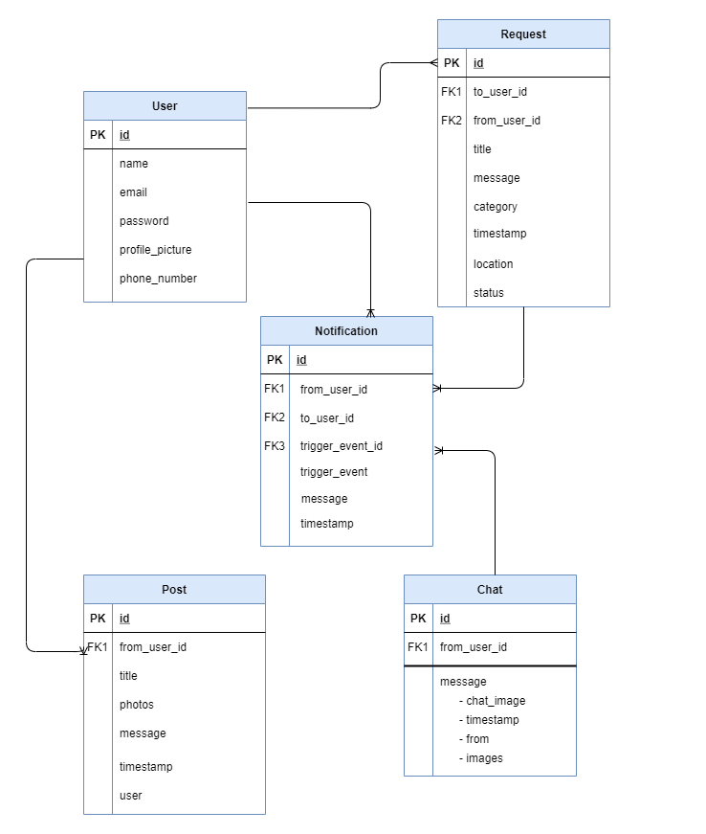

Component Diagram

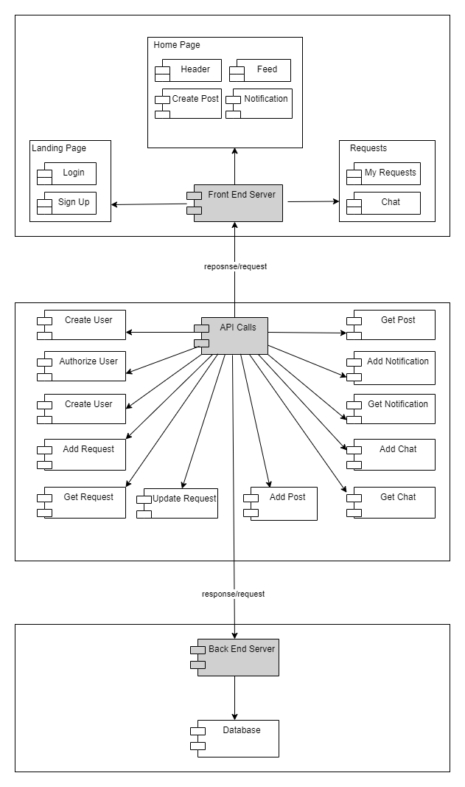

Sequence diagrams
Wireframes

- Landing Page- Login
This is the first page that Users are directed to. It contains a short description of the application. Existing users can Login directly or click on ‘Get Started’ to sign up.

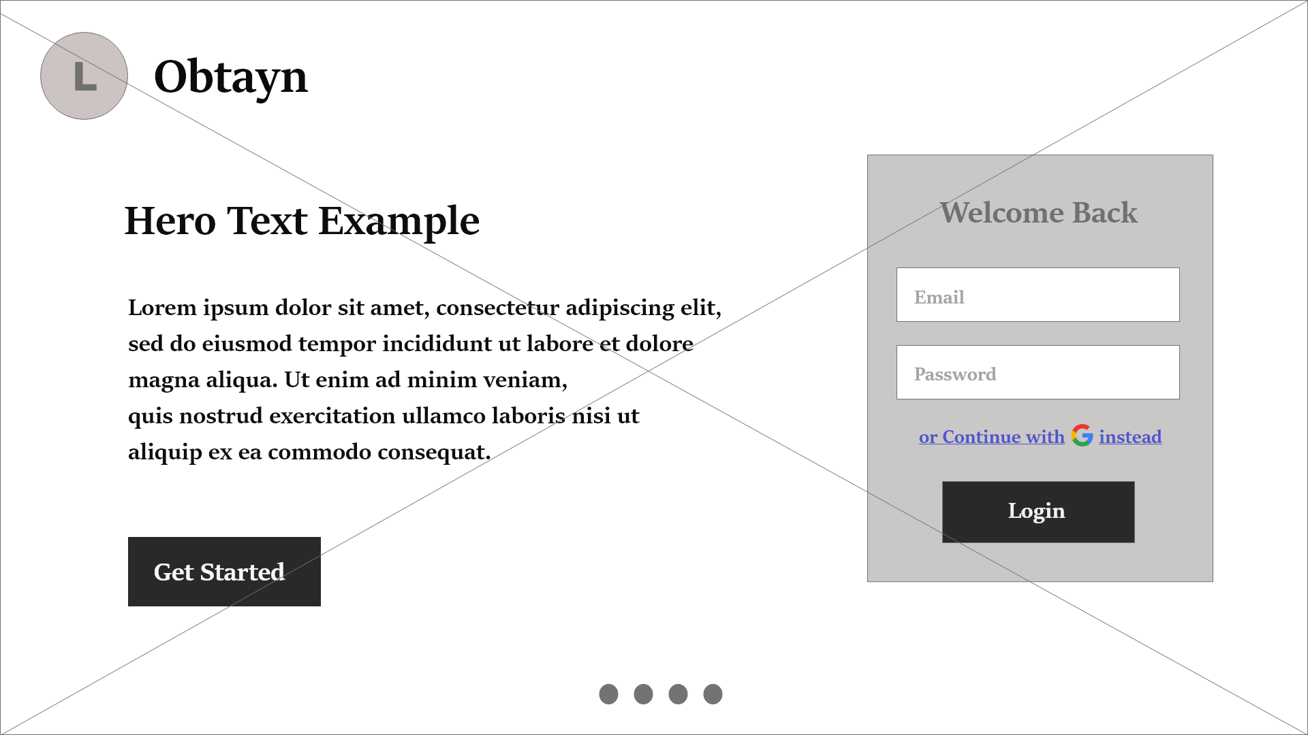Figure 2: Wireframe - Landing Page

- Landing Page - Signup
New users can register on this page. After successful registration, Users are redirected to Login.

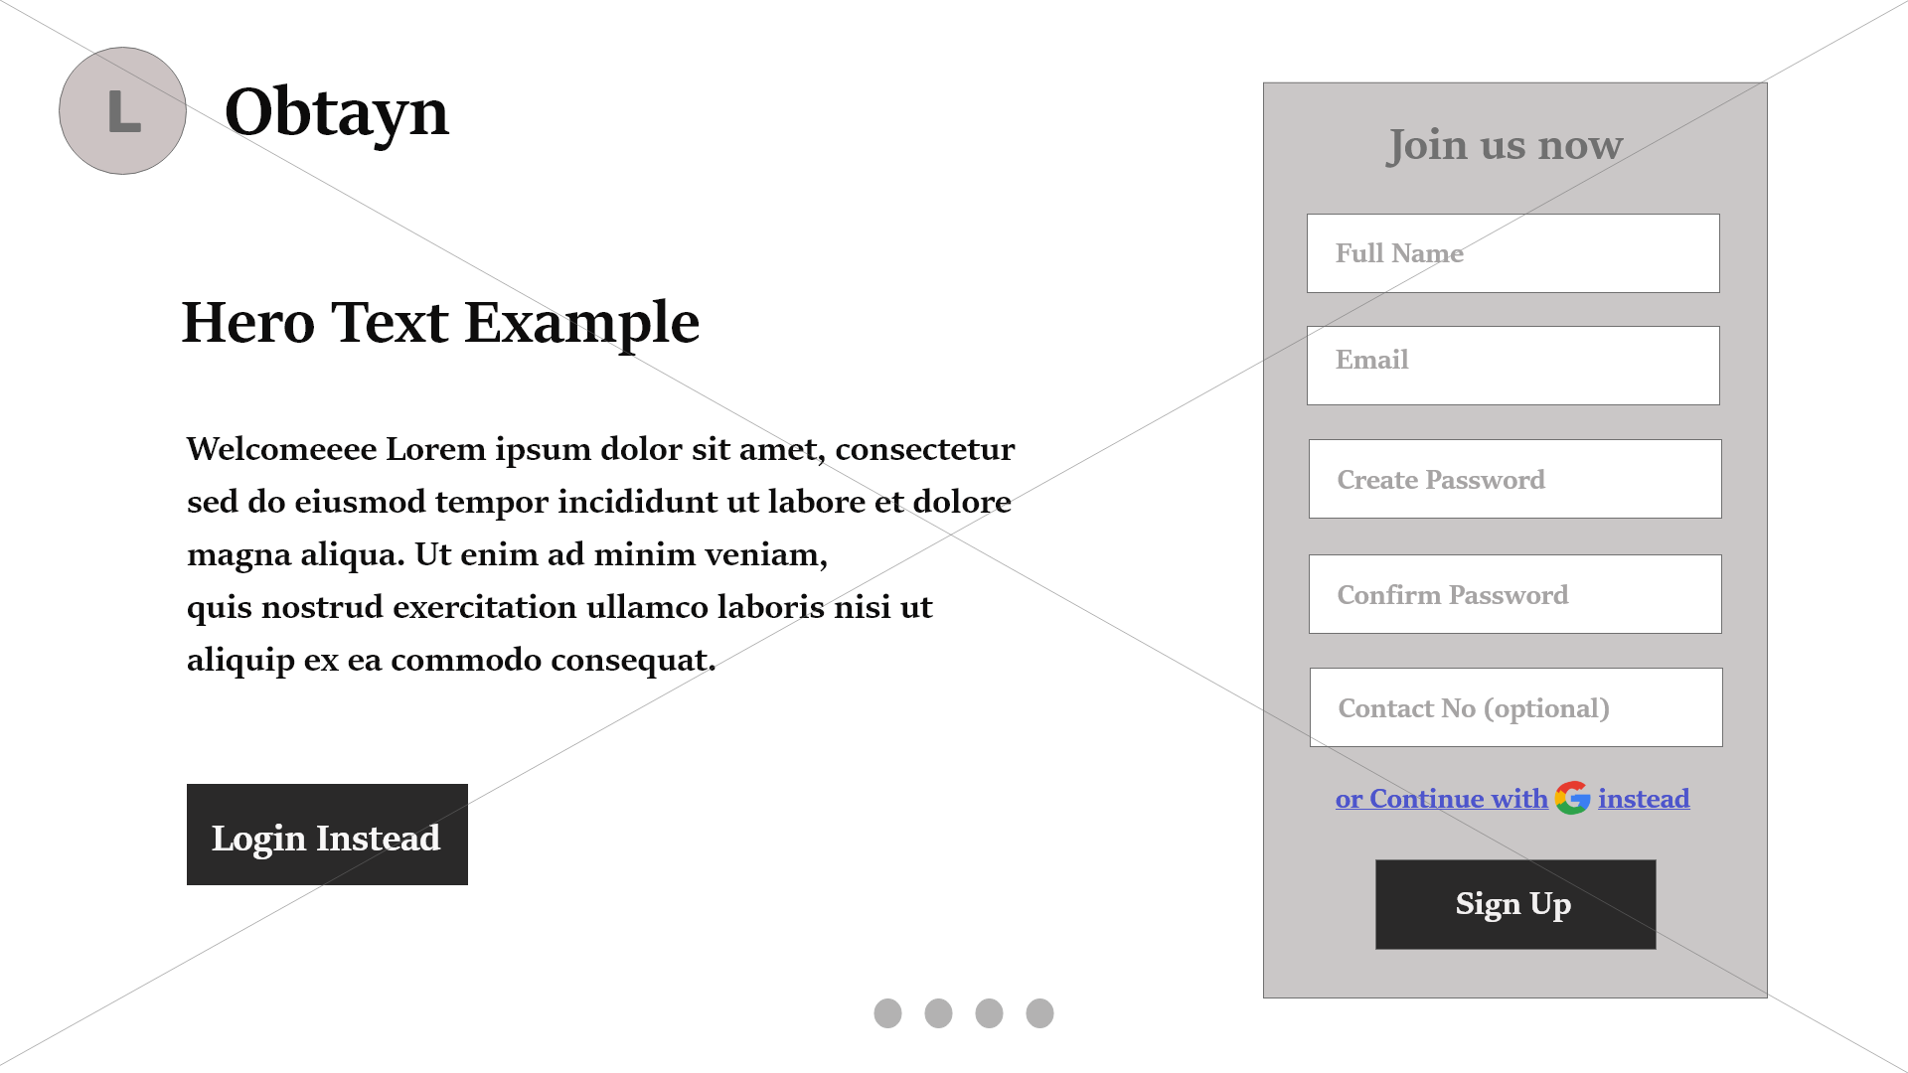

- Continue with Google
Users can opt to use their Google accounts, for easy log in. Google asks them to input their email Id and password.
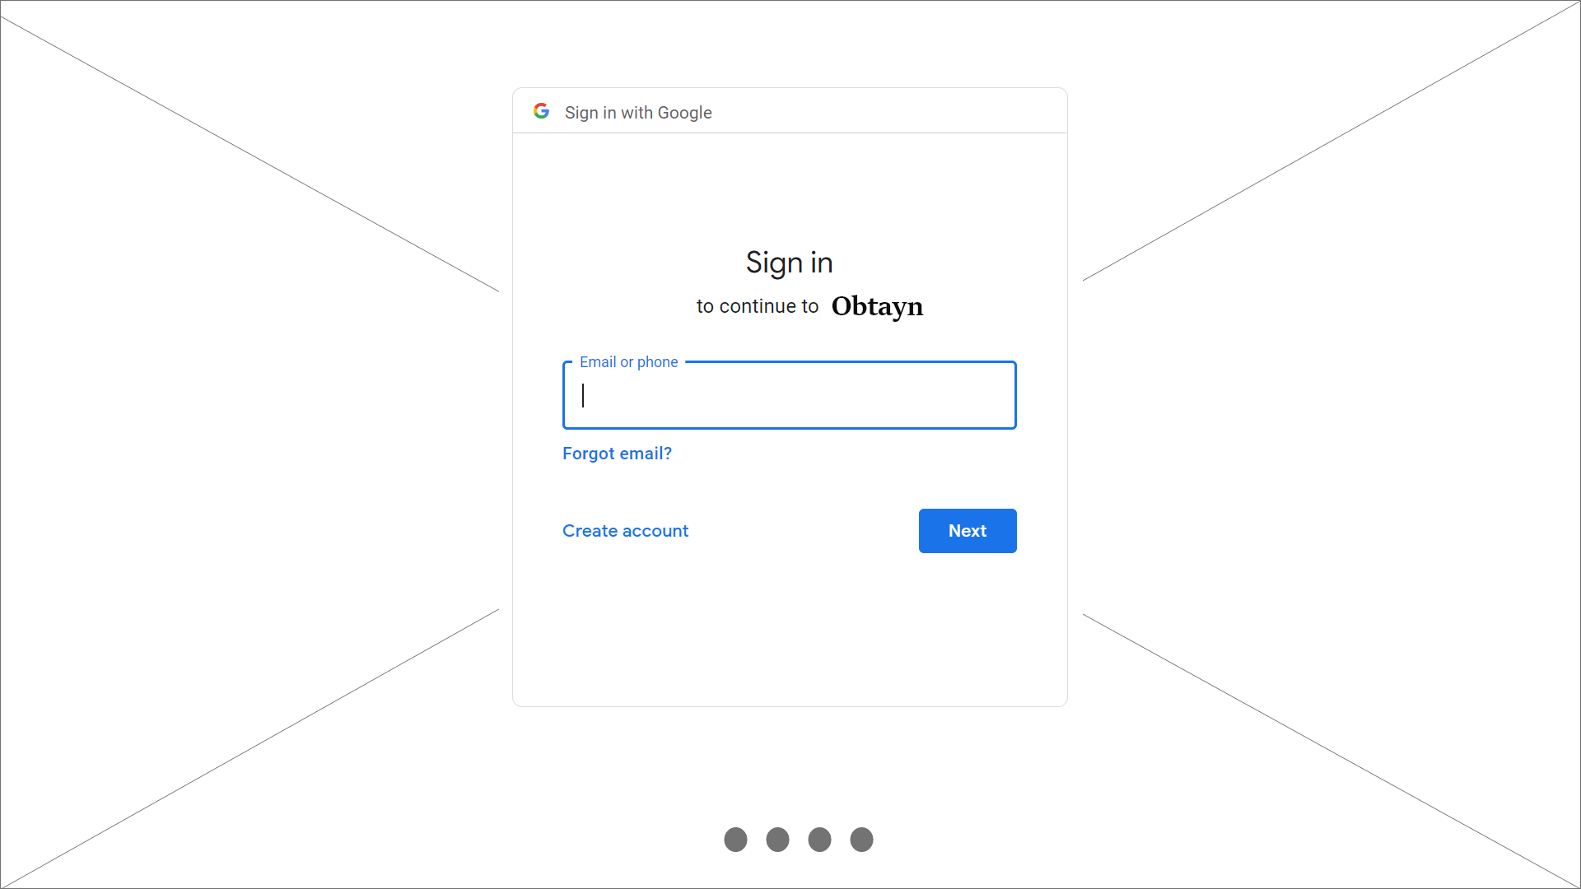

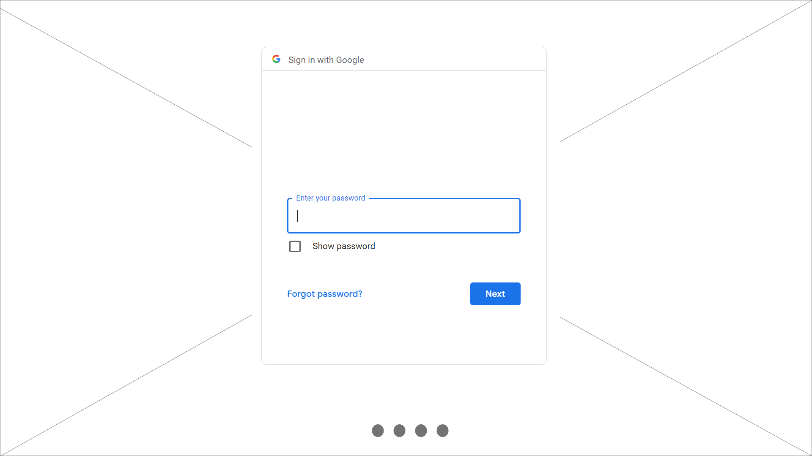
- Home Page
This page contains a list of posts which can be Requests or Appreciation posts. Users can also Create Post and view notifications. Search bar allows Users to filter the feed by categories, location, and also search for a particular post.
Users can navigate to the Requests page from the header.

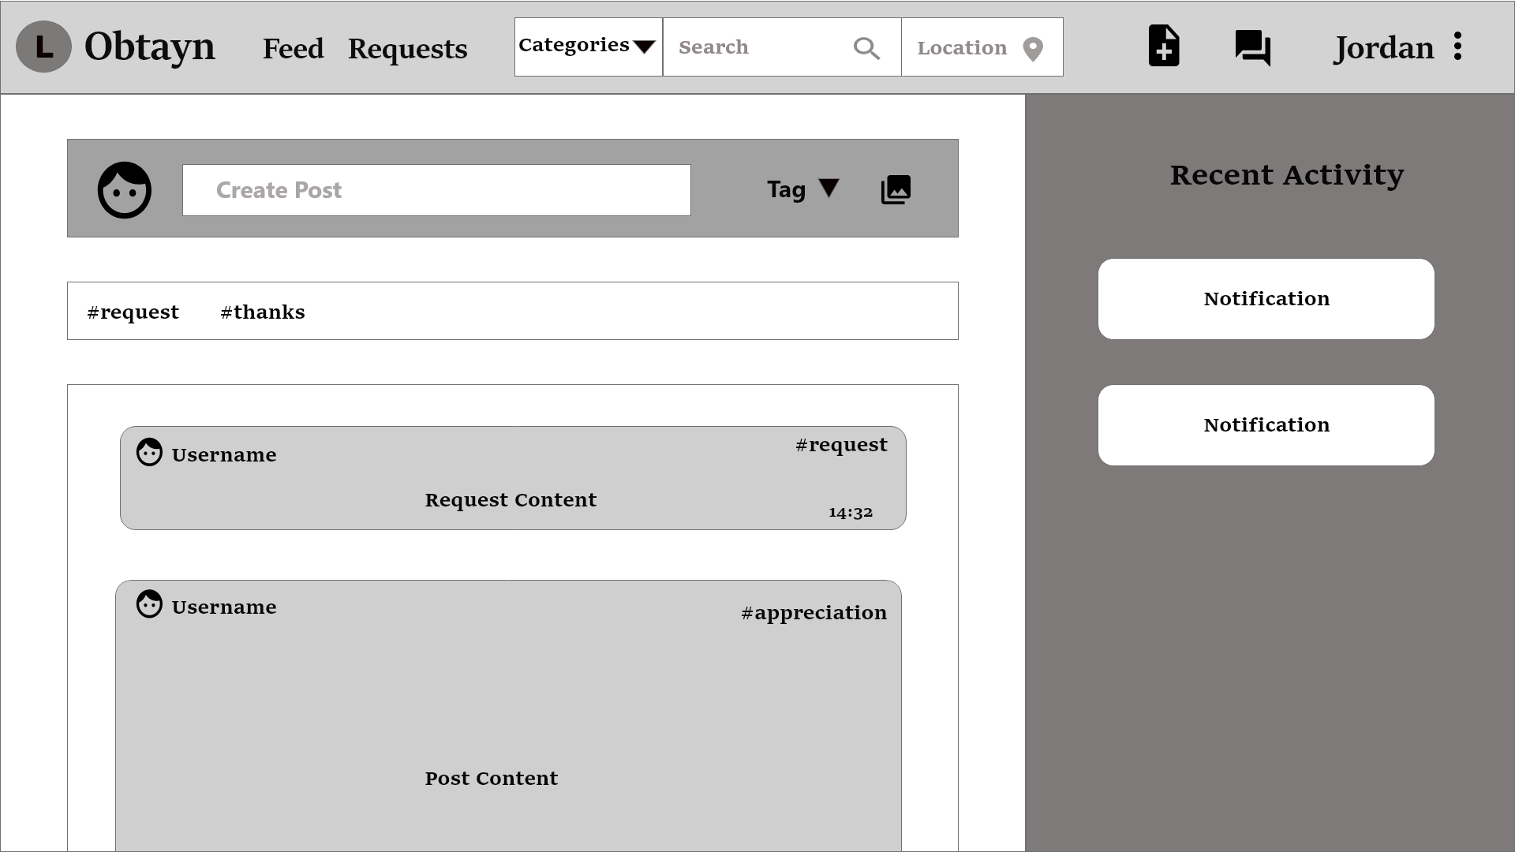Figure 3: Wireframe - Home Page

Below is a roadmap for the Homepage.

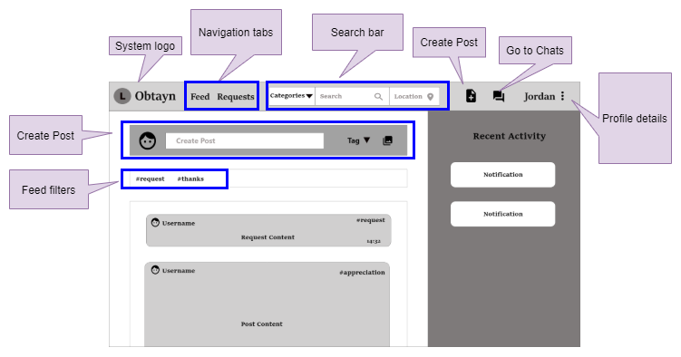

- View & Edit Profile Details

By clicking on their name in the header, Users can view their profile details, change profile picture and logout.

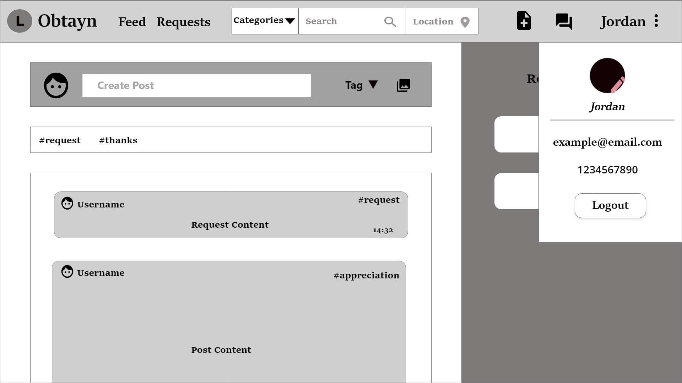

- Update Profile Picture
User prompts the user to browse images and select a new profile picture.

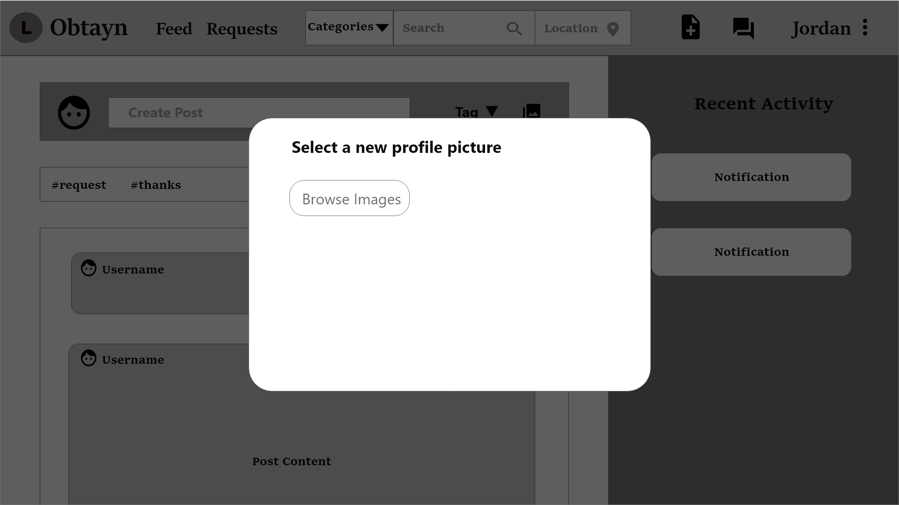

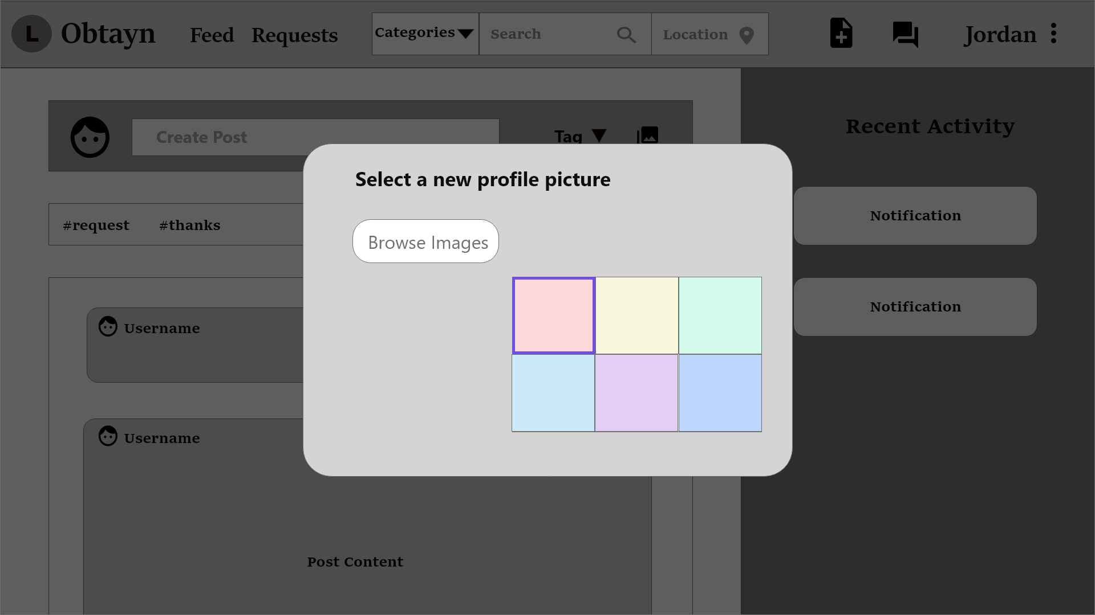

System displays a success message once the profile photo is updated successfully.

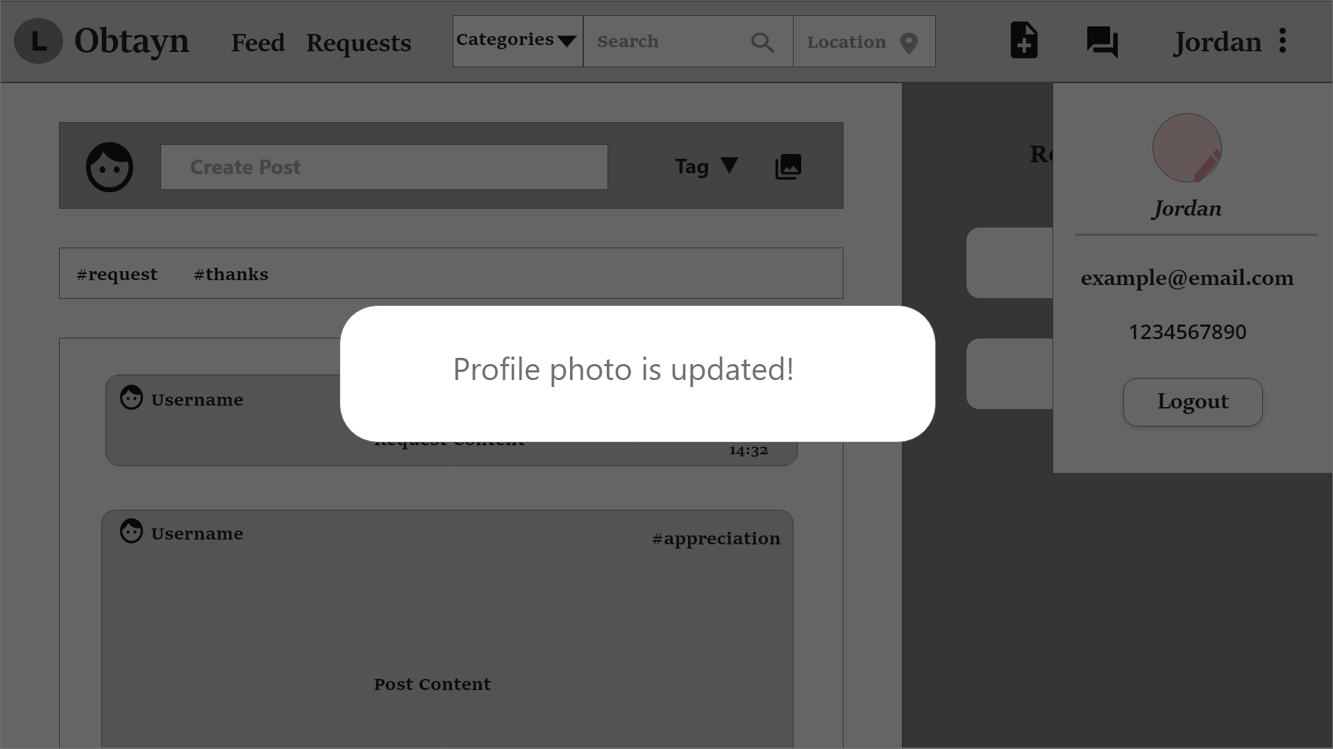

- Create Post

When Users click on Create Post in the header, or the one above the Feed, system opens a pop-up window. This window contains a dropdown list for “Tag” field, with 2 options - Request & Appreciation post. Tag describes the type of post.

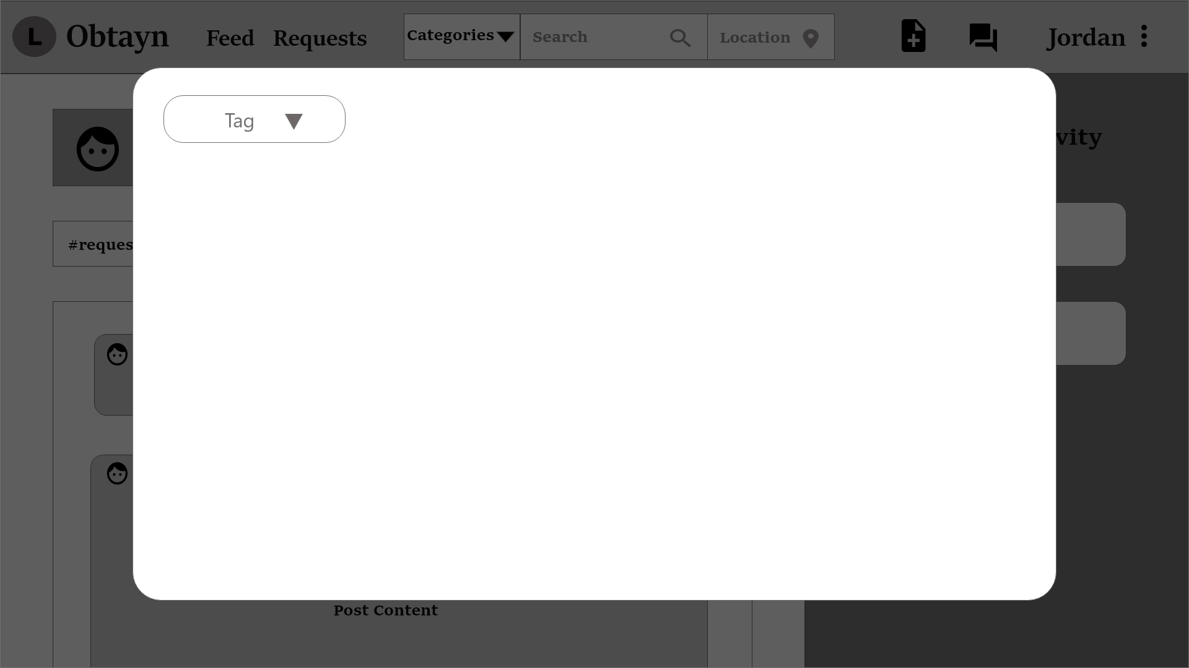

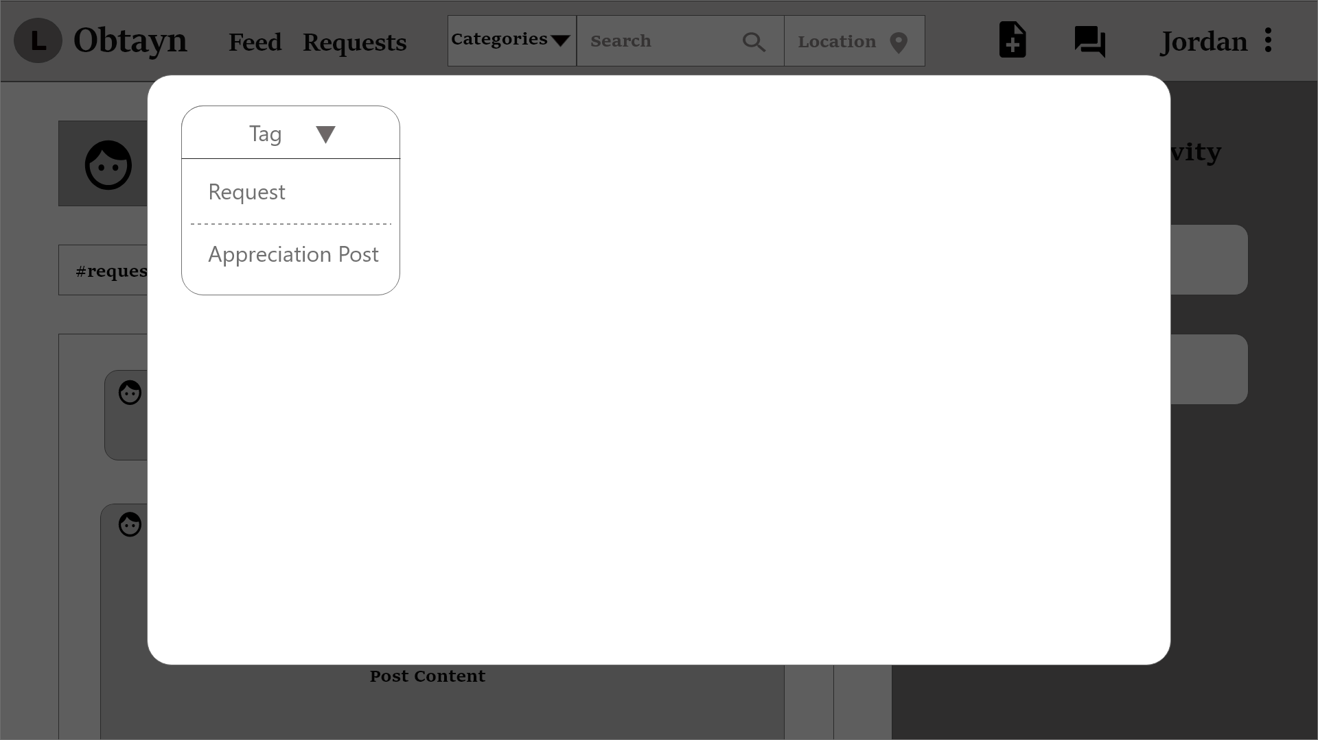
System displays form fields depending on the post Tag.

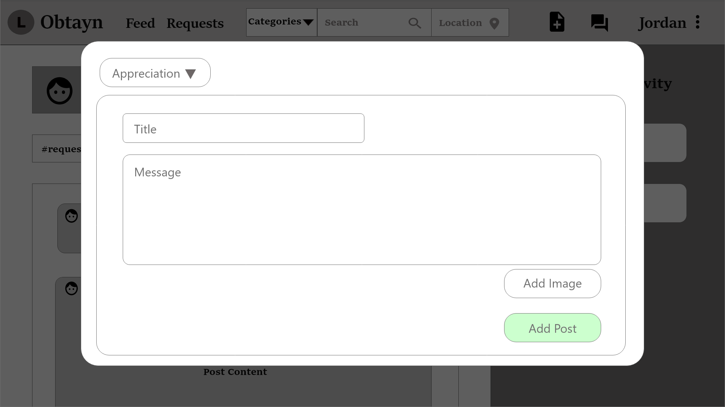

Once User clicks on “Add Post”, it shows on top of the Feed, and is highlighted.

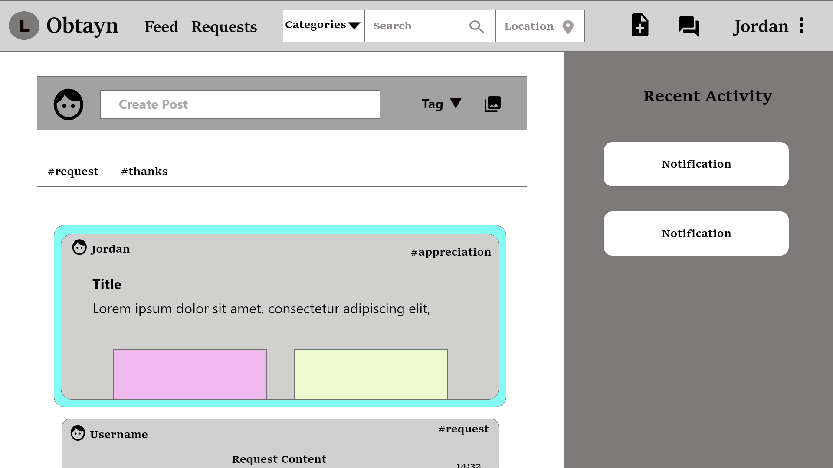
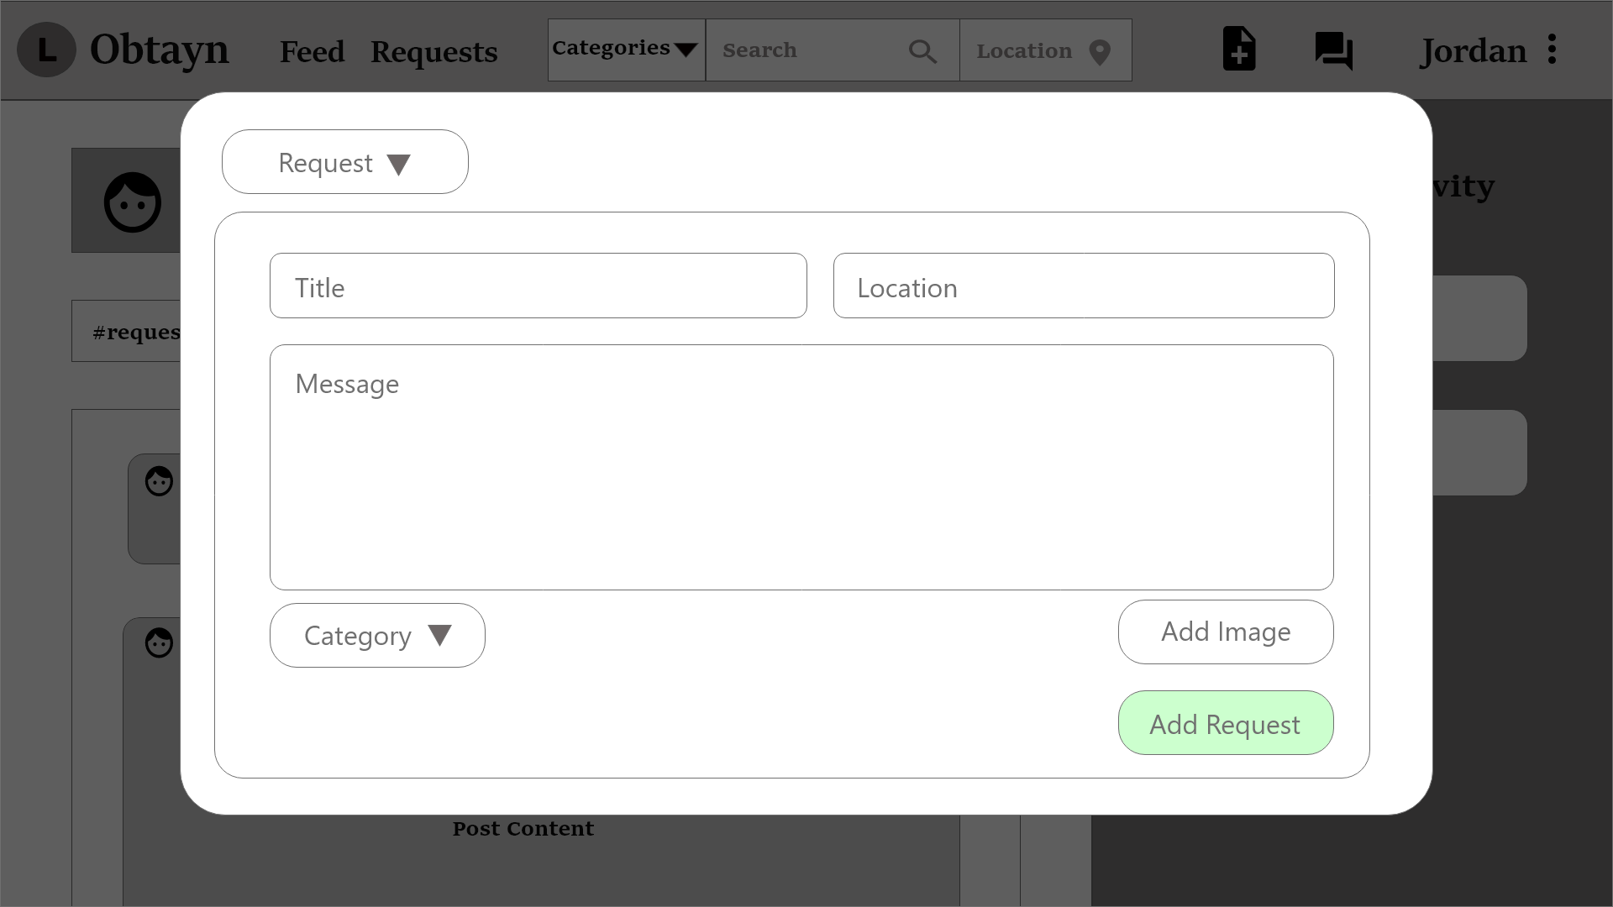

System disables User from accepting their own Request. Instead, Users can delete their Request by clicking the delete icon in the button-right corner of the post.

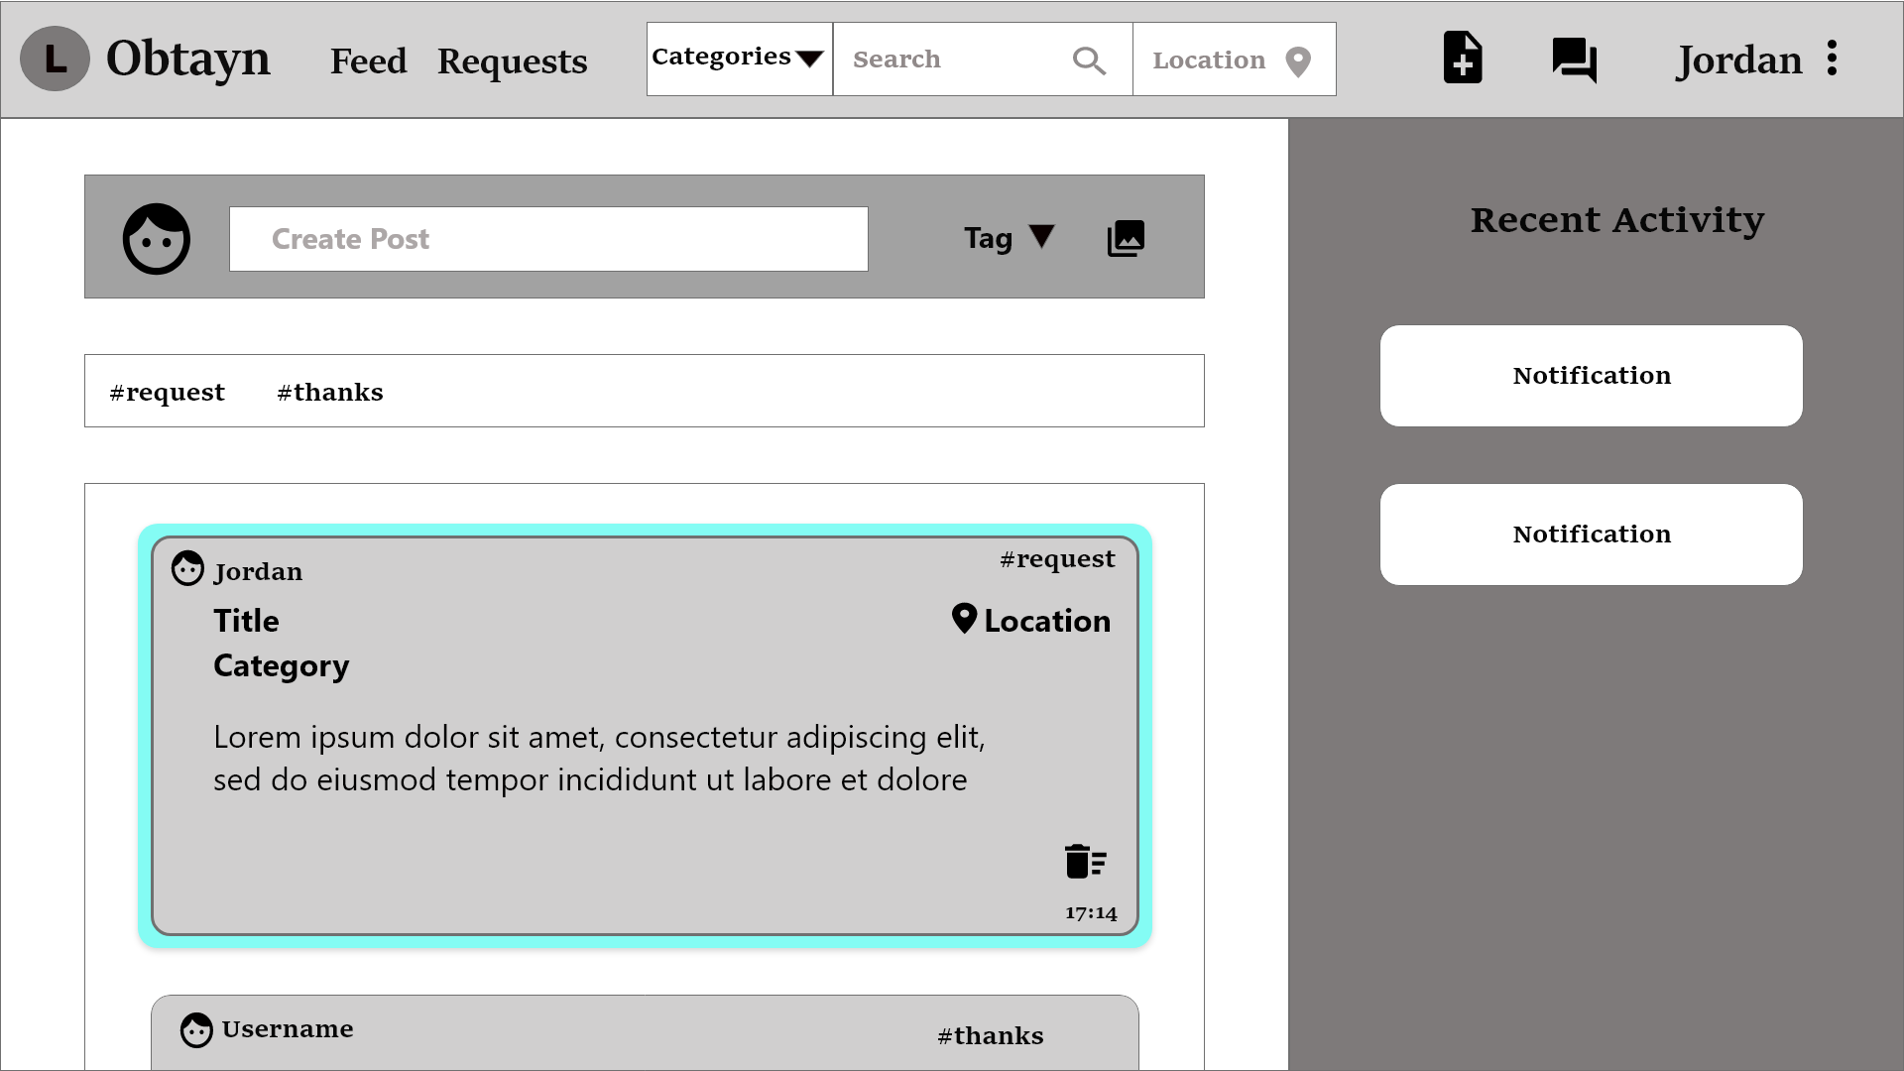
Similar to Requests, Users can delete their posts as well, by clicking the delete icon in the button-right corner of the post.

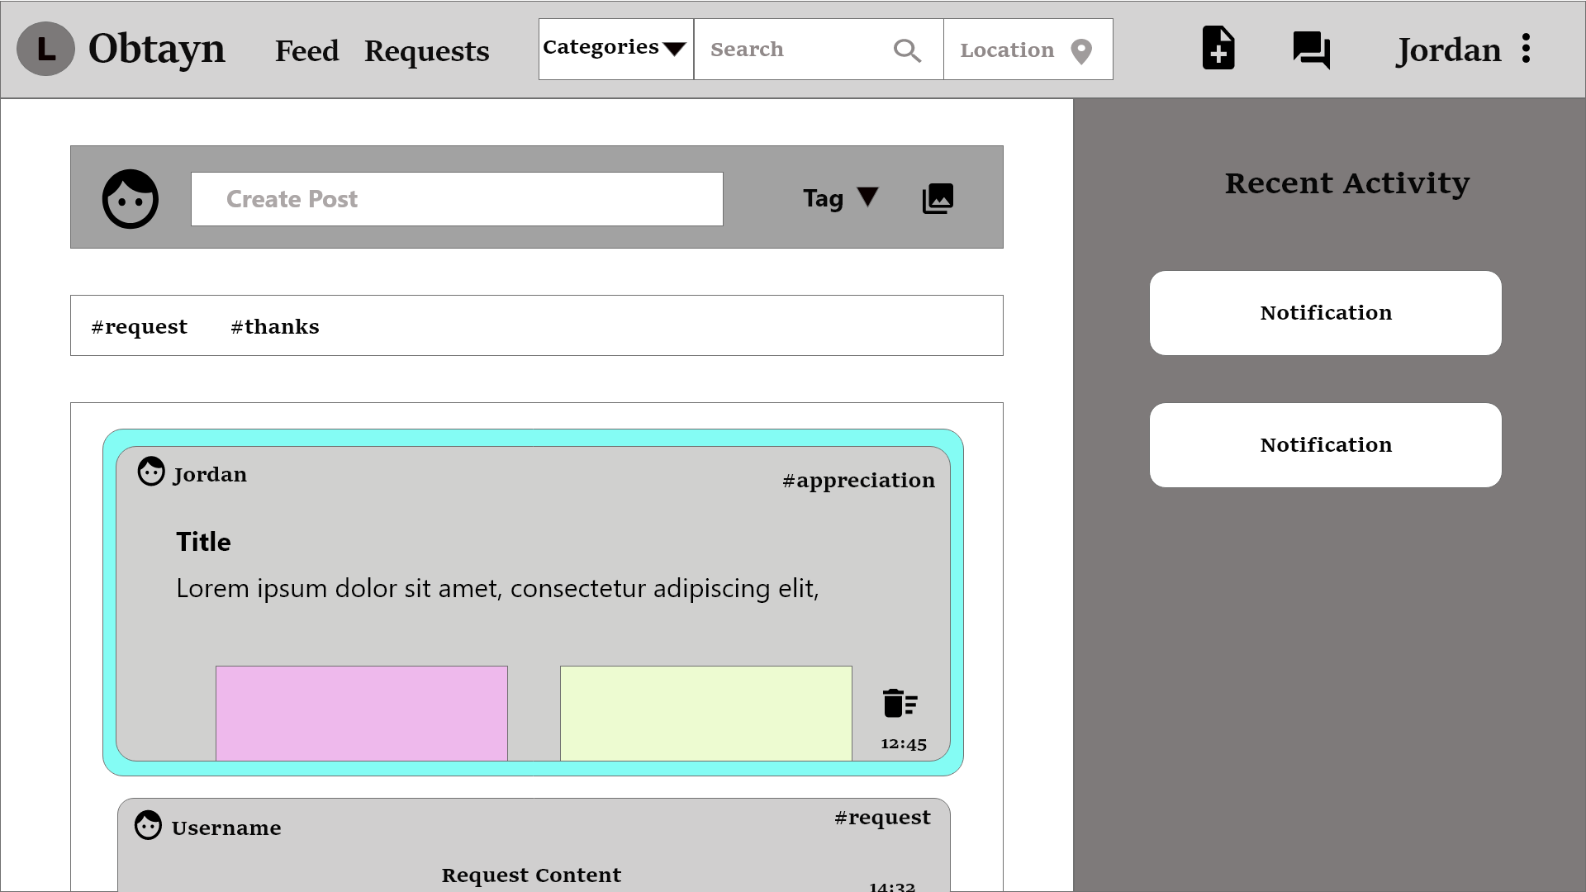

Other Users can accept Jordan’s request.

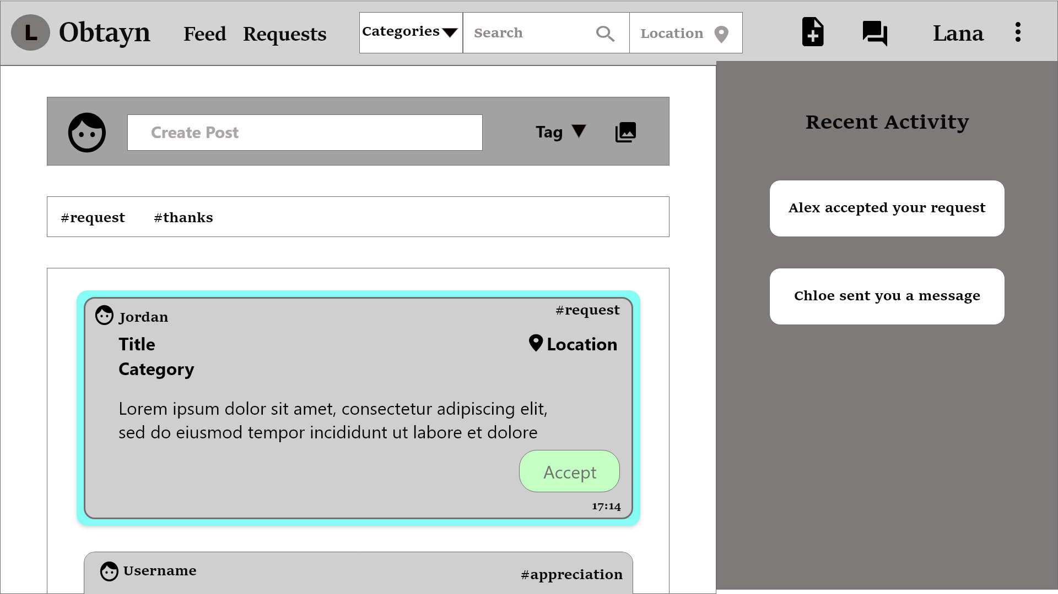

System displays a confirmation prompt when User clicks on “Accept”. If User clicks “Continue”, the corresponding request is removed from the Feed, and added to the User's Incoming Request.

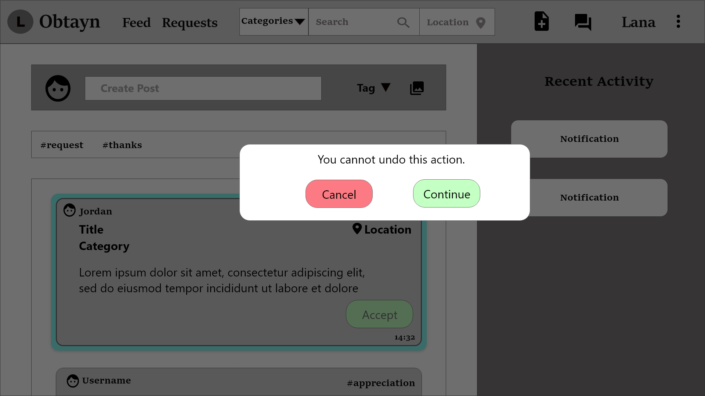

Once Users’ request is accepted, they receive a notification.

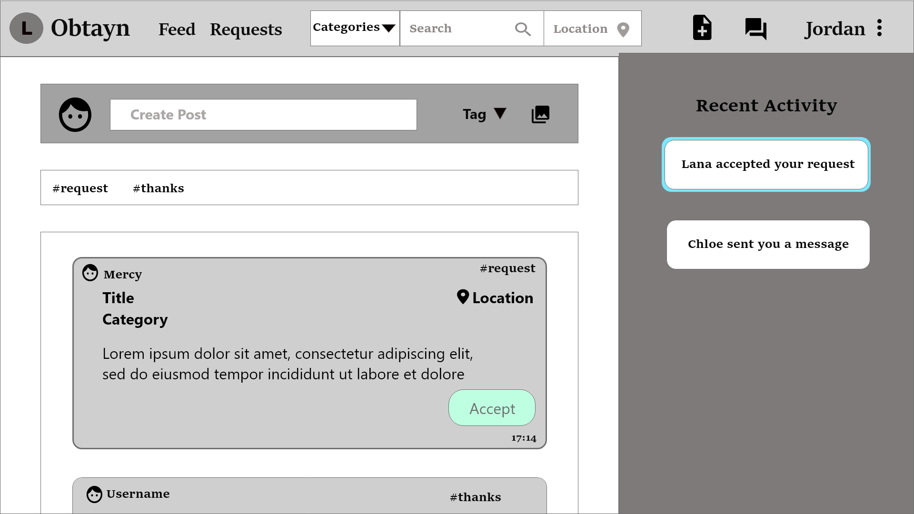
- Requests
Users can view Incoming and Outgoing requests from this page. They can also accept an incoming request.
Incoming & Outgoing requests can be of 2 types - pending & accepted. Incoming requests highlighted in green denotes that request was accepted. Outgoing requests with a smiley are User’s requests that others have accepted.
Users can mark an Outgoing Request as Fulfilled, which denotes that (s)he has received his/her item.
The Chats section shows active chats. Users cannot chat until their request gets accepted.

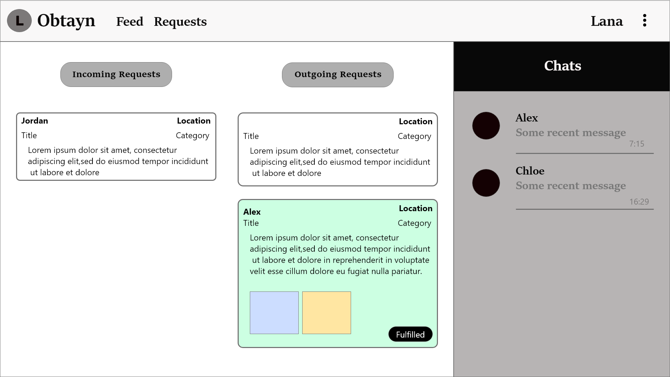Figure 4: Wireframe - Requests

When a User’s Outgoing Request is accepted, (s)he can start a conversation with the request acceptor.

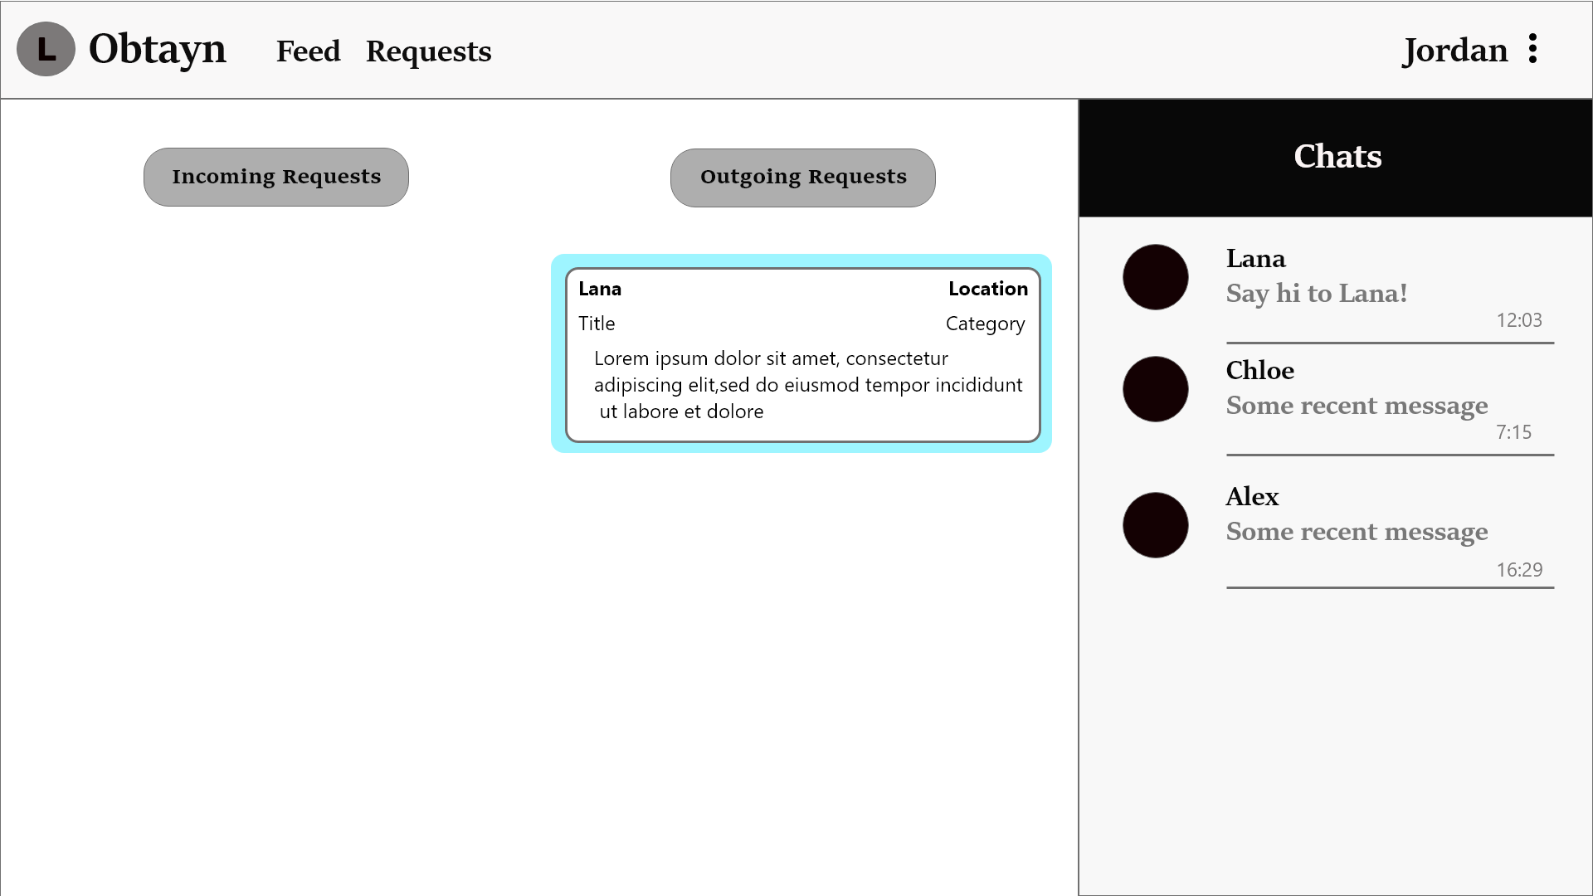
- Chat
Users can send text messages as well as images.

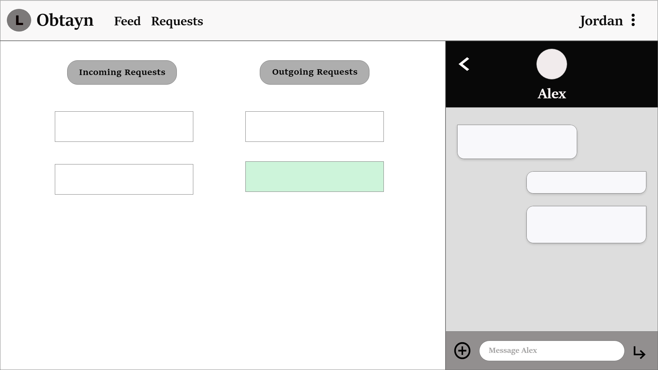

Users can also access Profile Details from the Requests page.

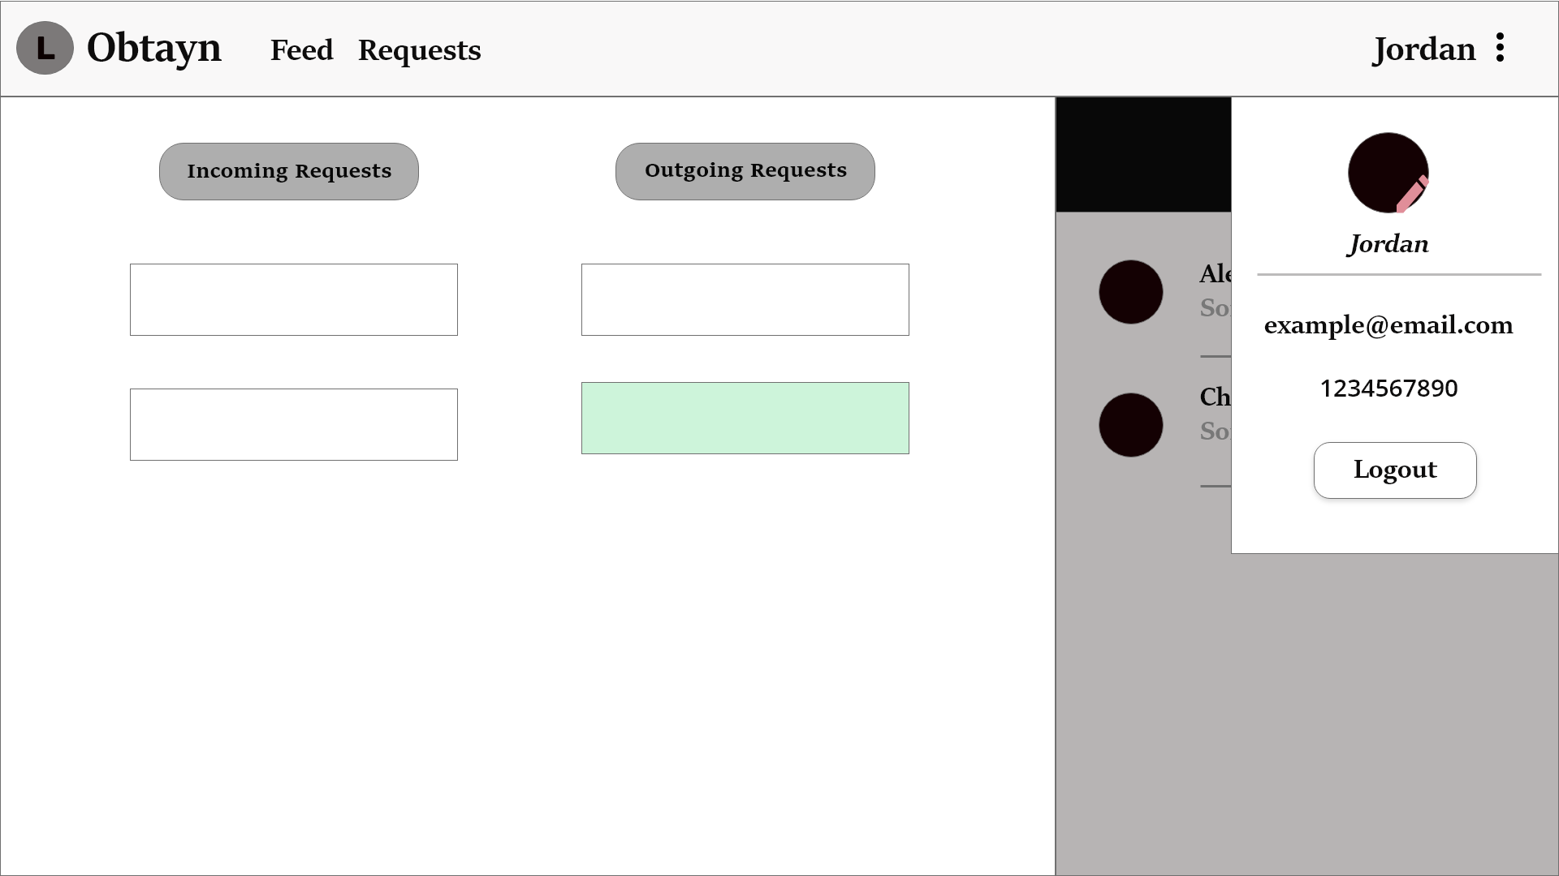

Development
{Add introduction}
Application flow
In order to access the Feed, Users need to log into the application. This can be done in multiple ways -new Users can register by filling out details in the Sign Up form, existing Users can login with their email & password or they can login using Google account
In case Users forget their password, they can also reset it using the “Forgot Password” button.

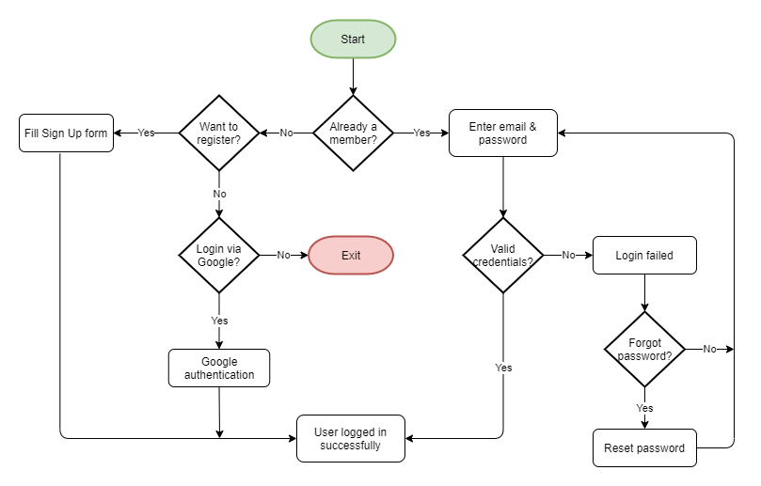Figure 5: Flowchart

Once Users are logged in, they are redirected to the Feed page, which is also the homepage of the application.
Users can now perform following actions -
- Scroll Feed to view various requests & posts
- Search for a particular request/post on the Feed
- Filter the Feed to view only requests or only posts
- Accept a request and chat with the User
- View notifications and check requests/messages related to that notification
- Add a new request/post
- Delete their own request/post
- View all requests (Accepted & Outgoing)
- Filter Outgoing requests into Pending & Fulfilled
- Mark their Outgoing request as fulfilled
- Chat with other Users

Application features
This is the landing page i.e. the first page Users land on when they visit our website. It contains the brand name, greeting message & login form by default.
Users can either login using their email, or simply use their Google account. They can also reset their password, if needed.
Landing Page
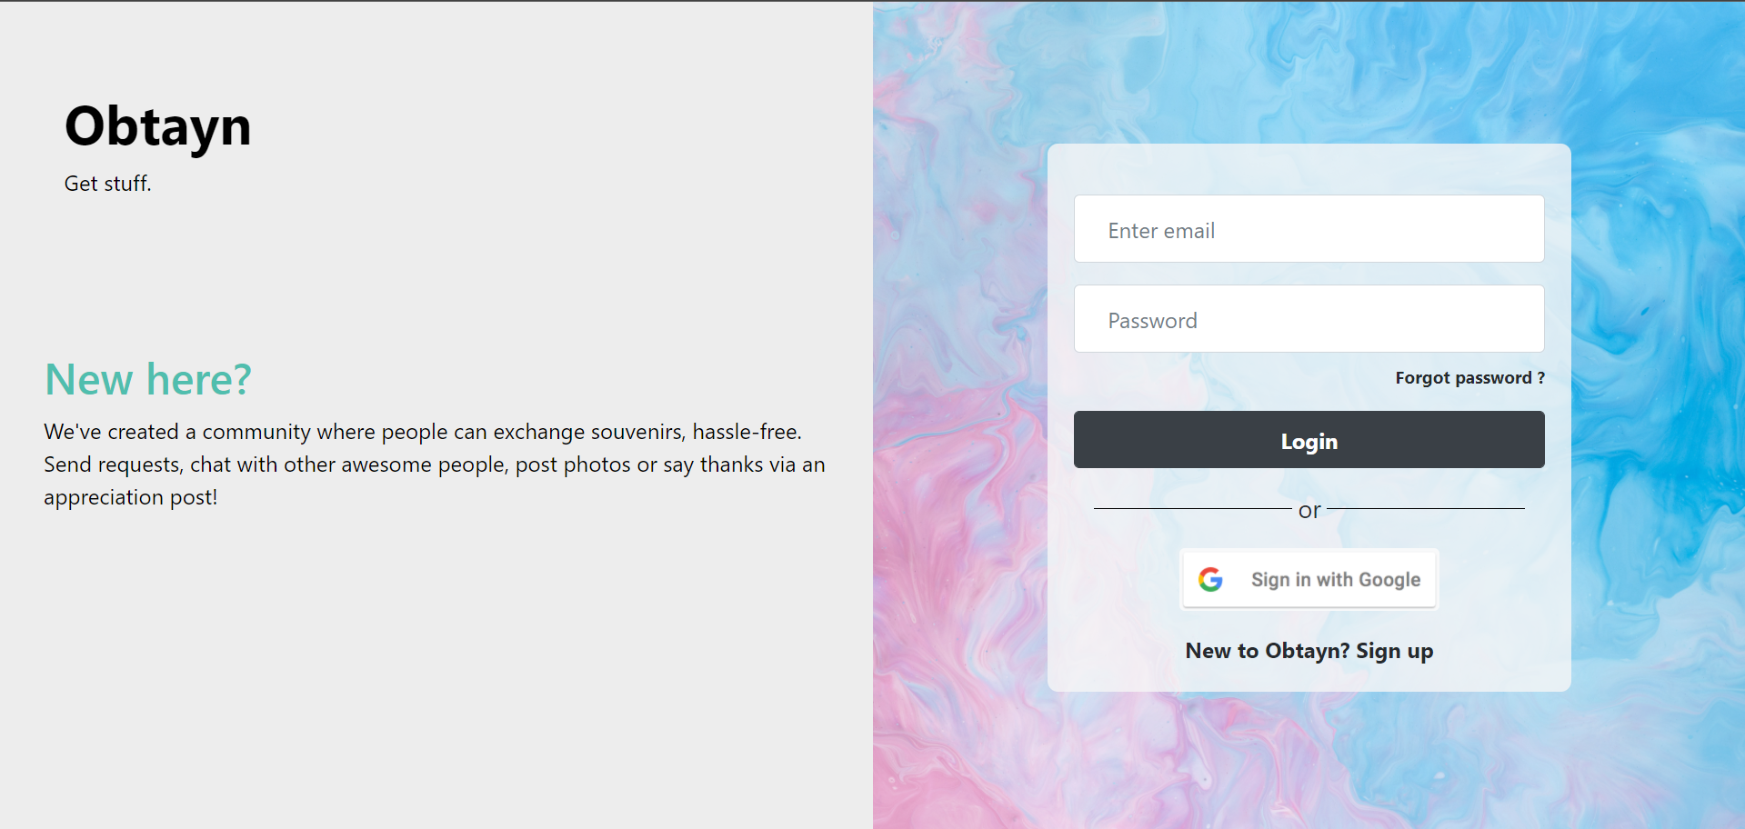Figure 6: Landing Page
Sign Up, Login & Validations

All form fields are validated to ensure that Users do not submit incomplete or incorrect information.
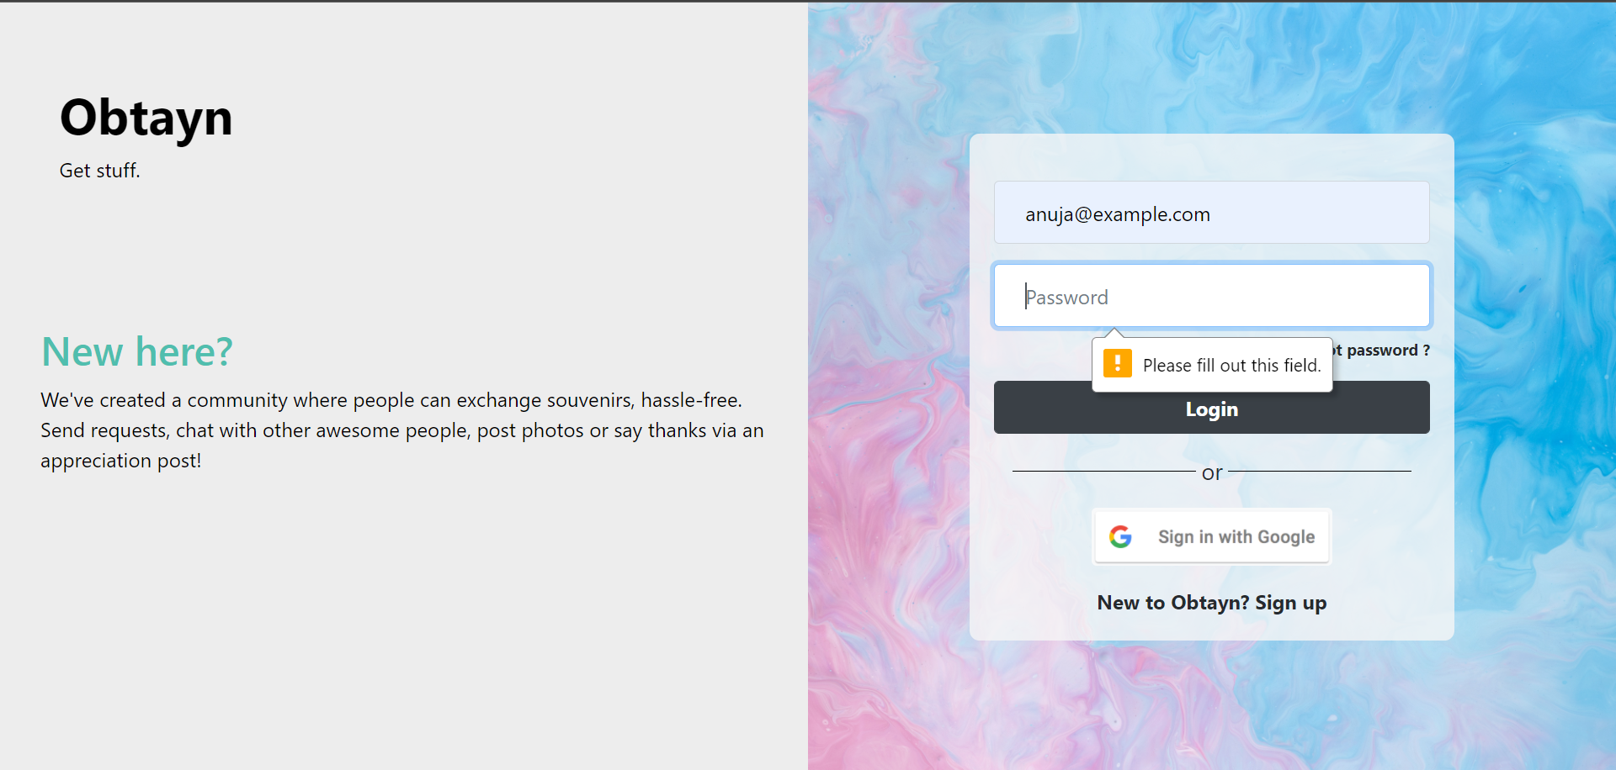
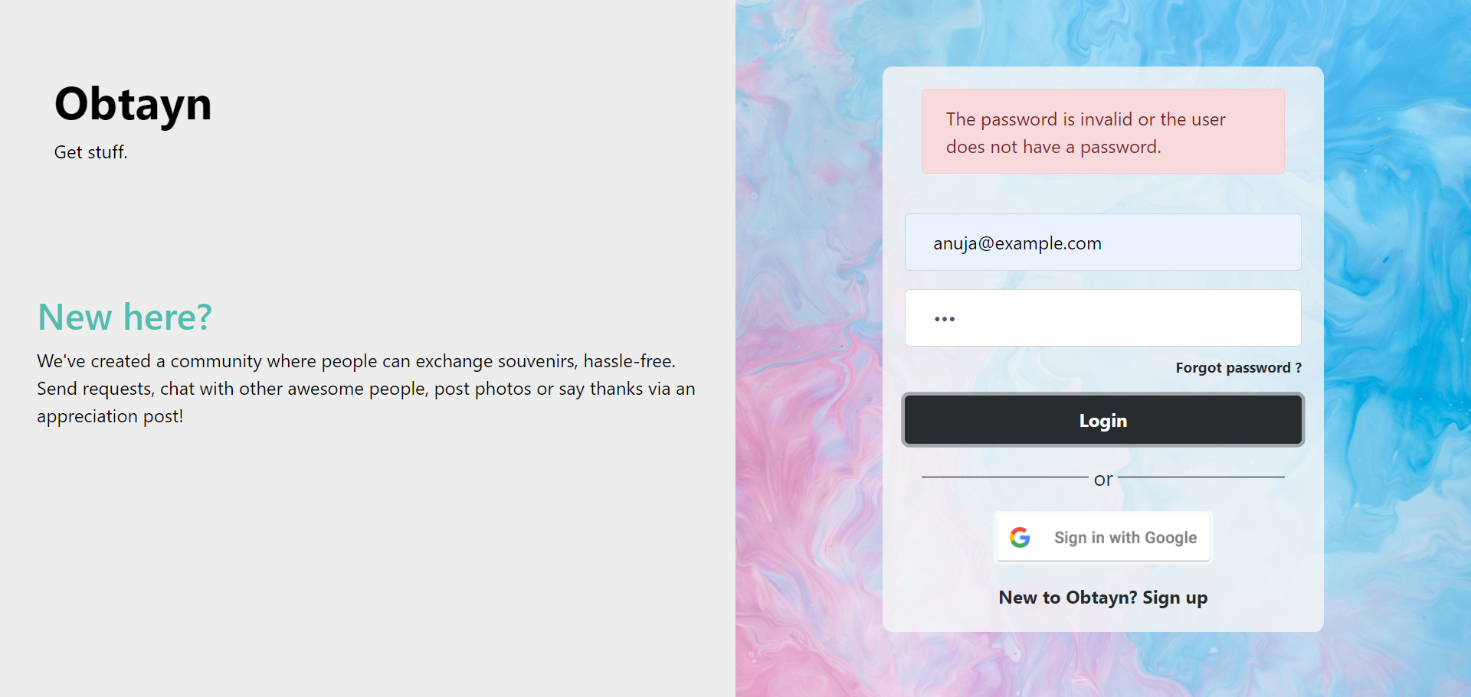
New Users can create account by switching to Sign Up form and filling in the required data. They can also use their Google account to directly login.
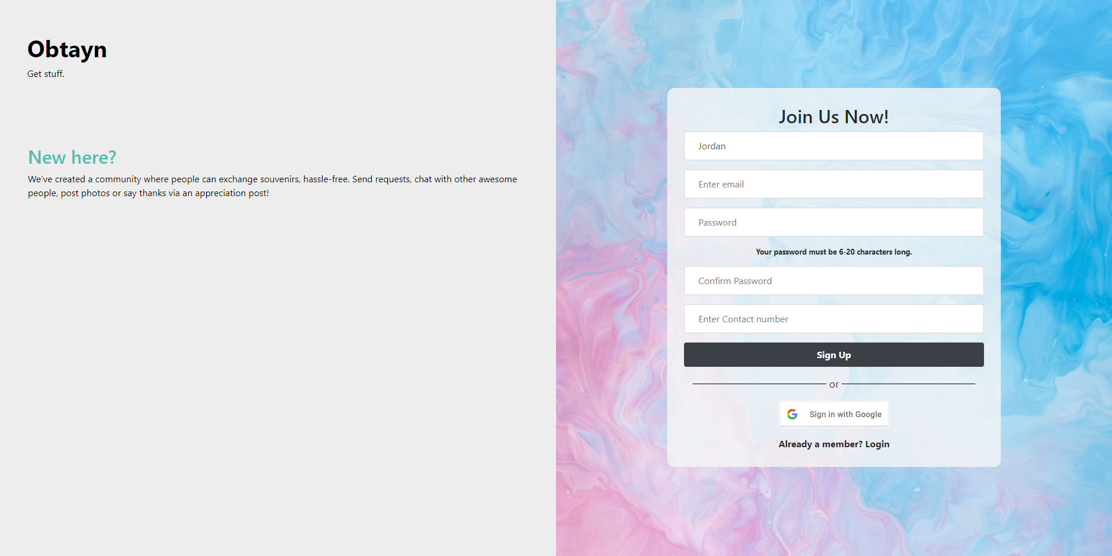
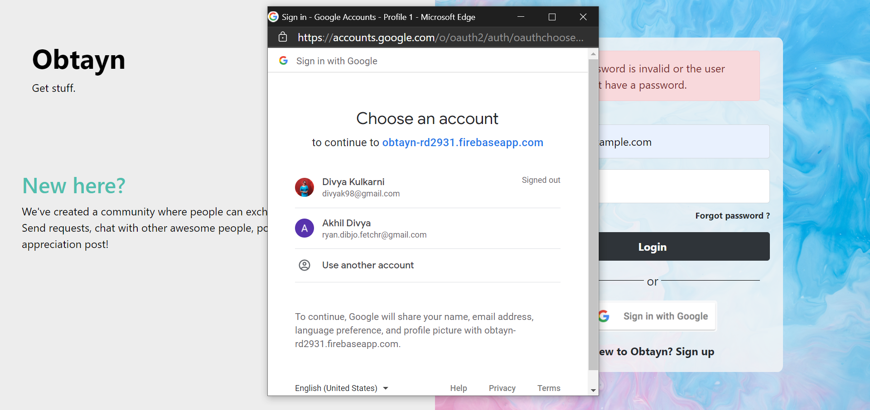

Sign Up form contains length restrictions on password.

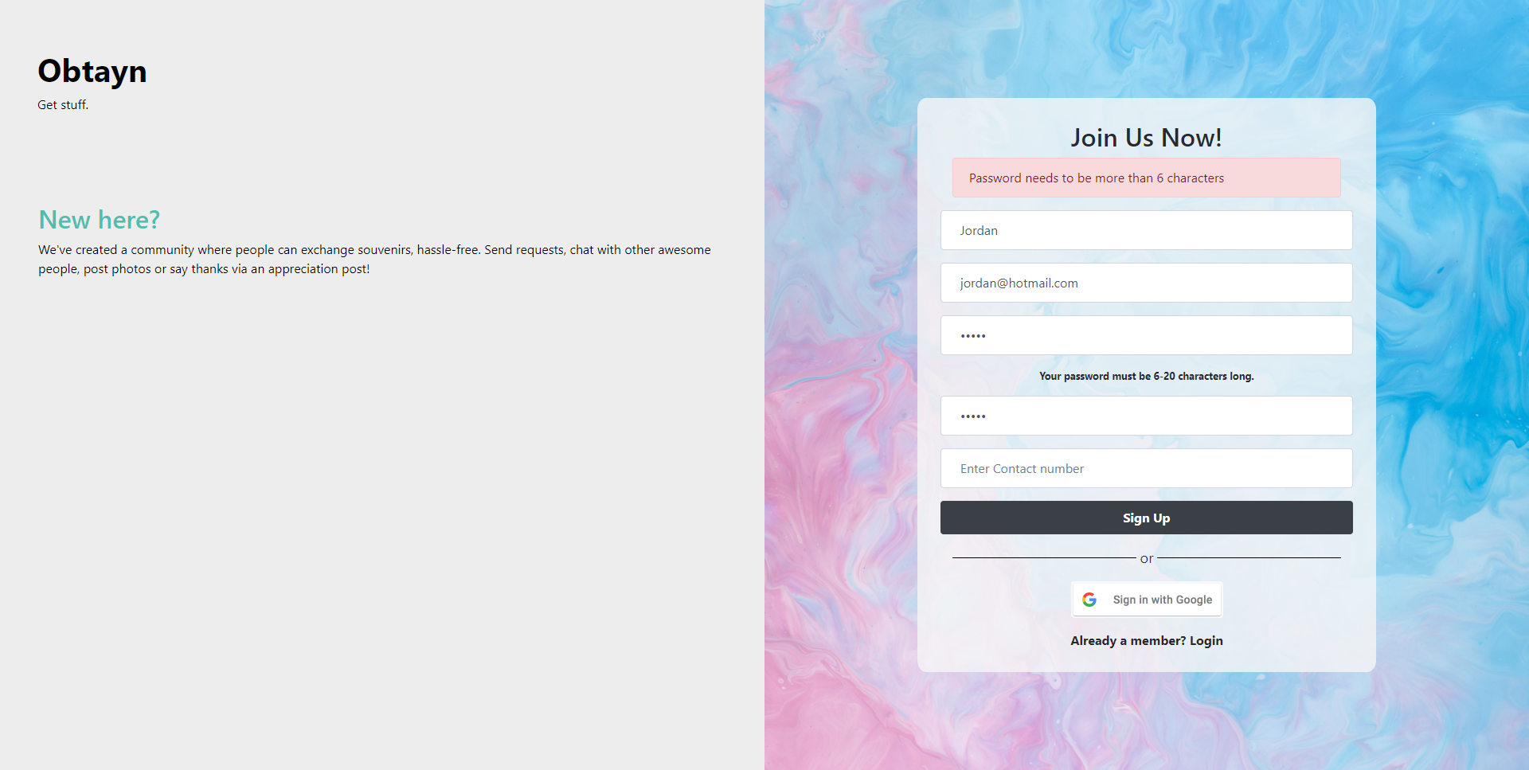
Since login is handled via email, multiple Users cannot use the same email to Sign up.

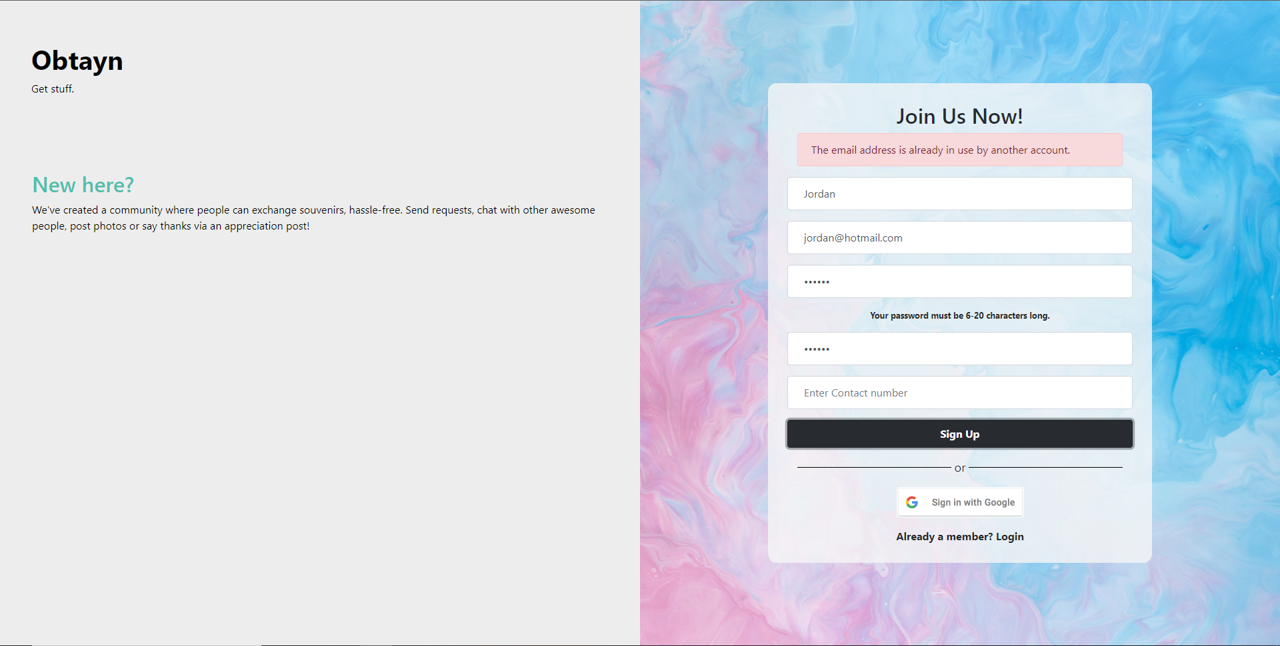

Users can reset their passwords if needed.

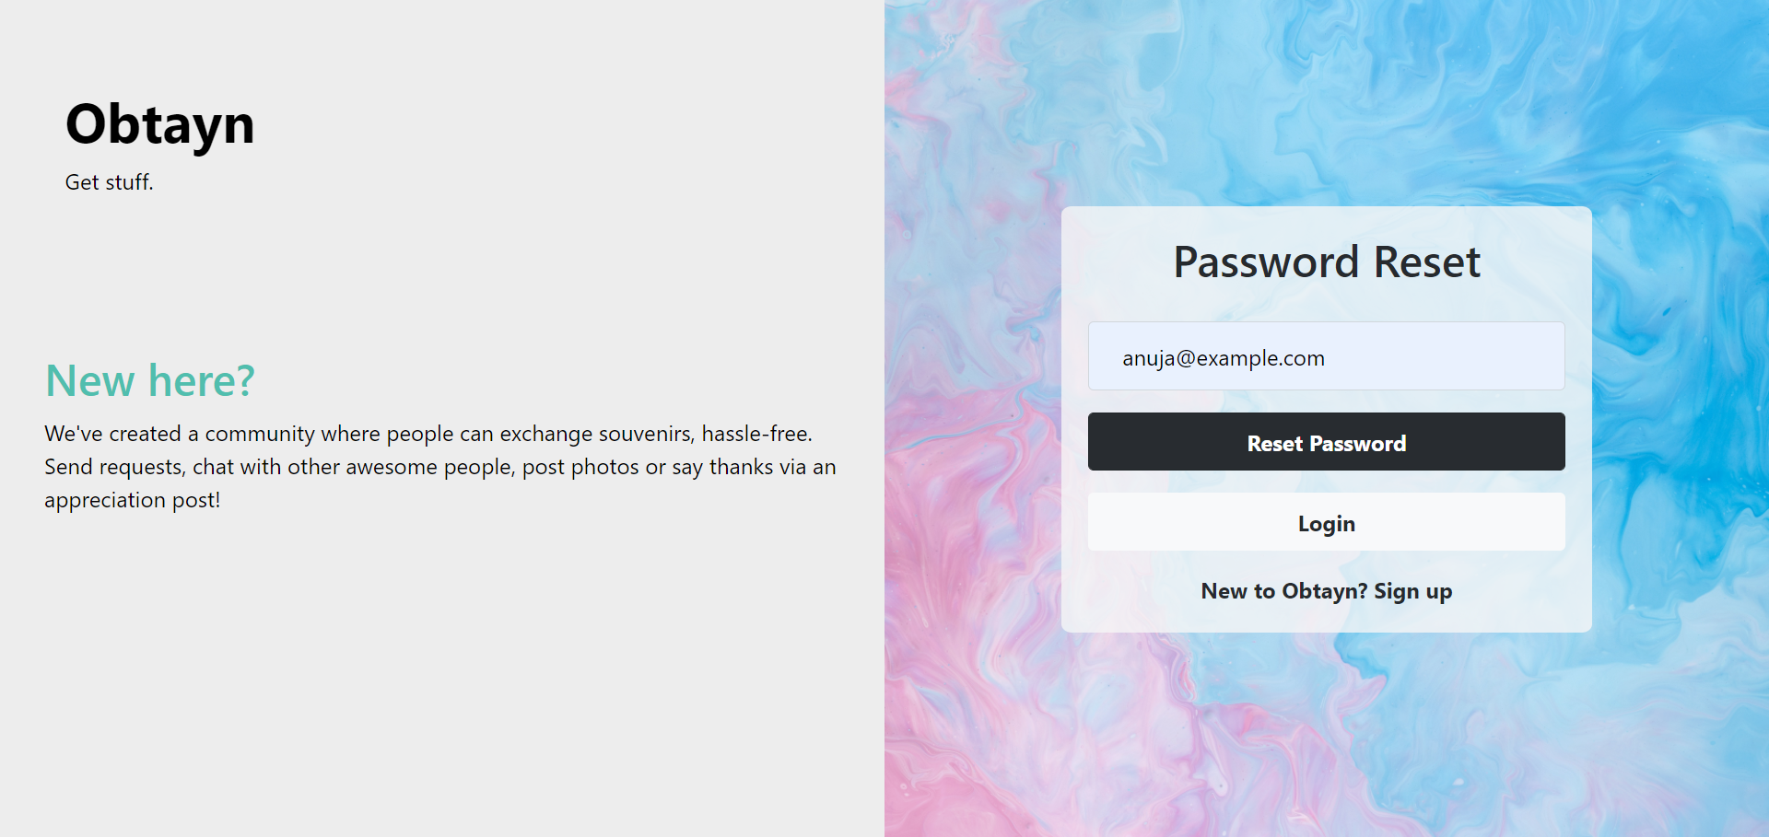

Homepage (Feed)
After successful login, Users are redirected to the homepage i.e. the Feed. It contains
- a header with brand name & various shortcuts - My Requests tab, Notifications button, New Post button, Chat button & User profile
- Search bar, so the Users can search for specific posts
- Filter, to view only Requests or Posts
- Feed containing all Requests & Posts
- Back to Top button, which scrolls to the top of the page

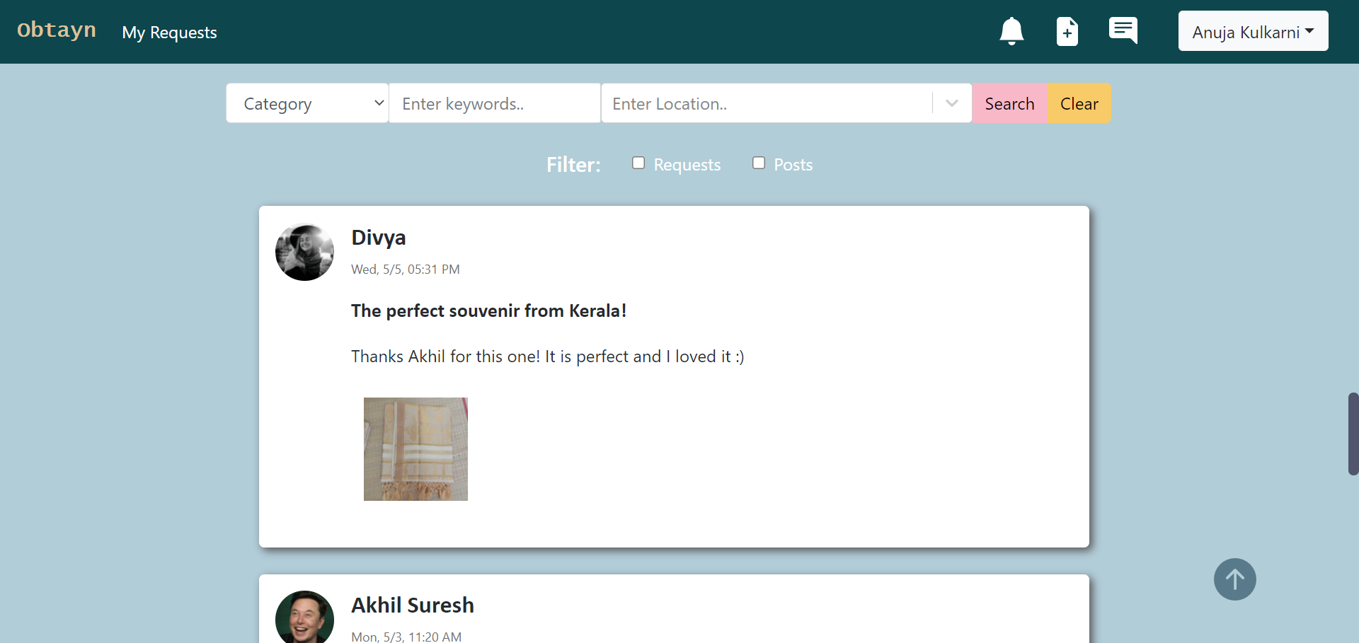Figure 7: Screenshots - Feed

Notifications
When Users click on the bell icon in the header, they see a sidebar containing most recent notifications. These notifications can be cleared individually or dismissed all at once.

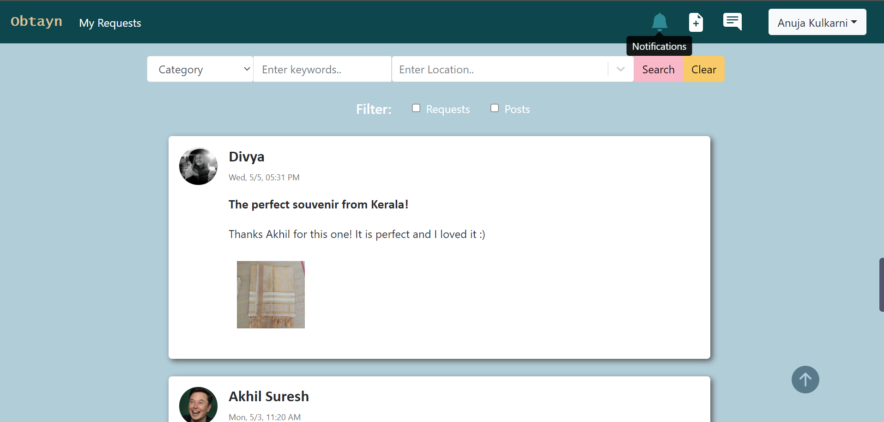

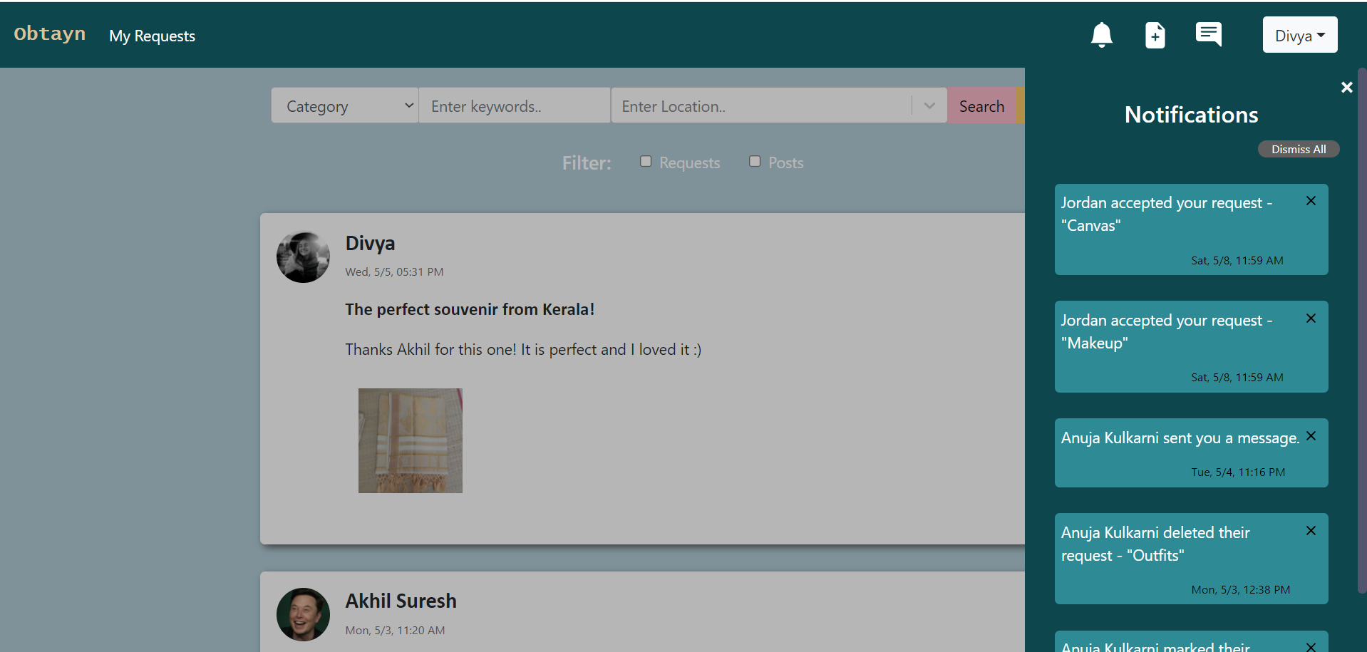
Add Request/Post
When Users click on the New Post button in the header, they are redirected to a new page. This page contains a form to add a new Request or Post. System shows Request form by default.

Users can fill various details such as title, location, message and can also add up to 3 images.
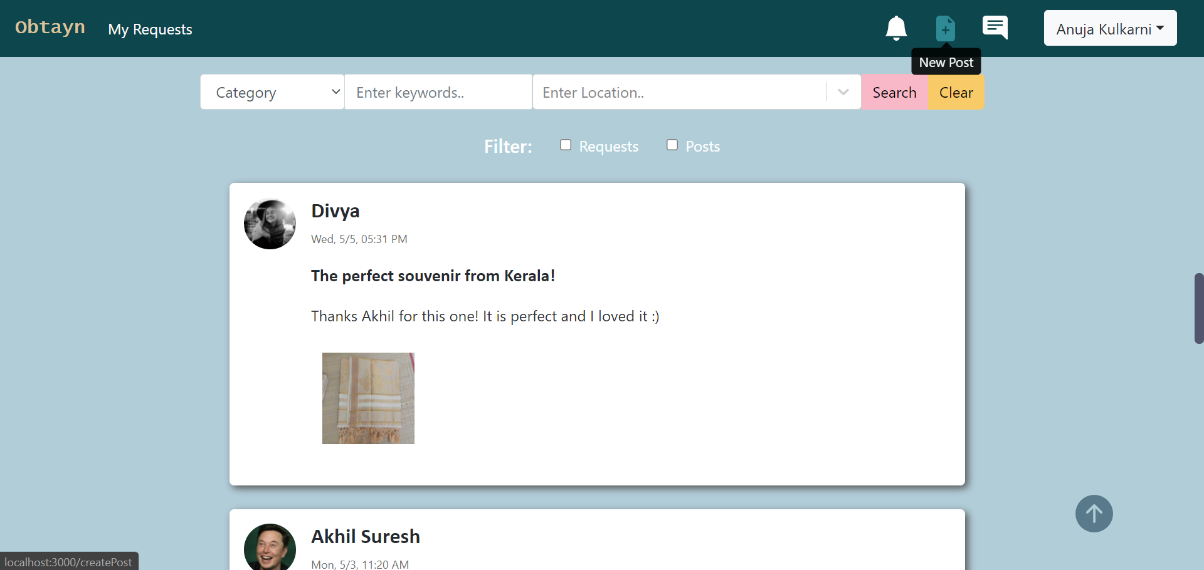Figure 8: Screenshots - Create Post
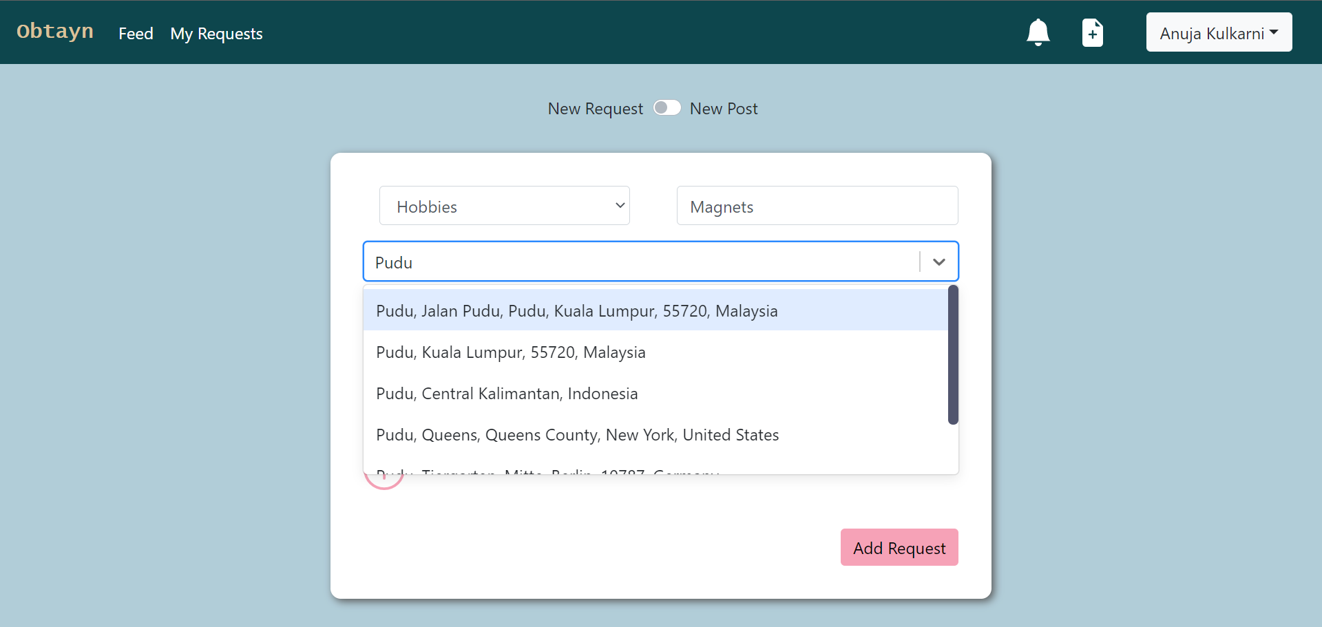
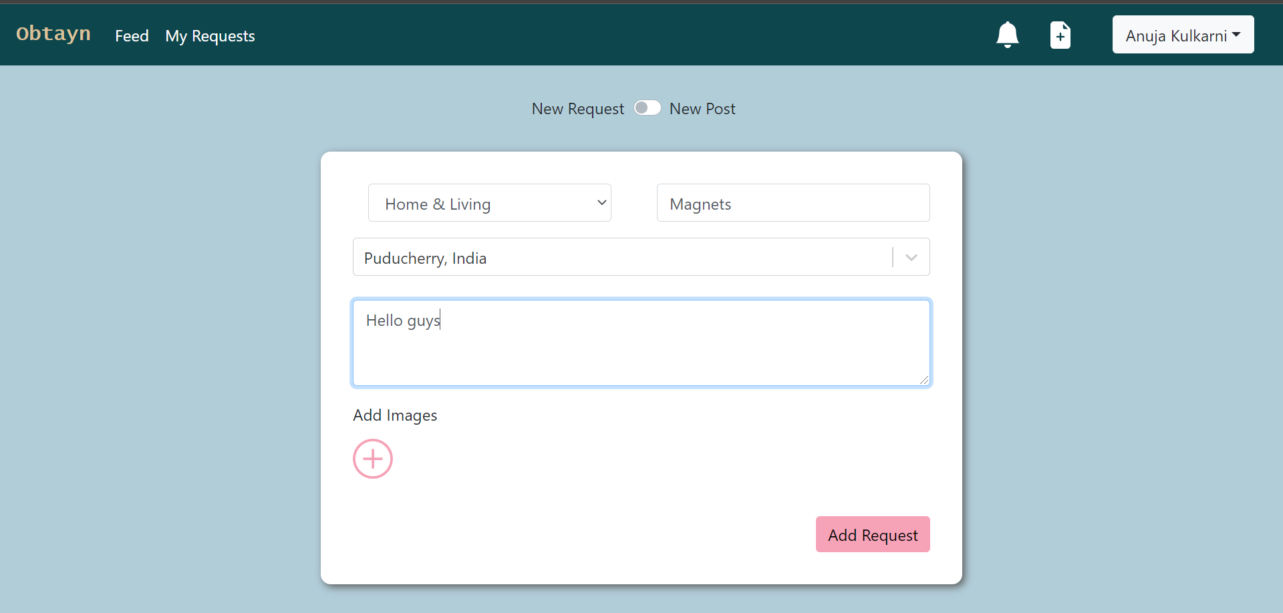

Users cannot upload any other files, except those of PNG or JPG format. Maximum 3 images can be added.
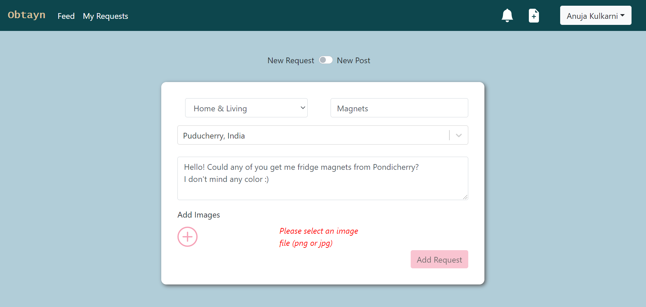

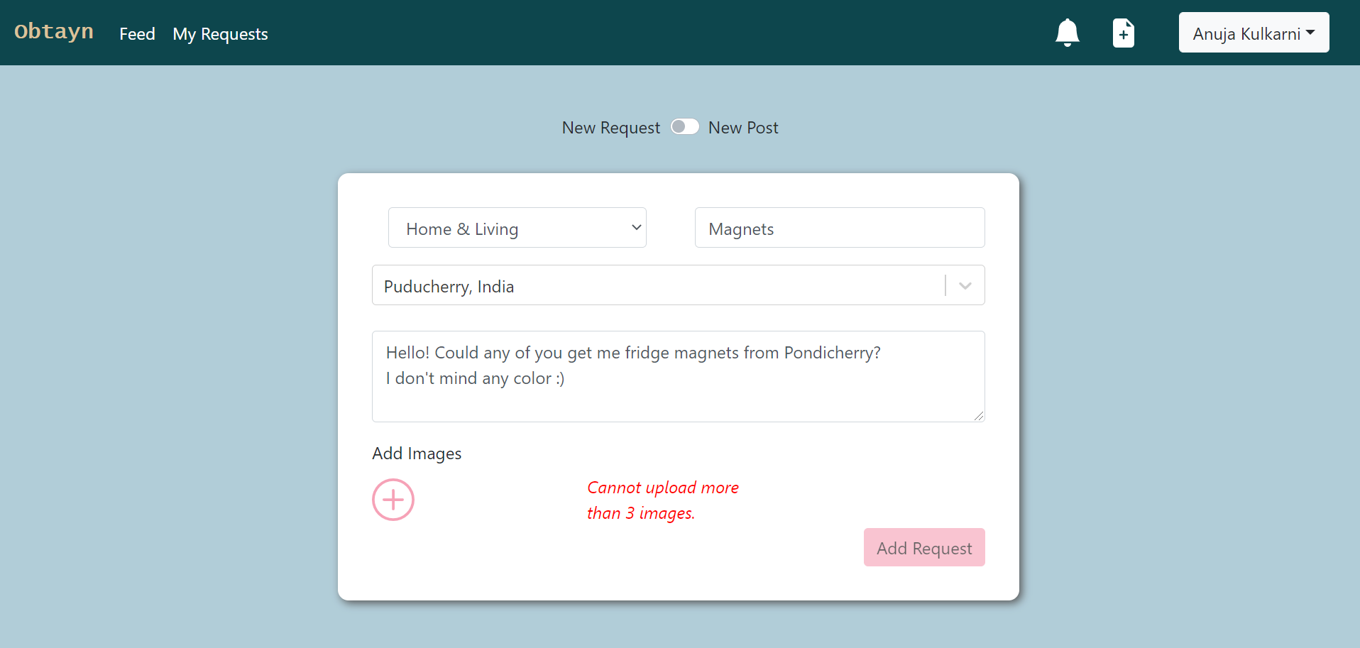

After filling required fields, when User clicks on Add Request, User is redirected to Feed, where the it appears on top of the Feed.
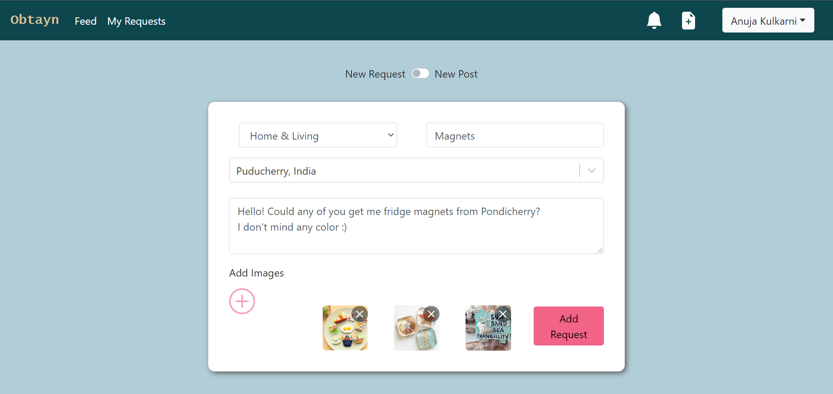

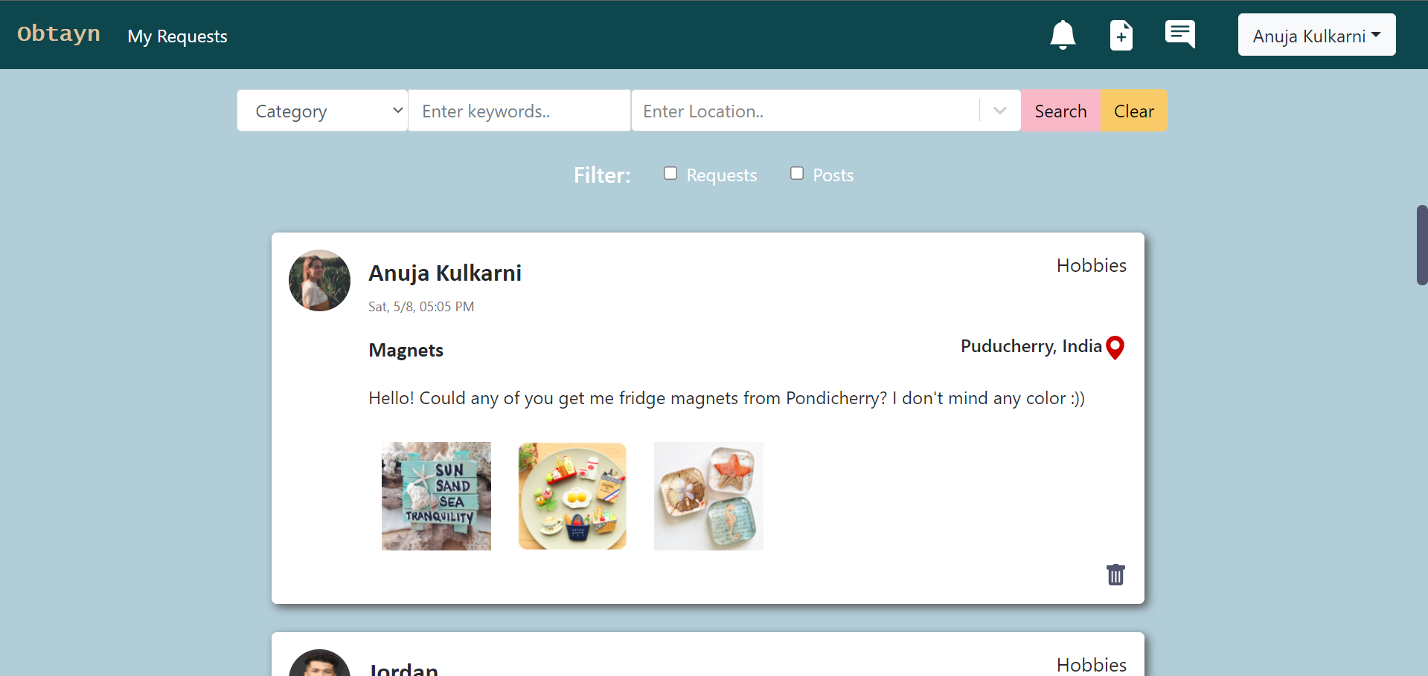

Users can switch to Post form using the switch above the form.
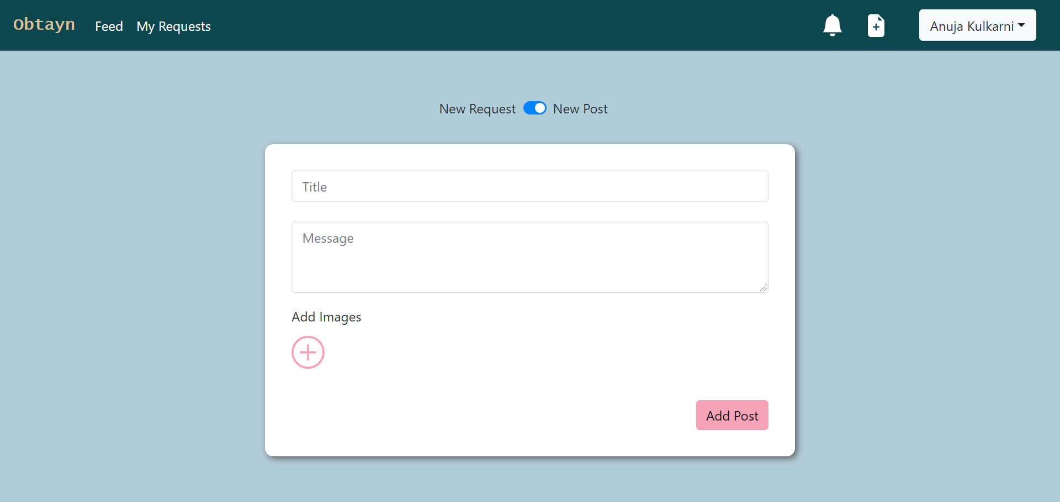

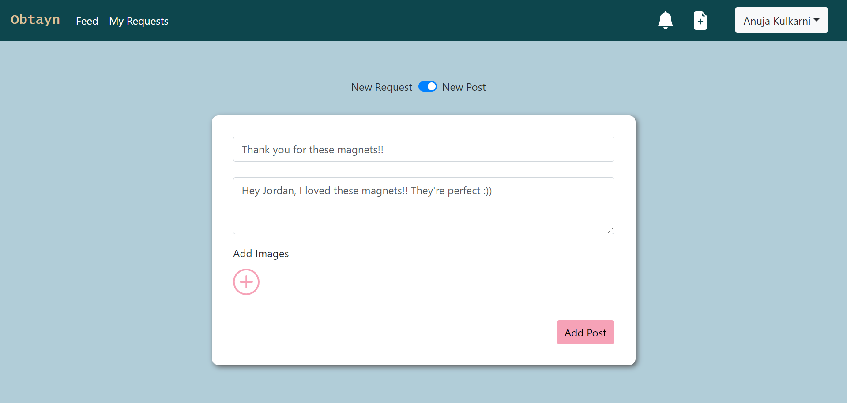

Post appears on the Feed after clicking on Add Post.
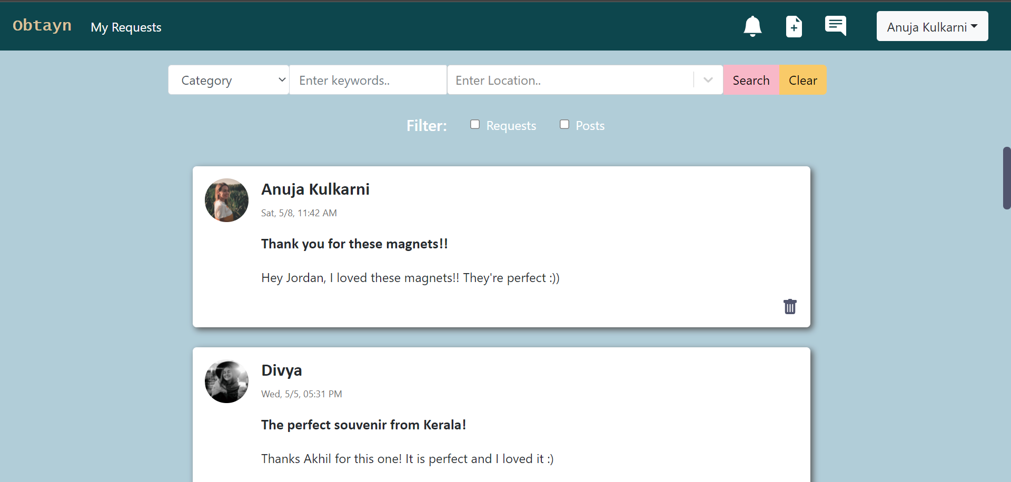
Accept Request
Users can accept a request by clicking on the “Accept” button on a request.
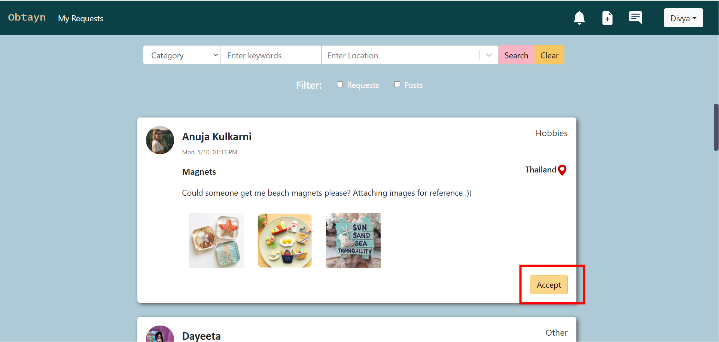
System shows confirm messages. On clicking Yes, selected request is removed from Feed.
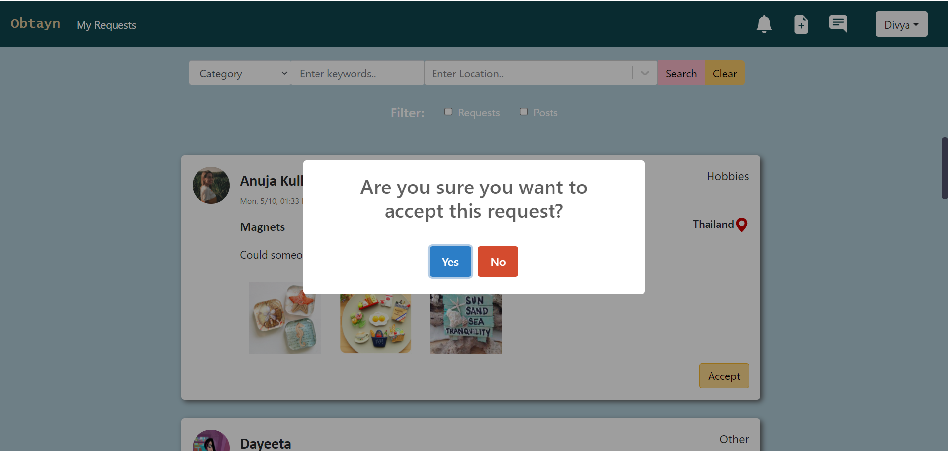
The new request appears in “Accepted Requests” lists in the My Requests tab for the User who has accepted.

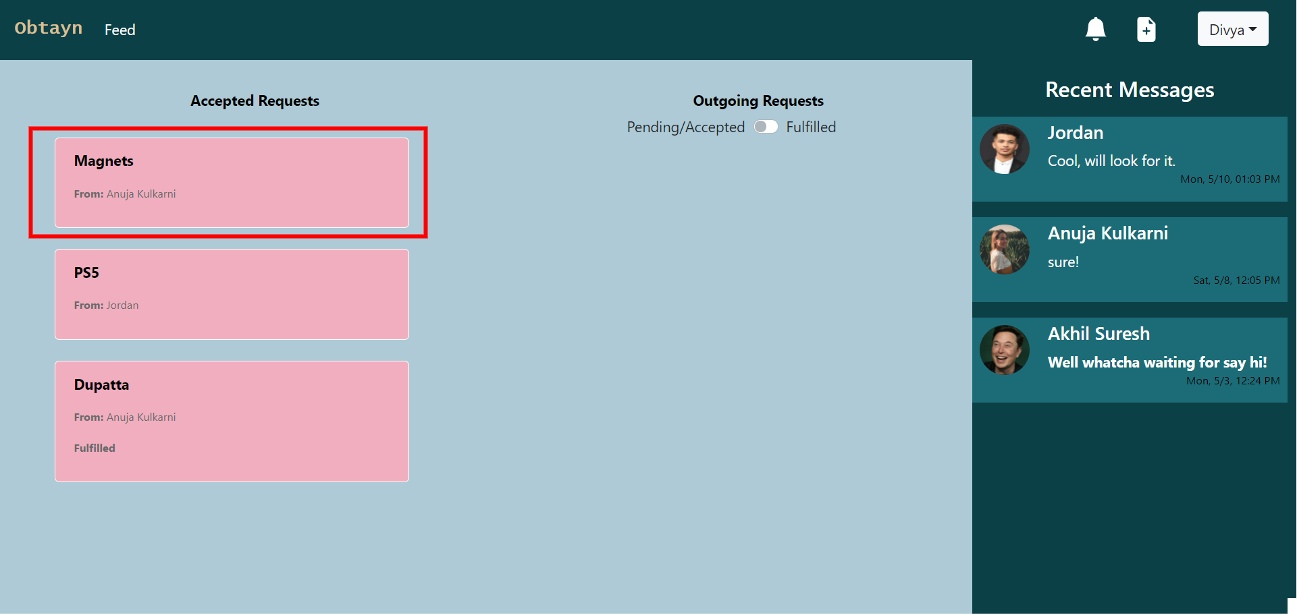
Request sender also receives a notifications regarding requests.

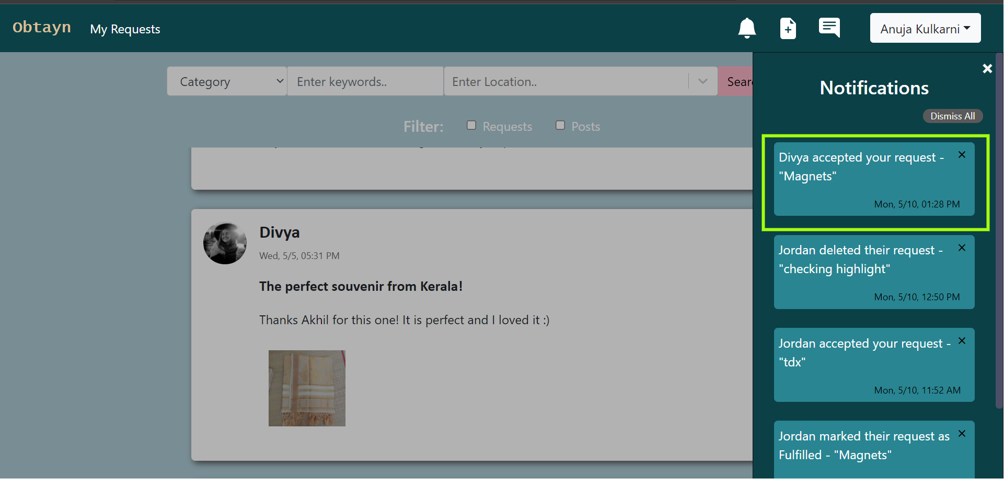
By clicking on the notification, sender is redirected to My Requests tab, with the concerned request highlighted.
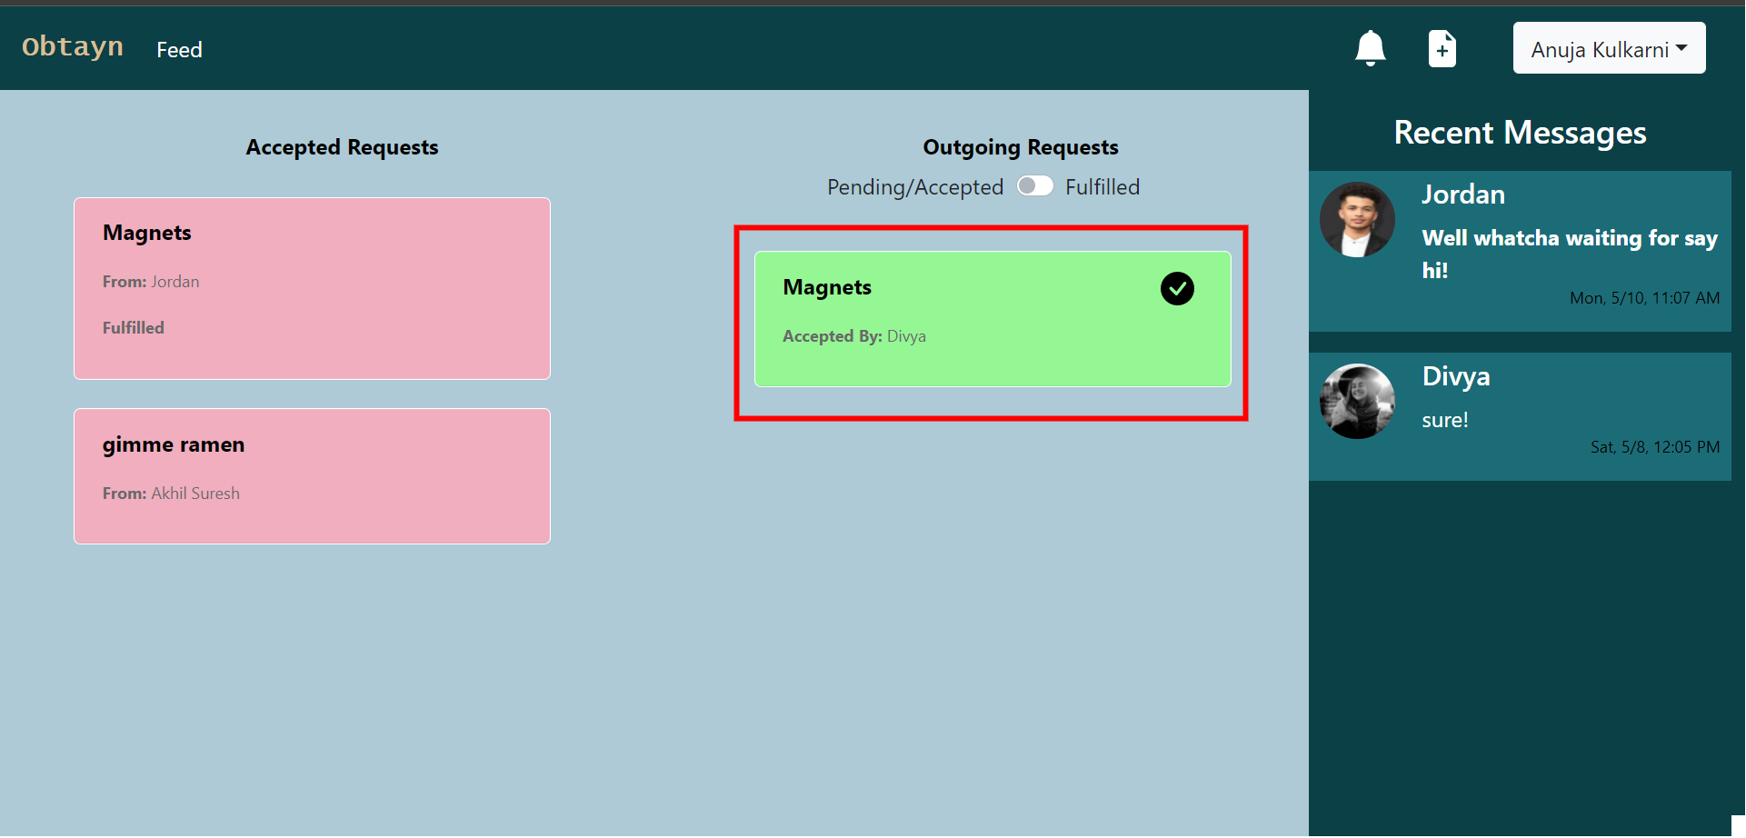
Delete Request
Users can delete their own Requests and Posts by clicking on the bin icon at the bottom of the post. It removes the Request/Post from the Feed.
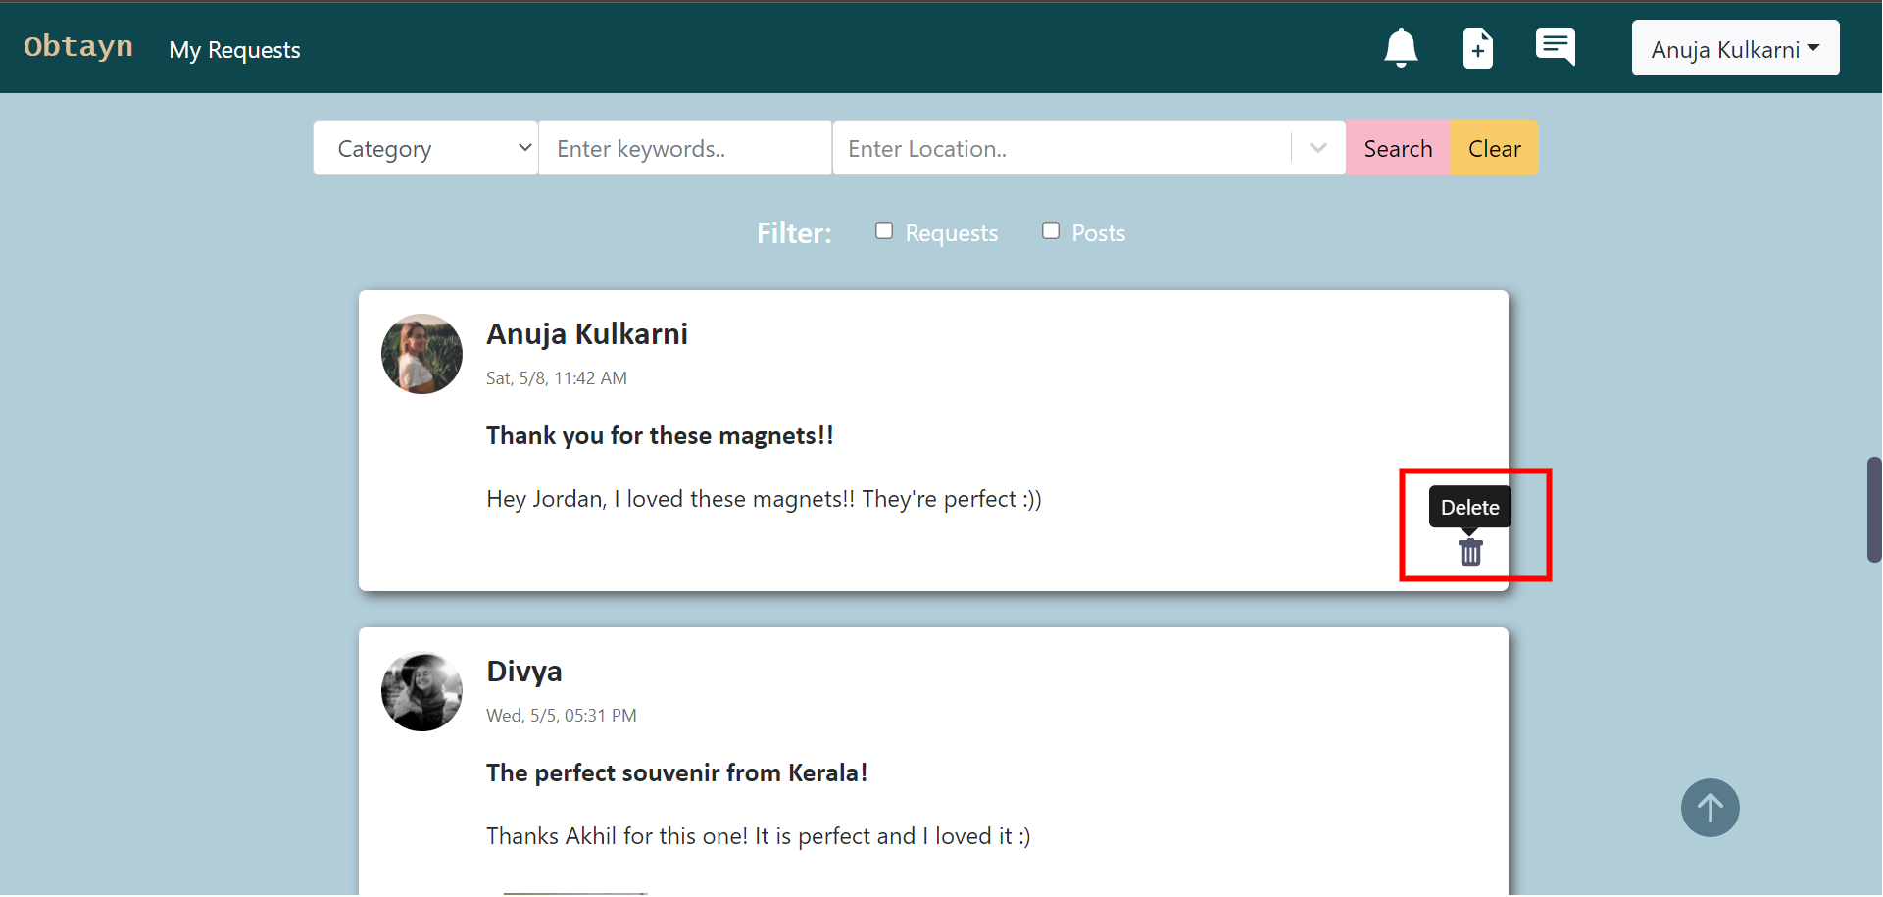
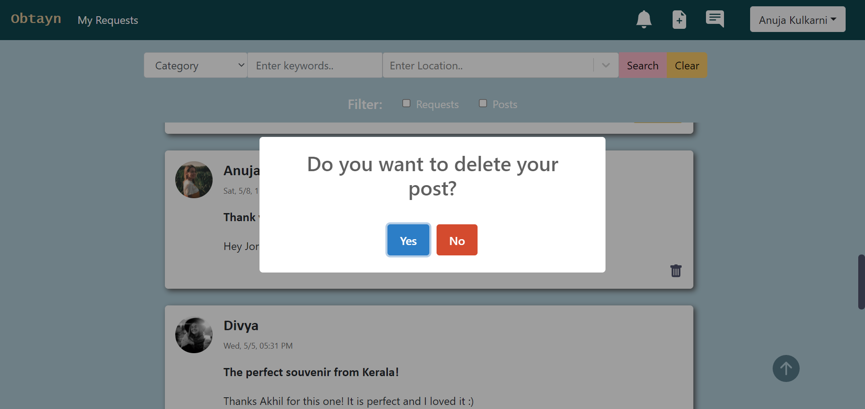
Edit Profile
By clicking on the username in the header, Users can view their profile details such as current profile picture, name, email, contact number (if provided)
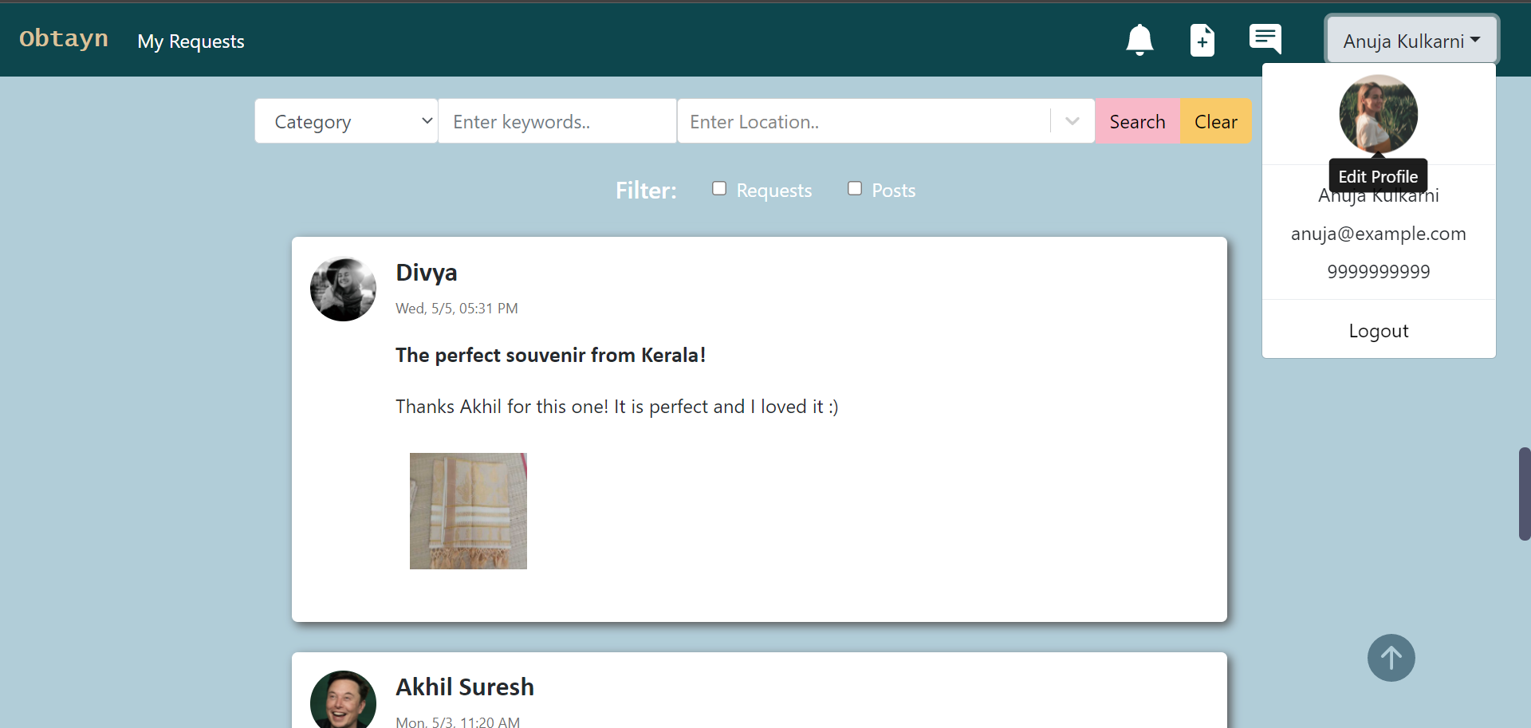Figure 9: Screenshots - Edit Profile
User can edit all profile details, except email address.

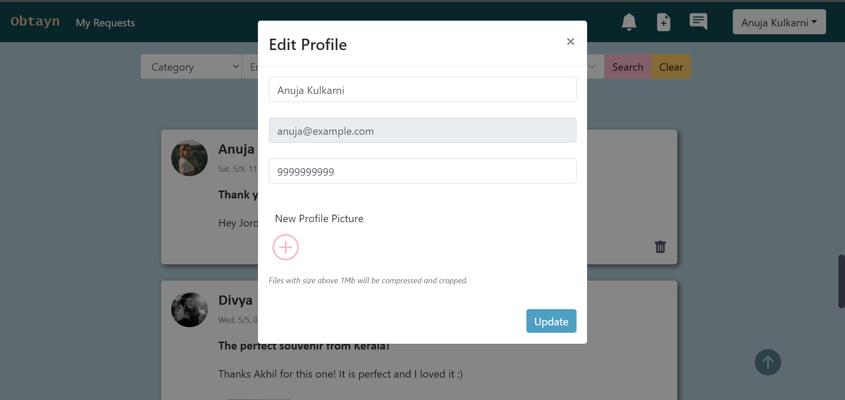
User can set new profile photo by clicking on the “+” icon. This opens a file browser, and on selecting an image, User can see a small preview of the one he has selected.

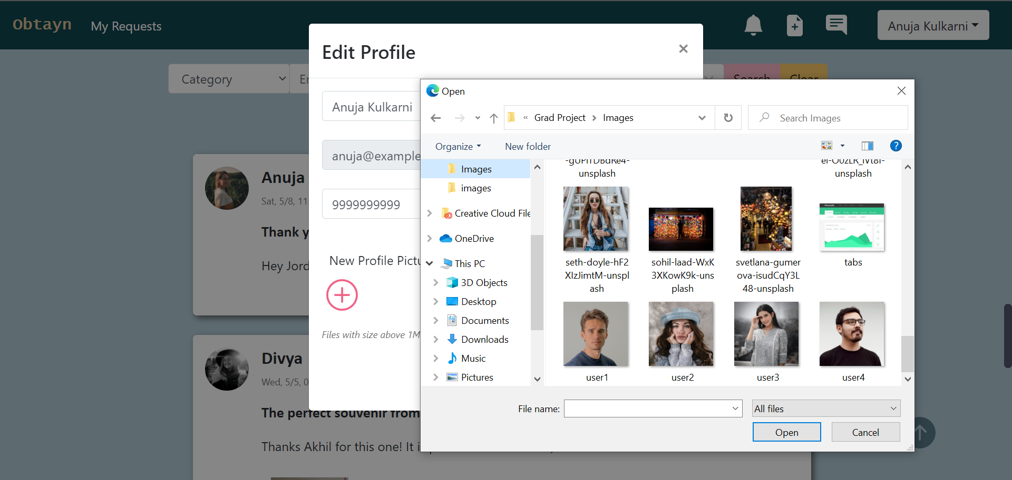

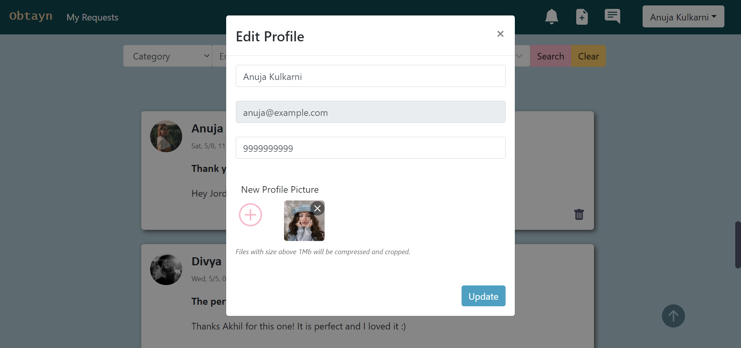

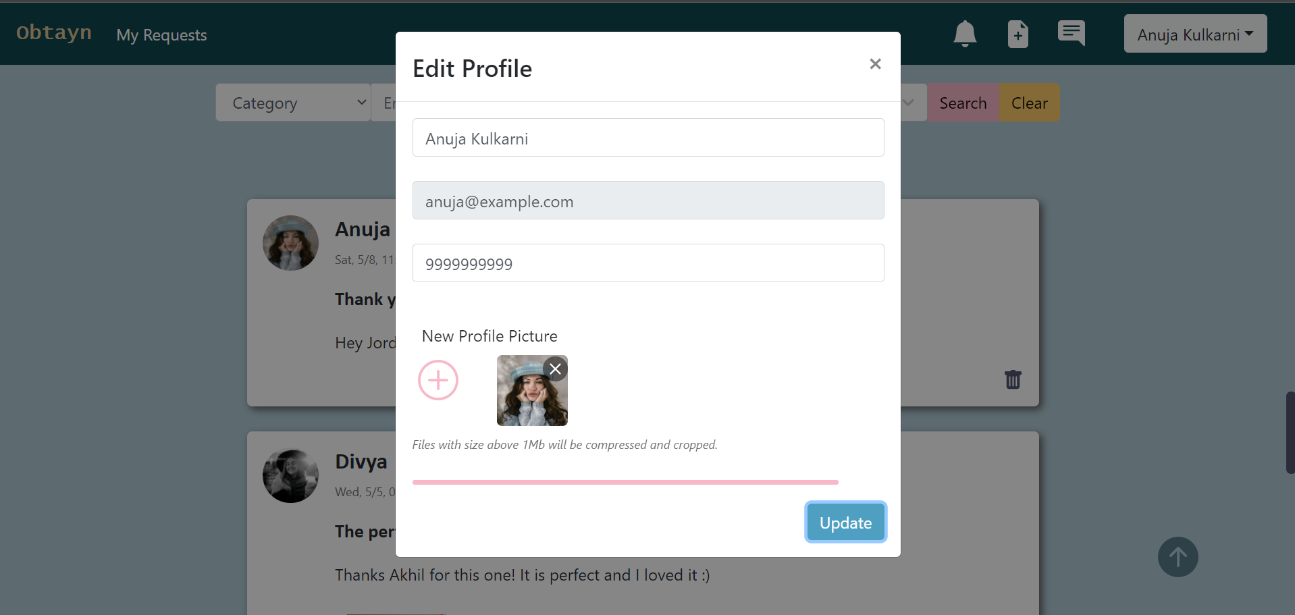
System shows a progress bar, denoting image upload progress. Once image is uploaded, profile details are updated.
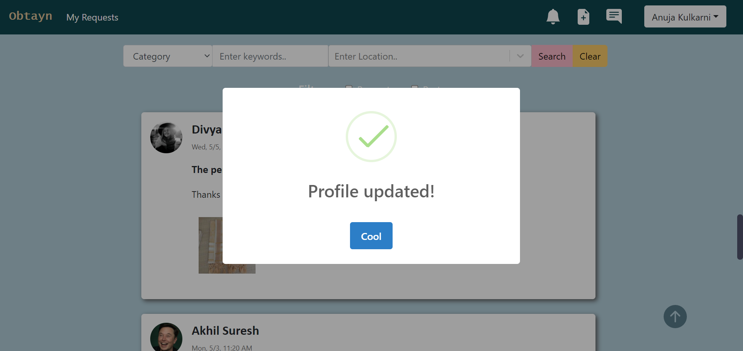

Edit Profile form contains validations such as
- Contact number should be in digits only, and 10 digit long.
- Selected file must be an image of PNG or JPG format.
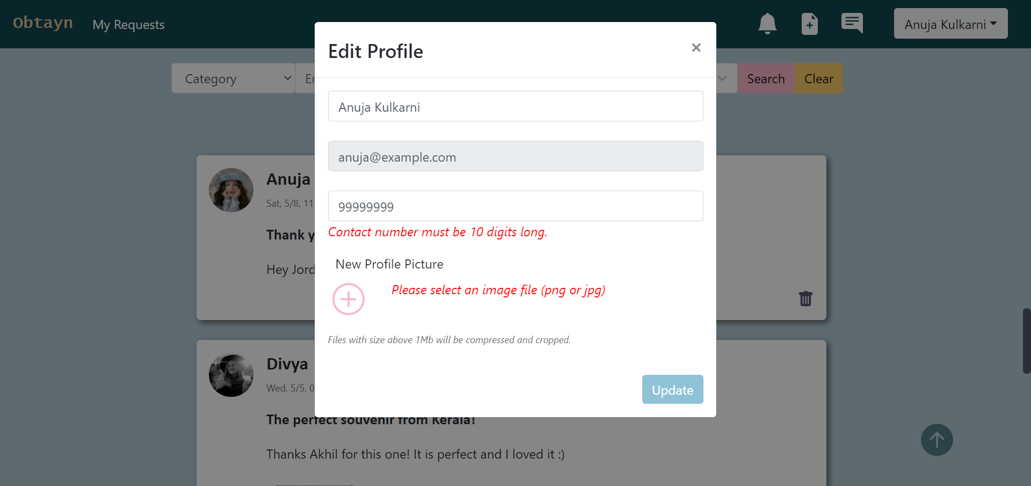
Search

Users can search for a specific post by either choosing a category, entering keywords, or picking a location, or all three. System displays relevant results.

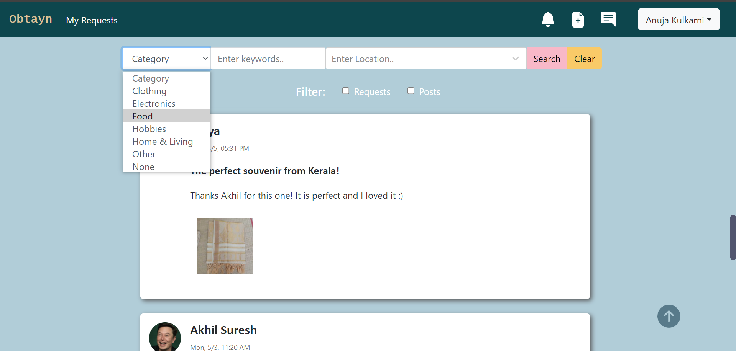Figure 10: Screenshots - Search

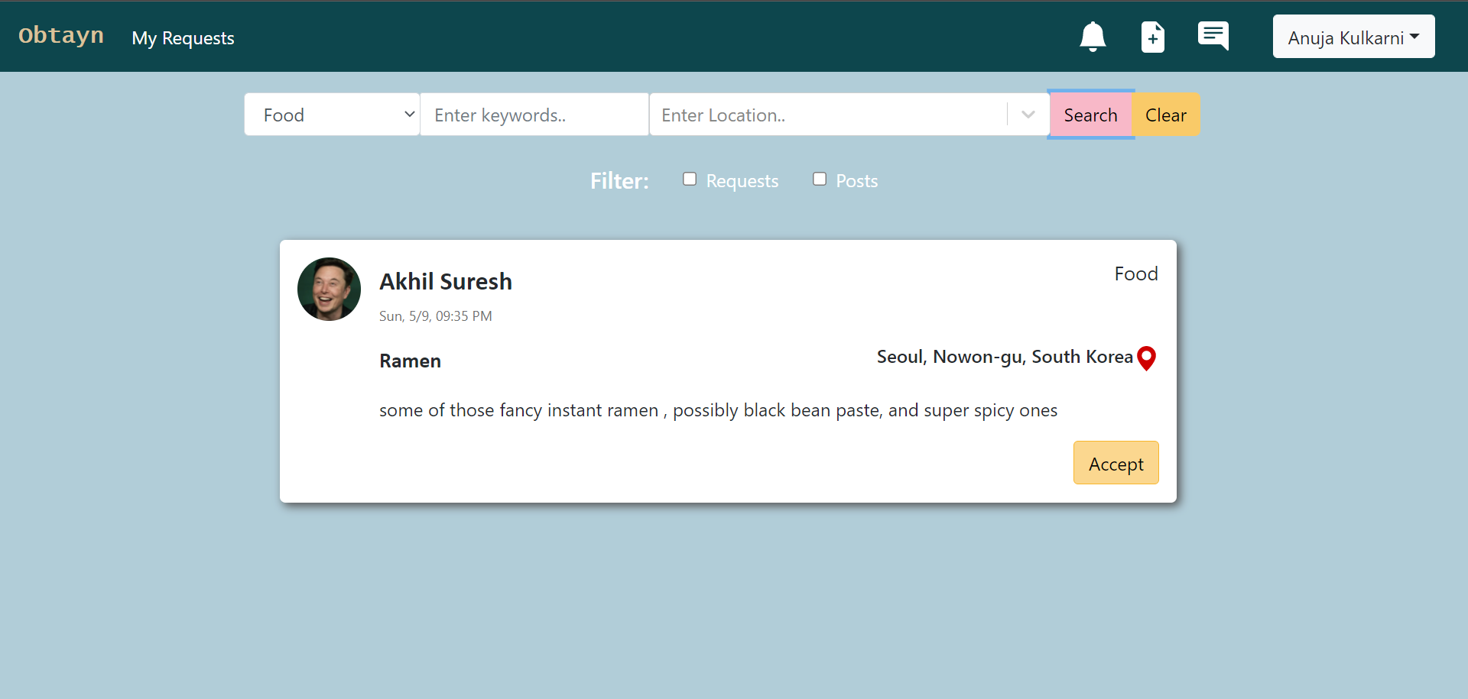
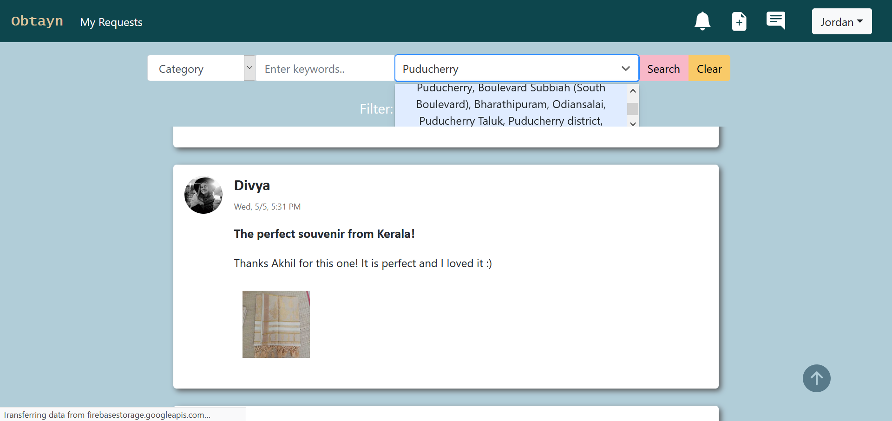

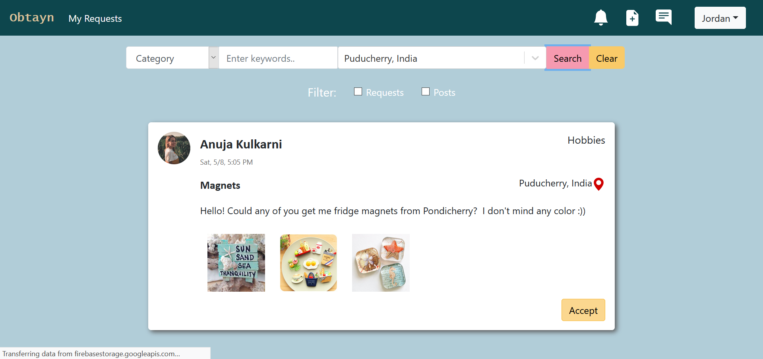
If Users try to hit Search without fillig at least one form field, system displays an error message.

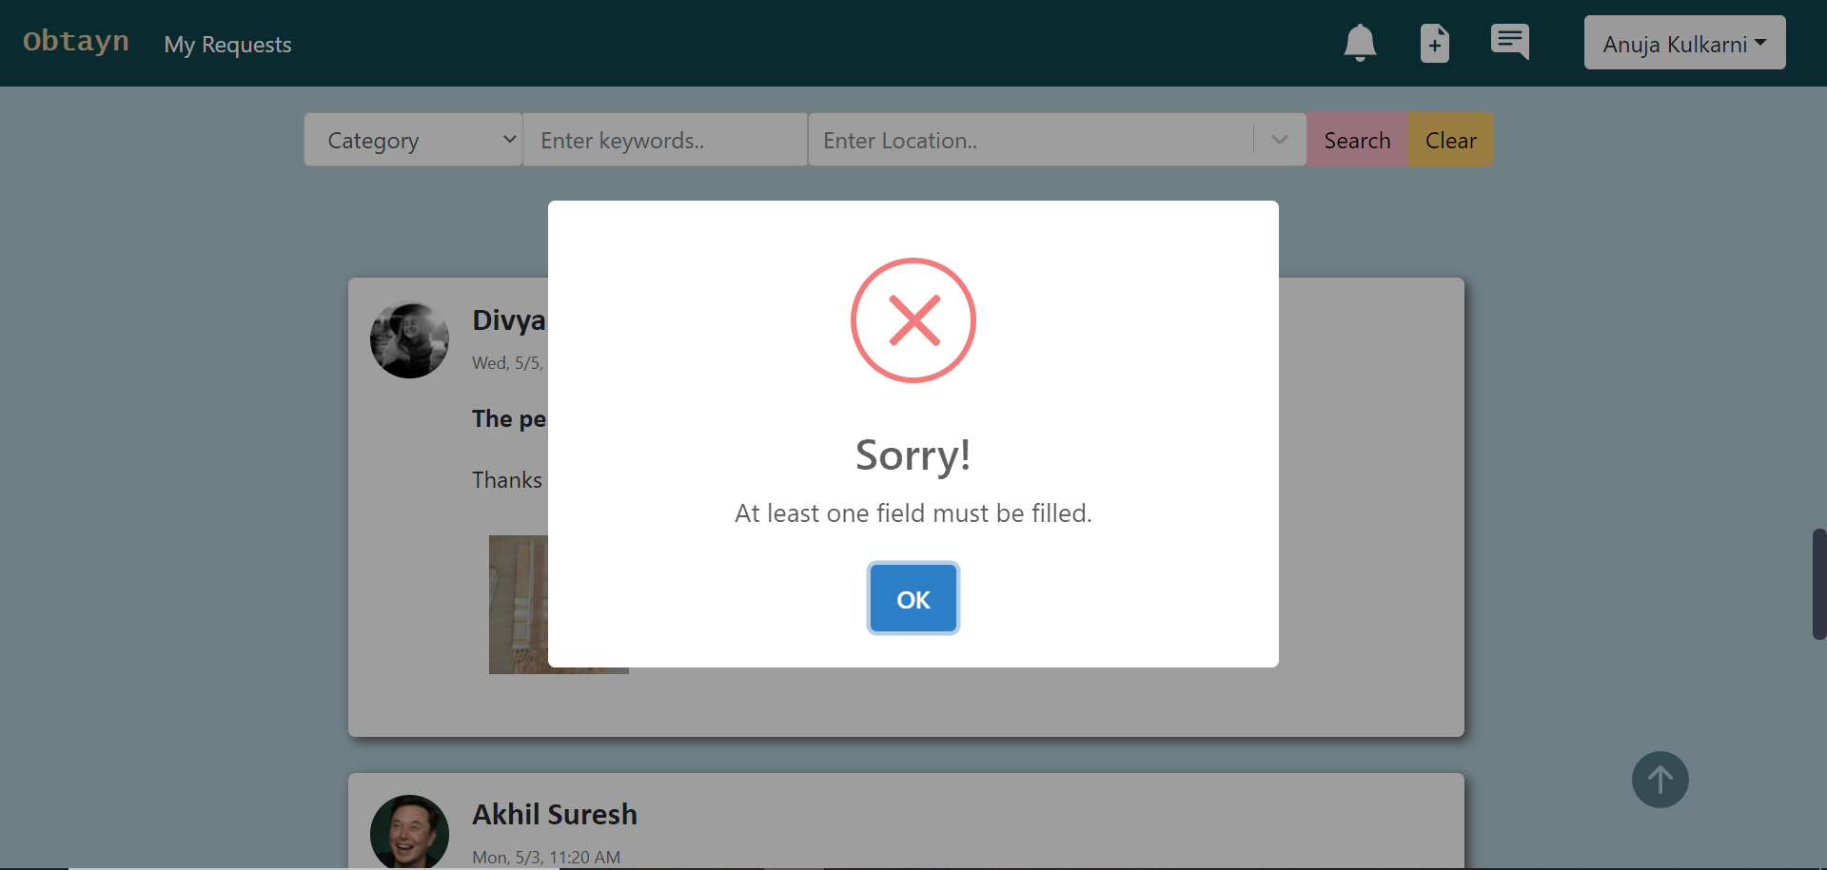

In case there are no relevant results found, System displays appropriate message.
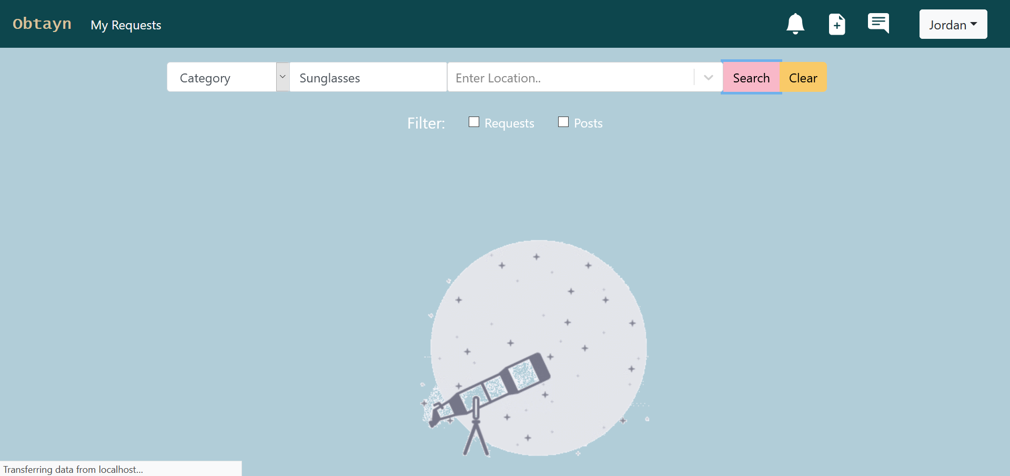
My Requests
On clicking the My Requests tab in header, Users are redirected to a new page containing -
- a header with brand name & various shortcuts – Feed tab, Notifications button, New Post button, Chat button & User Profile
- Accepted Requests list, which shows requests that current User has accepted
- Outgoing Requests list, which shows requests that User has sent. These can be of 2 types – Fulfilled & Accepted/Pending.
- Recent Messages, showing a list of all chats from most recent to oldest

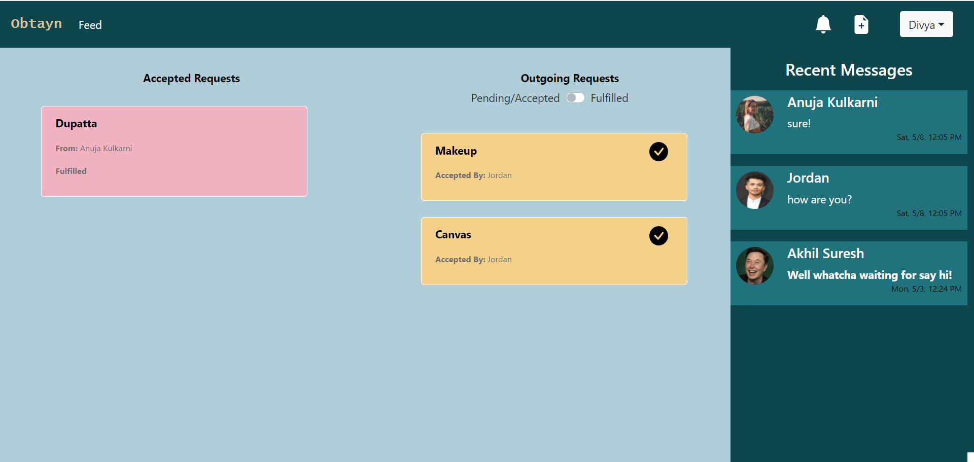Figure 11: Screenshots - My Requests

Chat
When Users click on a chat, they can view the entire thread with that User. In case of empty chat, no messages are displayed.

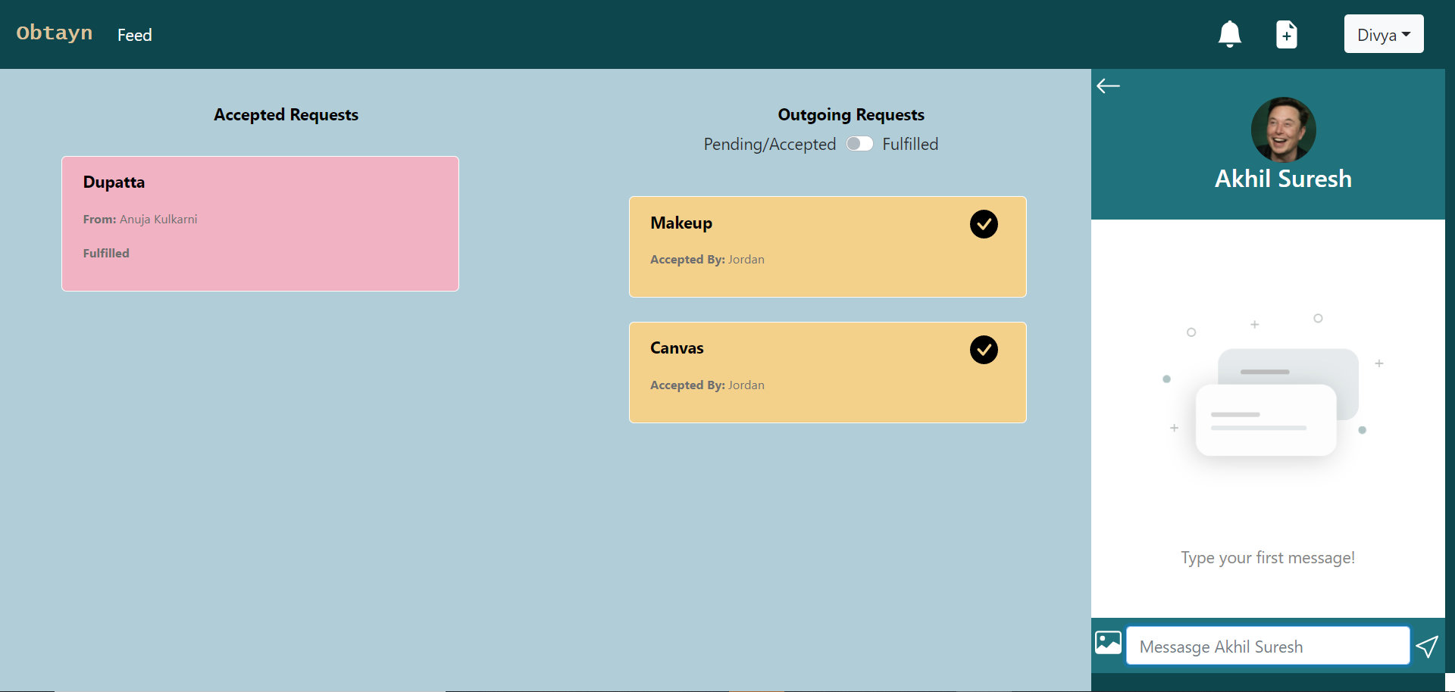
Users can also send up to 3 images at a time, preview selected images & cancel their selections.
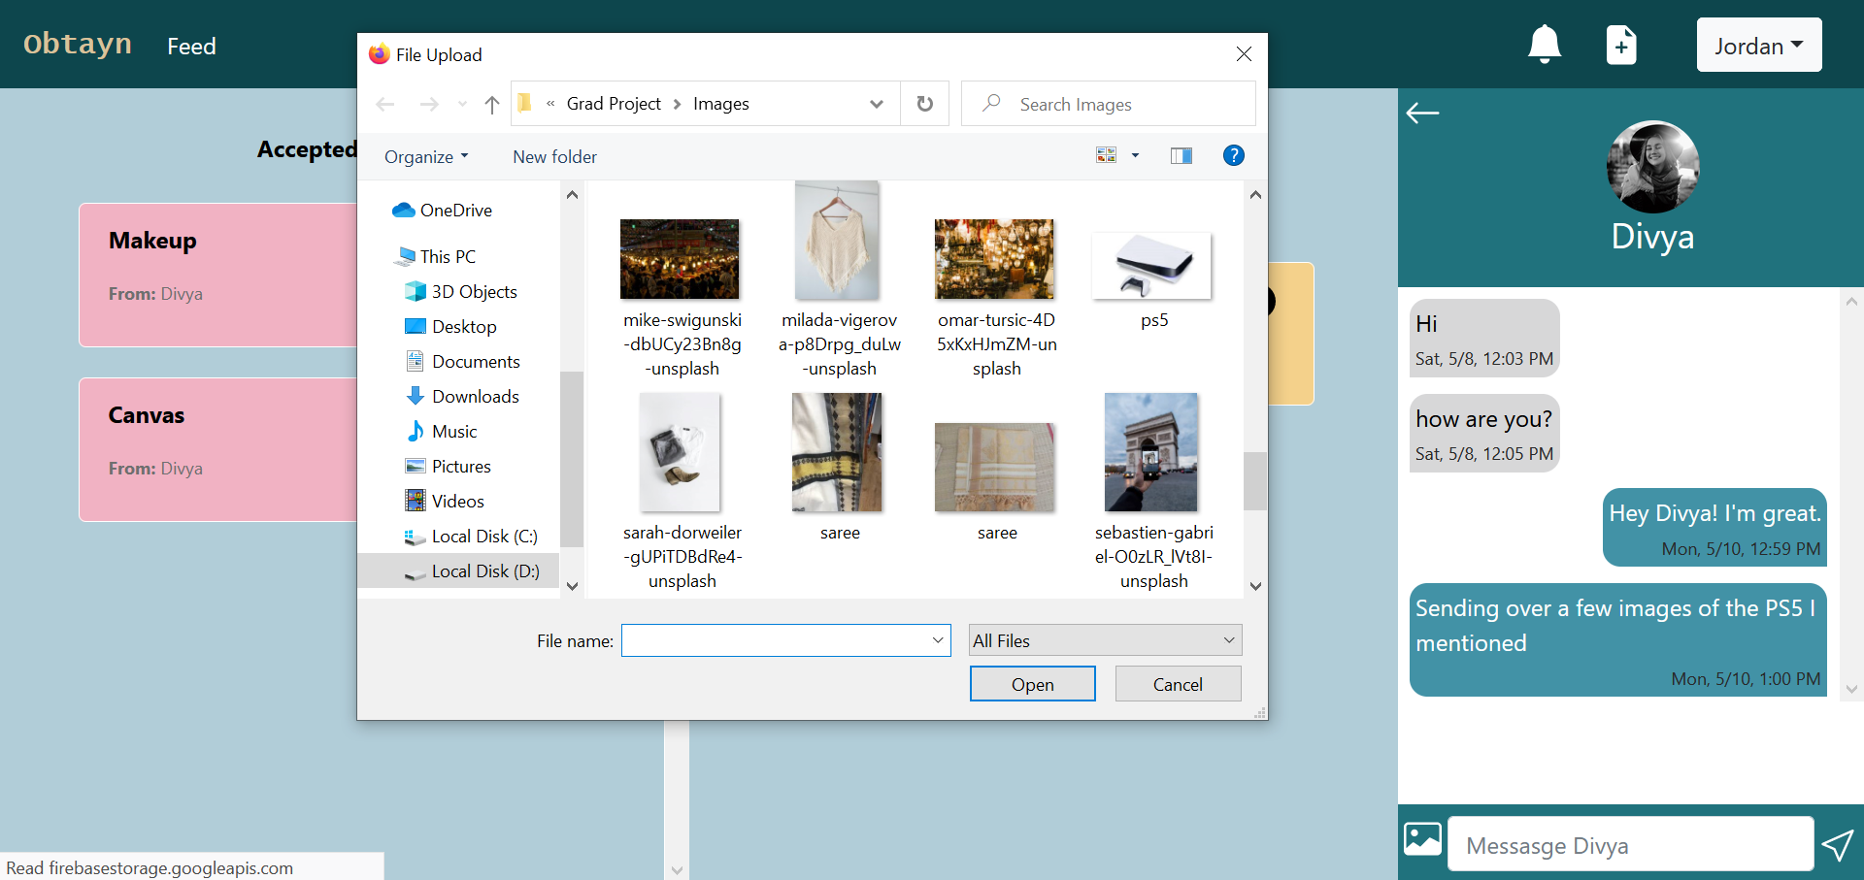
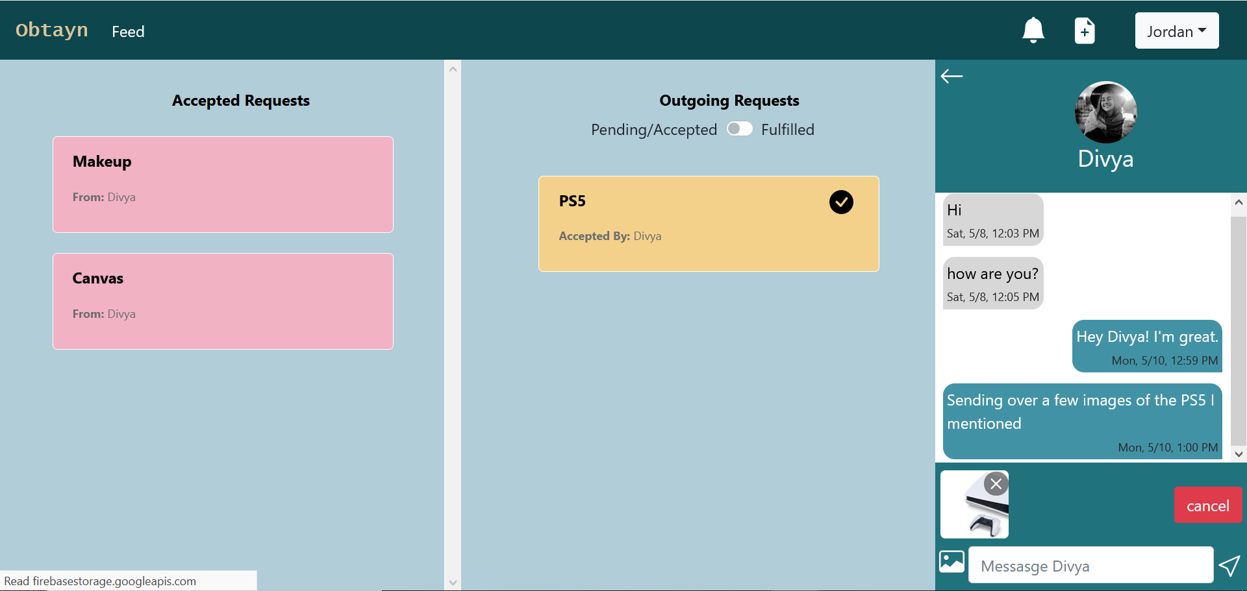

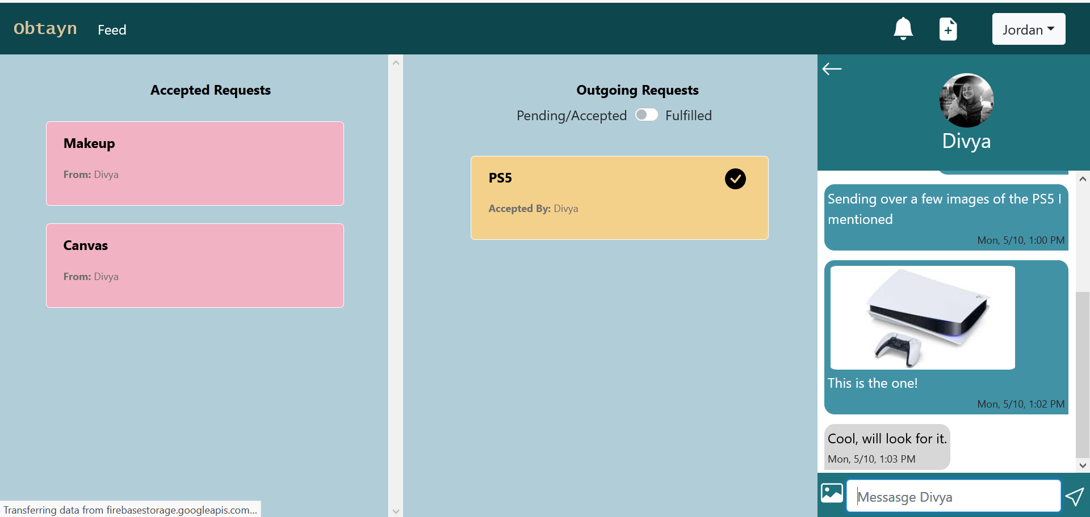
Unread messages appear in bold text, in the Chat list.
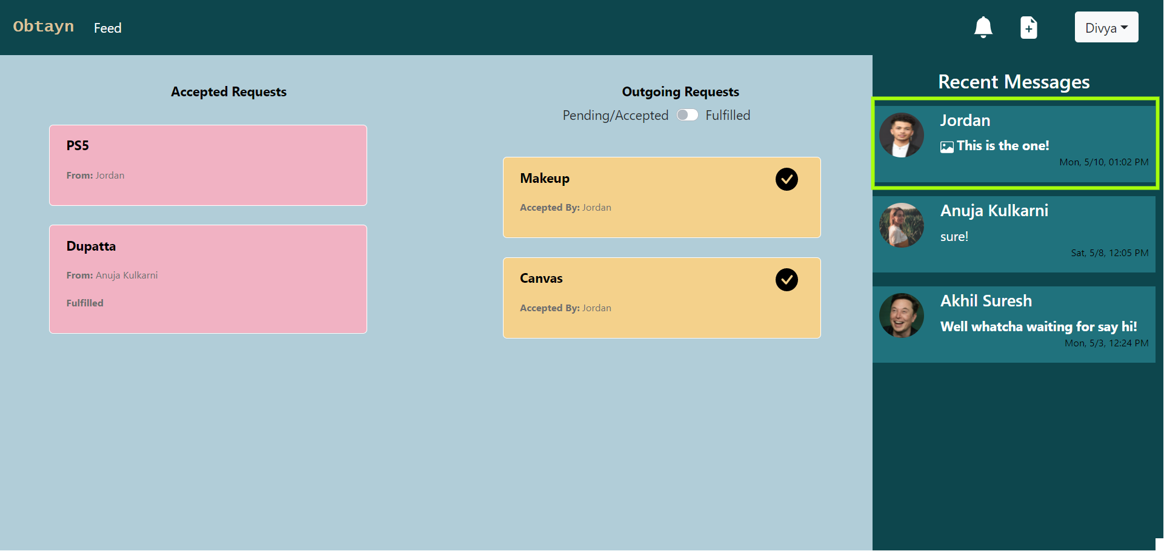
Mark Request as Fulfilled

Users can mark an Outgoing Request as Fulfilled, which means that they have received the item that they requested for.

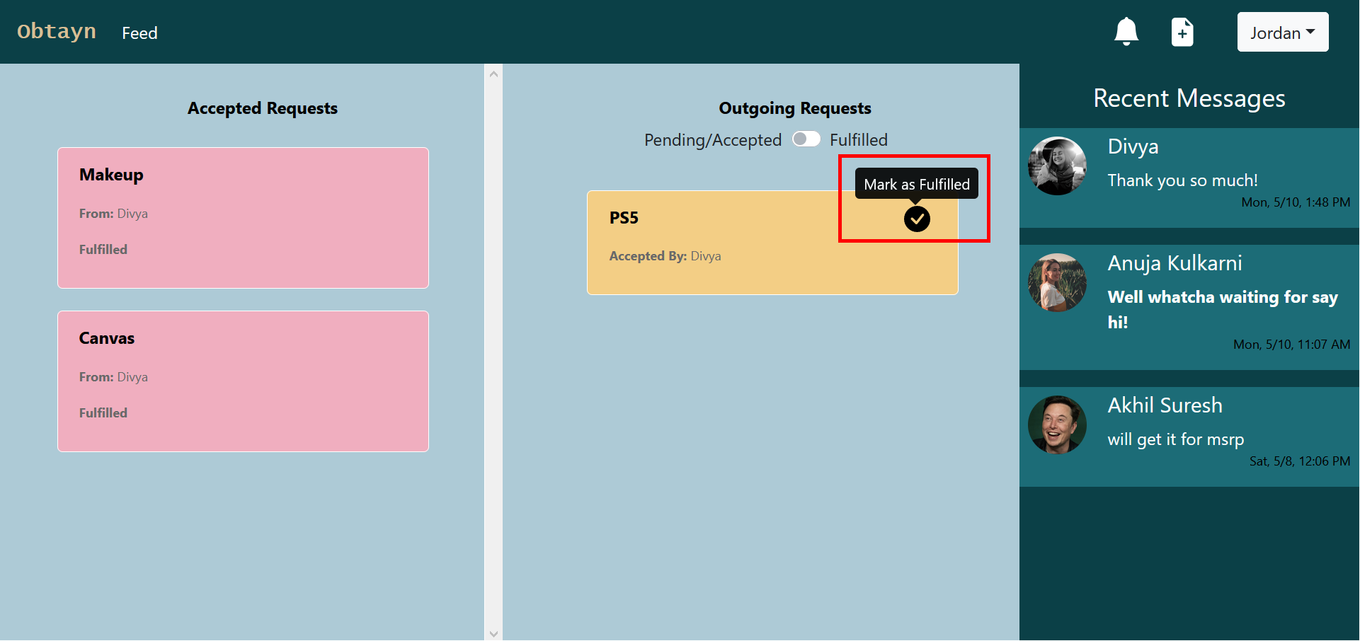

On clicking the “Mark as fulfilled” icon, system shows a confirm box. If User clicks on Yes, selected request status is changed to Fulfilled, and it appears in the “Filfilled Requests” list. User who accepted that request receives a notification.
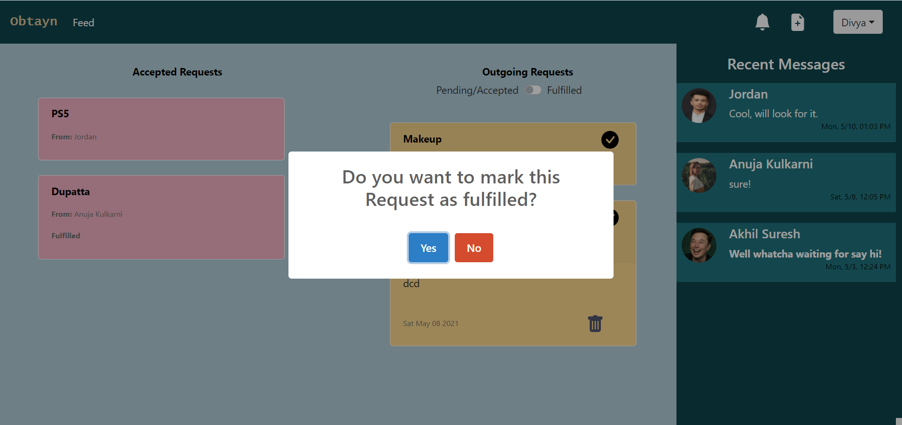

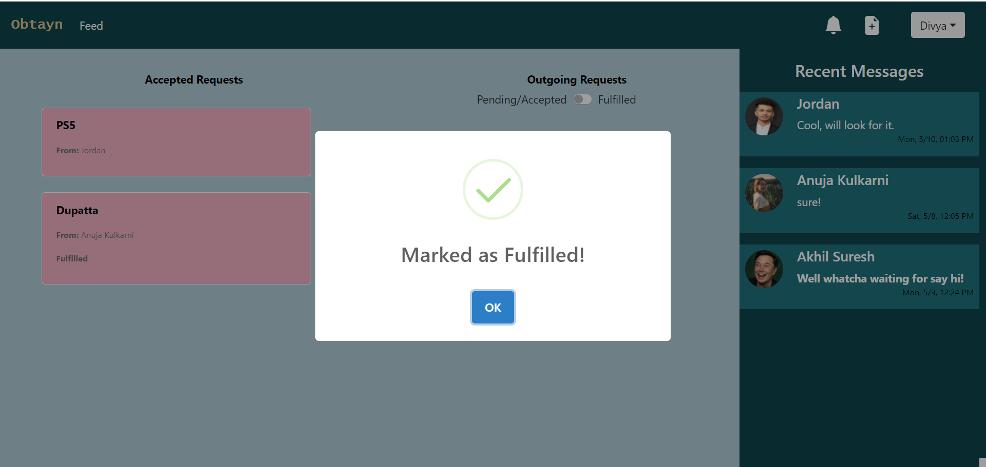
Fulfilled Requests are shown in green.
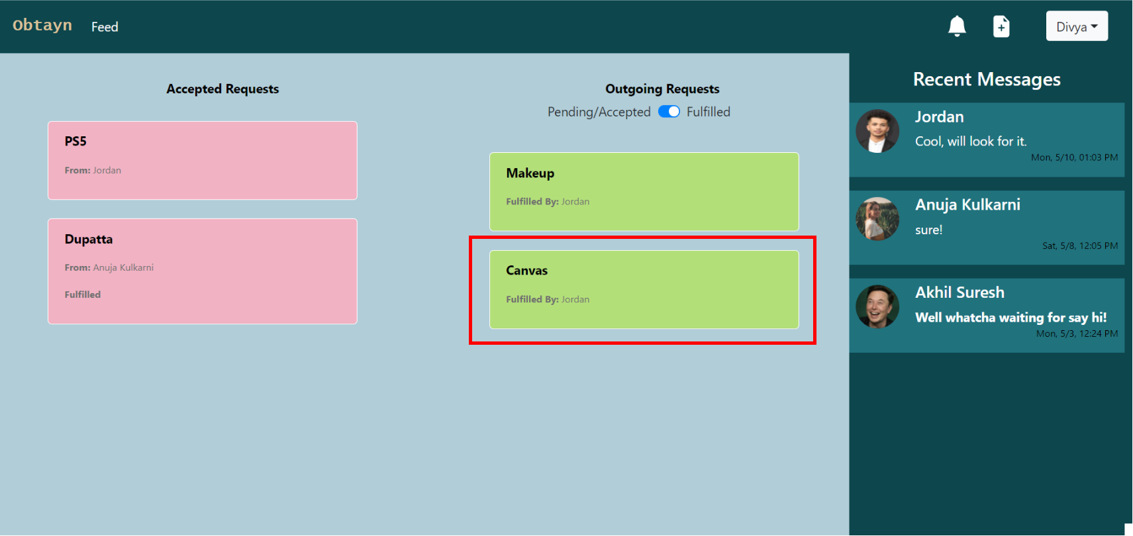

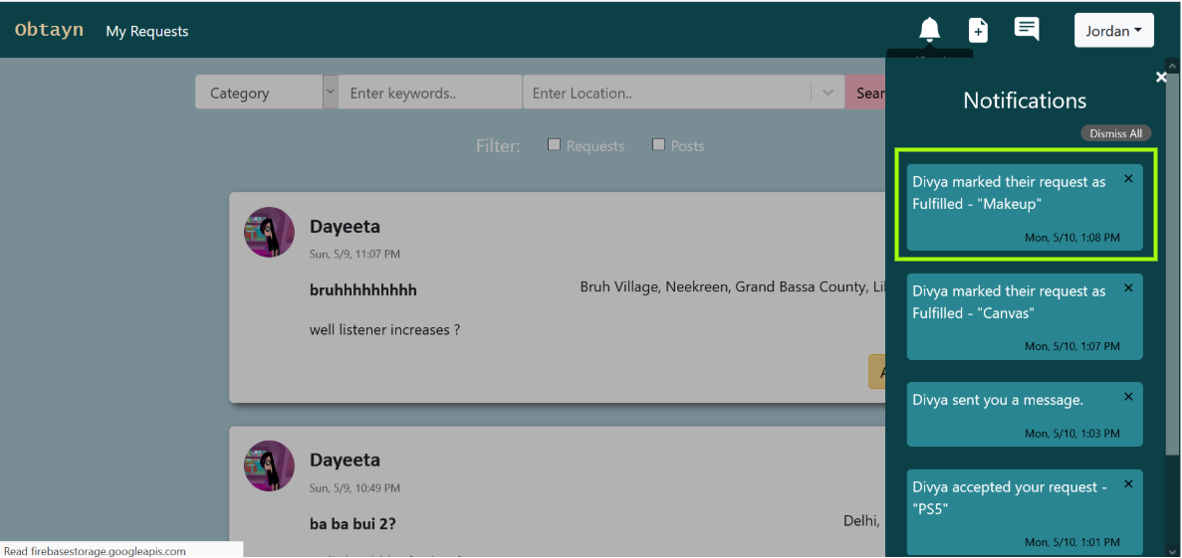
Delete Request

Users can also delete an Outgoing request by clicking on the bin icon at the bottom of a request card.
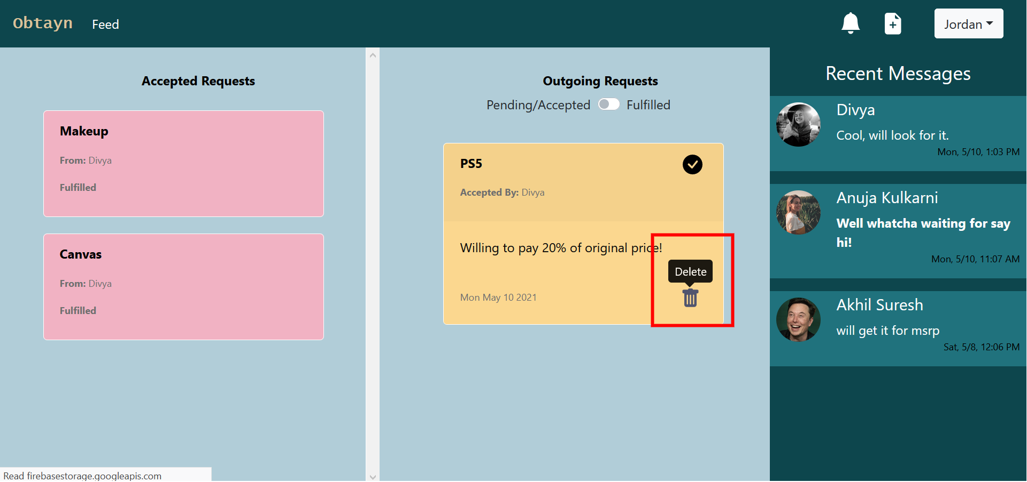
System shows a confirm message, and on clicking on “Yes”, selected requesr is deleted from Users lists.
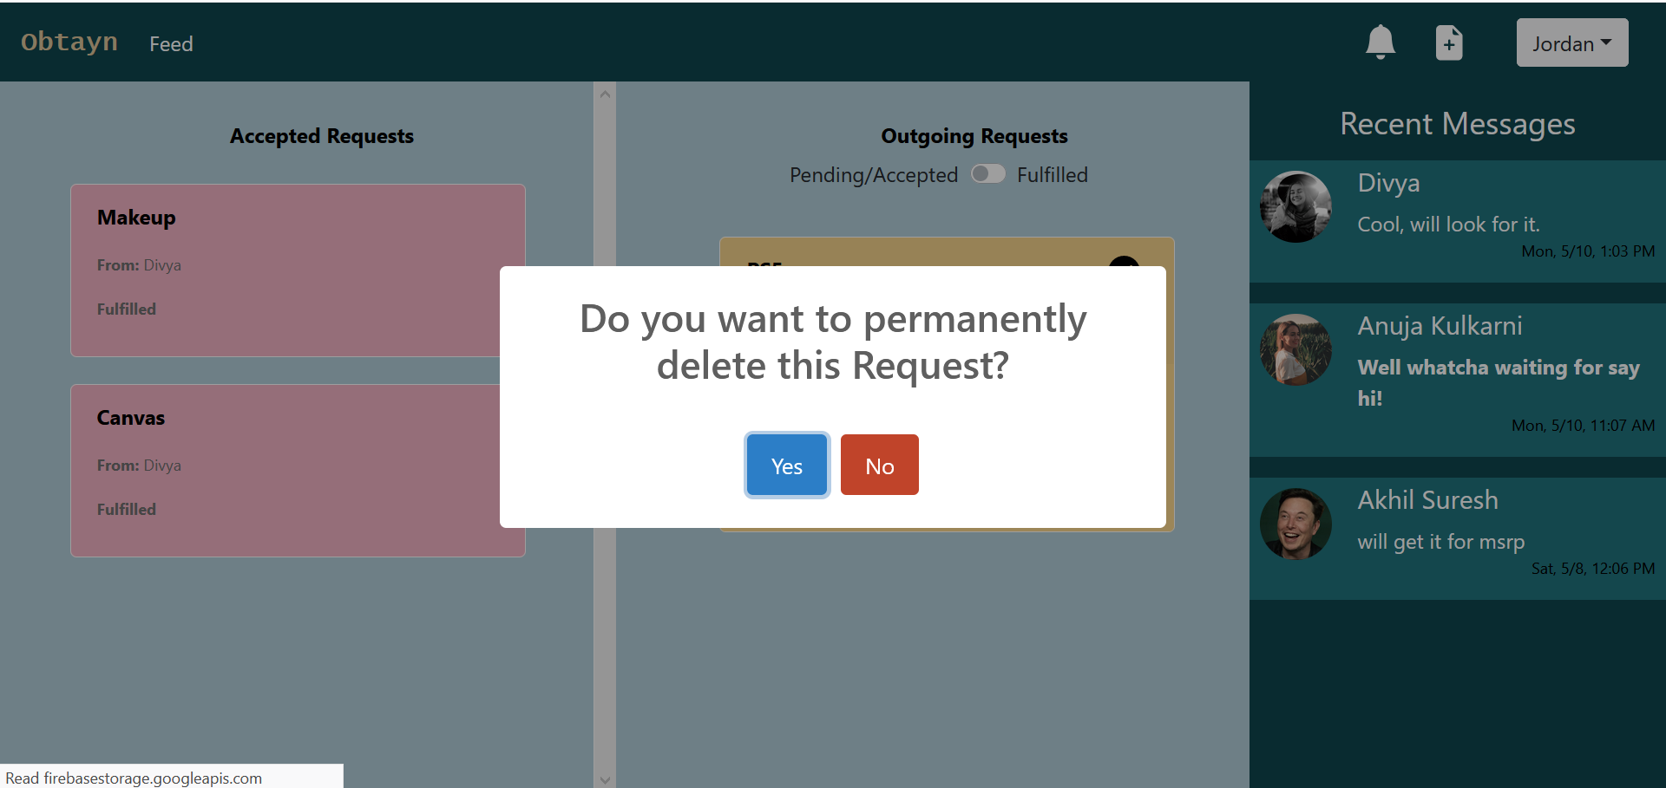
Chat Notifications

Users also receive notifications regarding new messages that they receive from other users.
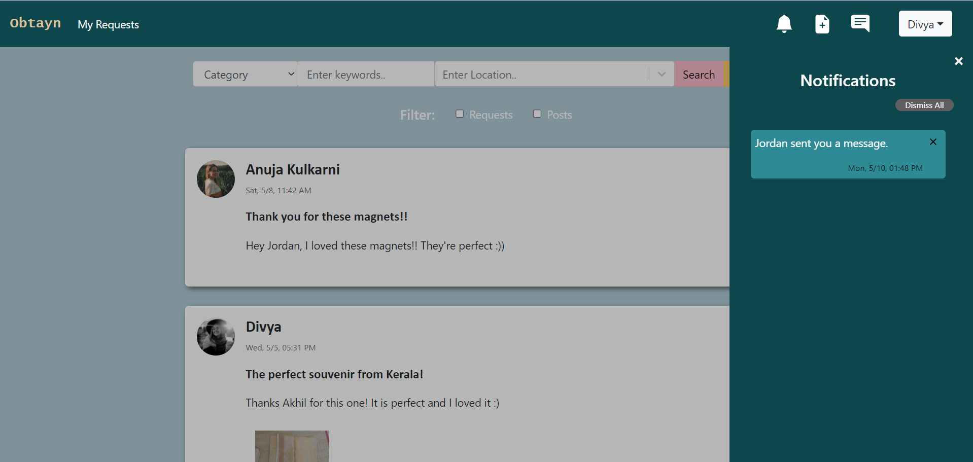
By clicking on the notification, User is redirected to that particular chat thread.
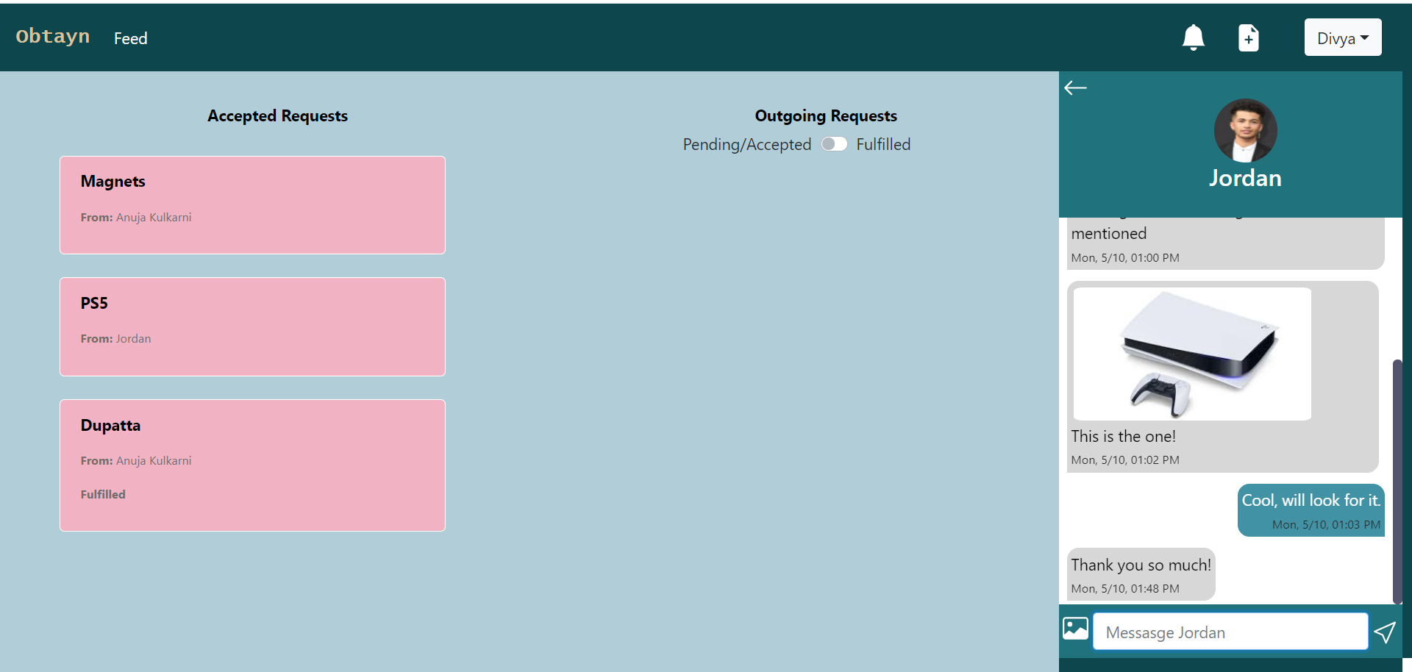
Error Page

If Users try to navigate to a page that does not exist, System displays following 404 page:
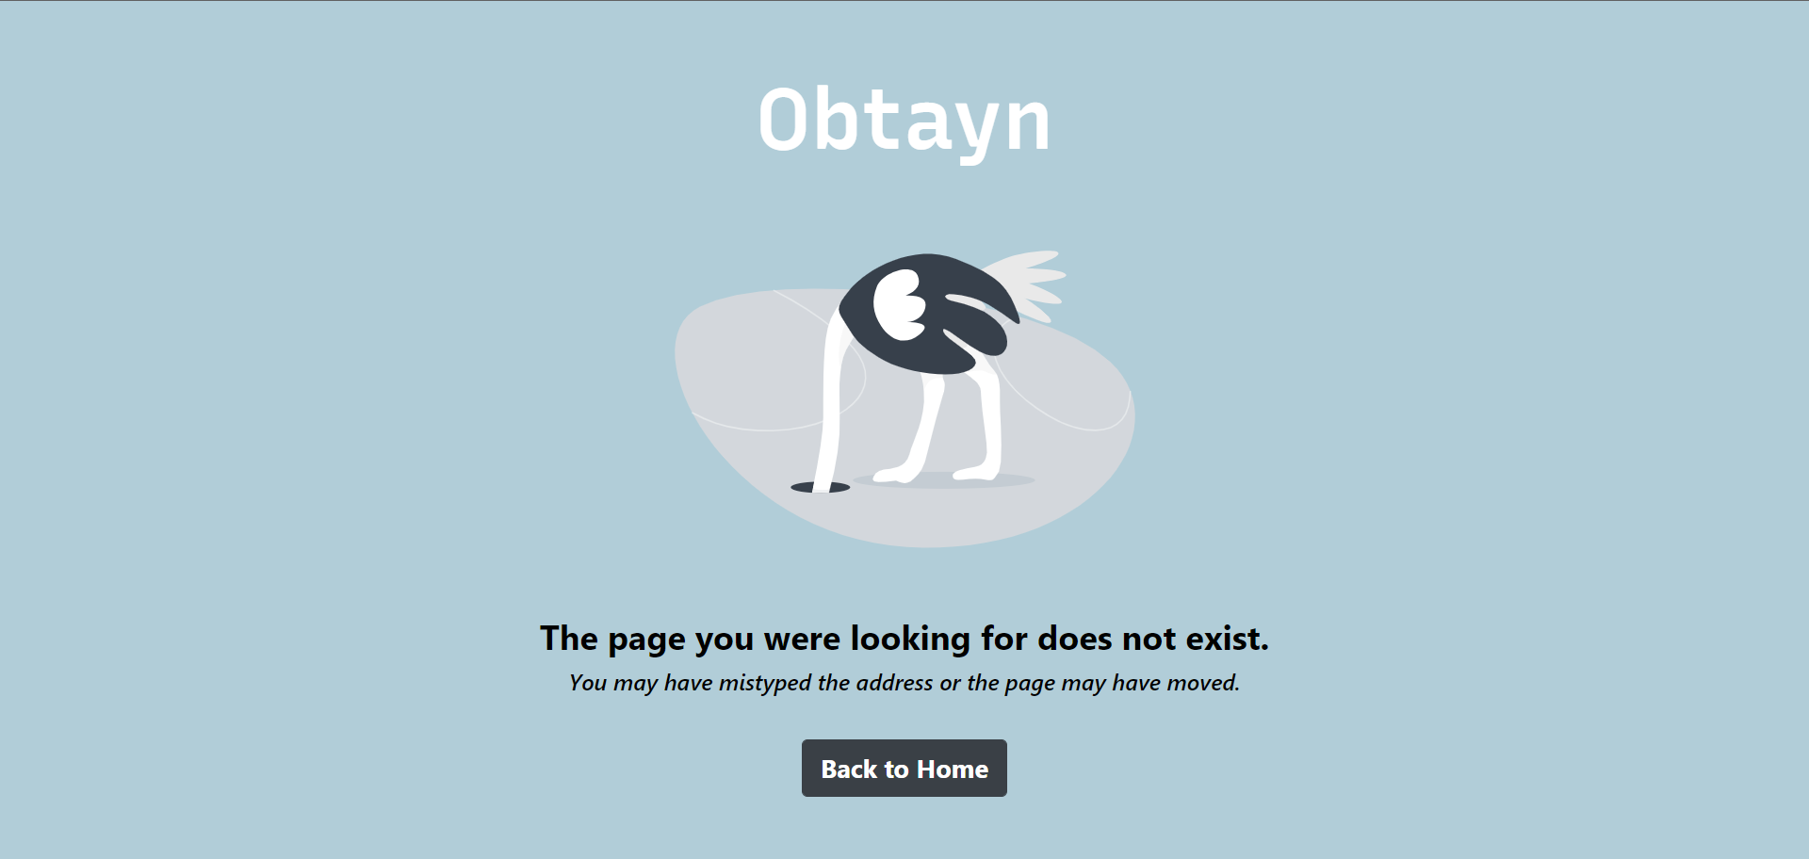Figure 12: Screenshots - 404 page

Testing
{Sample Text Sample Text Sample Text Sample Text Sample Text Sample Text}

Quality process
Test Cases identification
Test Cases execution
Defect Tracking and analysis
Limitations & Future Enhancements

Limitations

- This application is not developed using a mobile-first approach. Hence, it is not completely responsive to all devices.
- Users cannot view other Users’ travel plans and add requests accordingly.
- Users cannot post their own travel plans.
- Payment has to be handled by Users.

Future Enhancements

- Travellers can add their travel plans.
- Users can view others’ travel plans.
- Travellers can post available items.
- Add payment integration to the system.

Conclusion
This project was completed in fulfillment of the Industrial Training requirements of the course. It provided us a very good opportunity to obtain both theoretical knowledge and practical experience. It helped us to get more familiar with web development as well as the processes involved in project development.
We gained a deeper understanding of all the planning process that happens in the initial phases of the project, and how important those processes are. We also learned how to plan for extra features as well as to track our own tasks and progress, so that the project stays on track.
The results of our project met both the requirements of the course and our expectations.

References
<Use the citation style for your discipline. Indicate materials referenced in the project and from sources you have actually used.>

https://devpost.com/software/react-toastr
https://markheath.net/post/font-awesome-circle-background
https://firebase.google.com/docs/firestore/query-data/query-cursors
http://react-redux-firebase.com/docs/queries.html
https://dev.to/yanns1/how-to-render-different-components-based-on-screen-size-2p35
https://sweetalert2.github.io/
https://redd.gitbook.io/react-advanced-form/components/form/methods/reset#reset-controlled-fields
https://react-bootstrap.github.io/components/forms/
https://templates.office.com/en-us/Simple-Gantt-Chart-TM16400962

Glossary:
{Sample Text Sample Text Sample Text Sample Text Sample Text Sample Text Sample Text Sample Text Sample Text Sample Text Sample Text Sample Text Sample Text Sample Text }

Appendix A:
{Sample Text Sample Text Sample Text Sample Text Sample Text Sample Text Sample Text Sample Text Sample Text Sample Text Sample Text Sample Text Sample Text Sample Text }

